**ARC-GIS**

**EXCERCISE: 1**



**AMANUEL LEGESSE**

**SOFTWARE ENG. EXT**

**ID – ATE/3628/11**

**GETTING TO KNOW**

**ARCGIS**

**1.A** : Start the program ArcCatalog and access spatial data

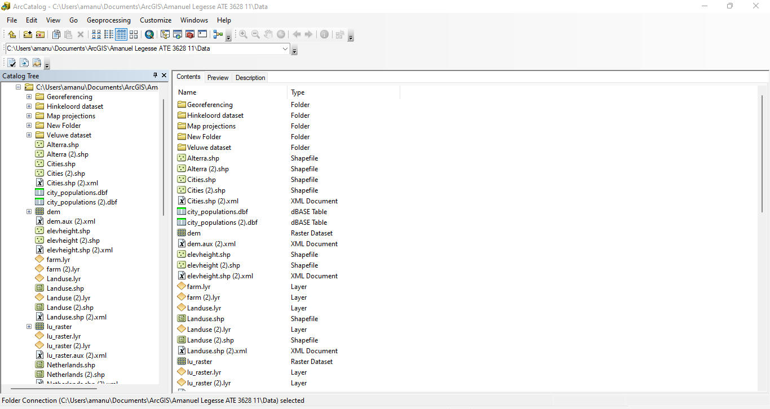

* The different file types of this folder are .shp, .xml, .dbf and .lyr

**1.B :**

* layer, database table and xml document

**Examining spatial data**

**2.A**:

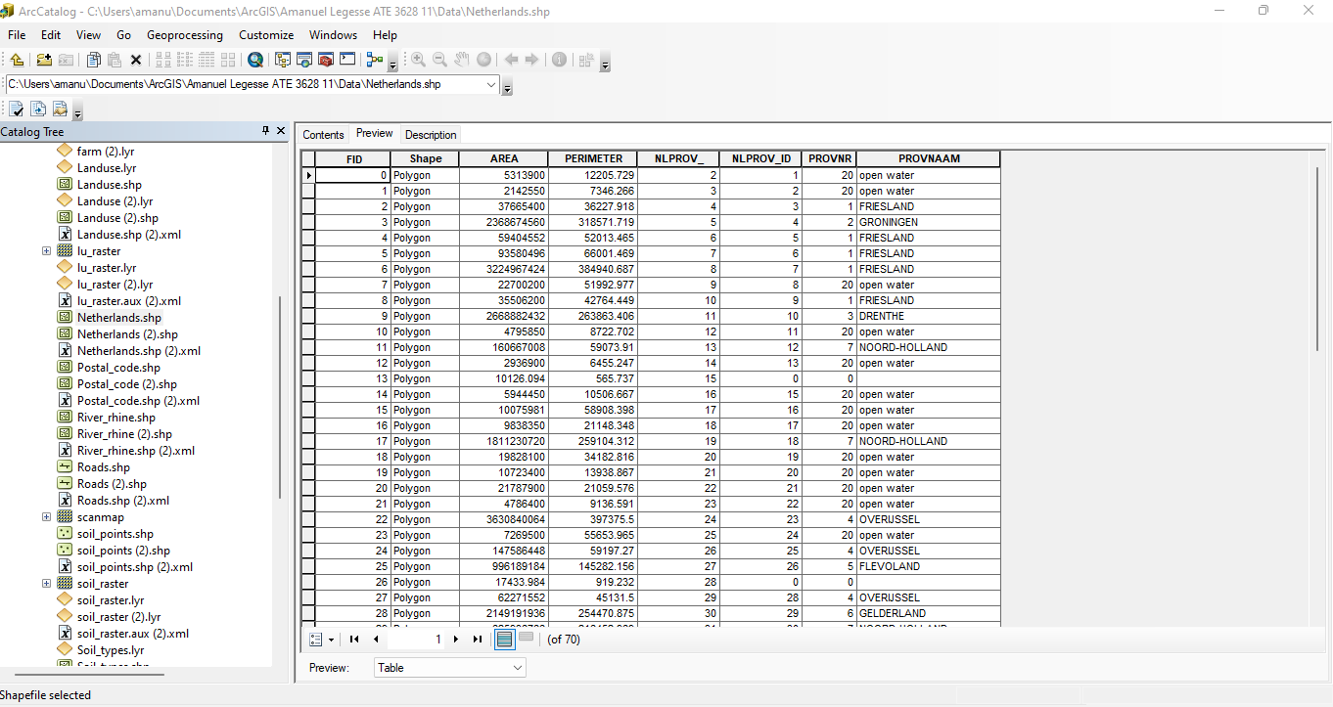

* The table contains 70 records and 8 fields.

**2.B:**

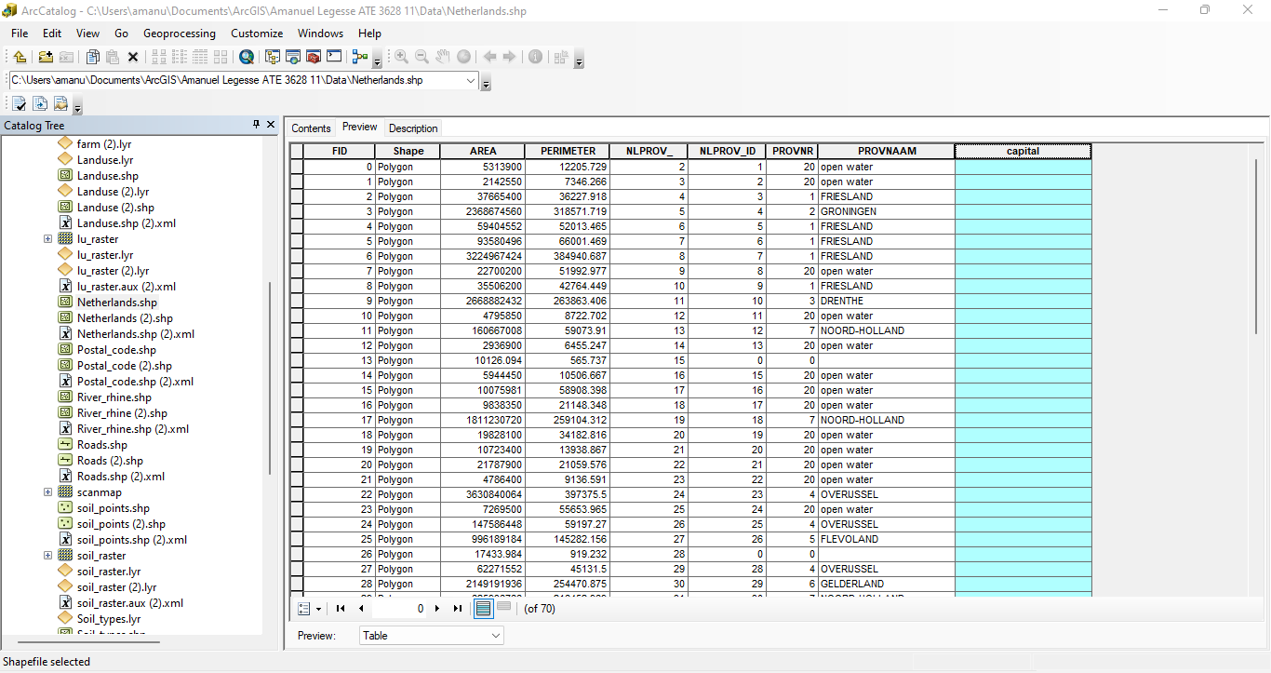

**2.D:**

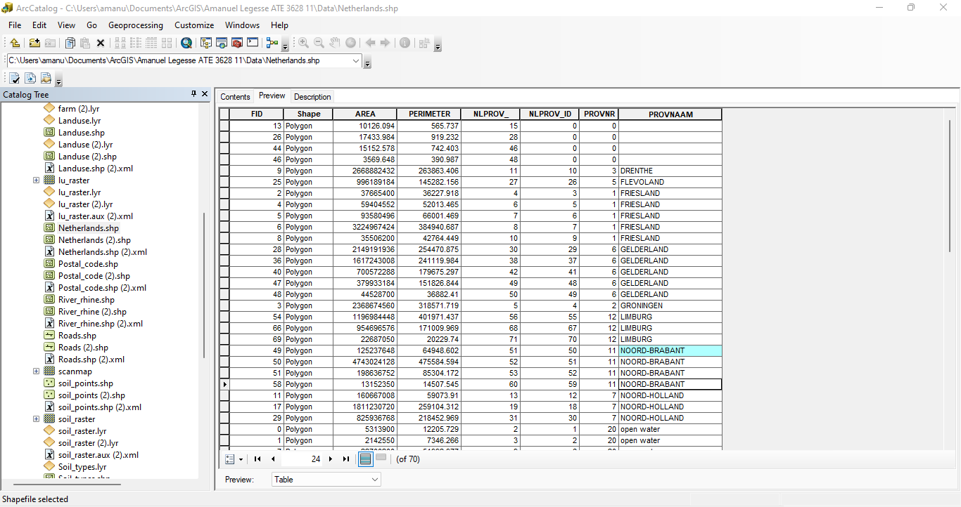

* 4 records belong to the province of Noord Brabant

**2.E :**

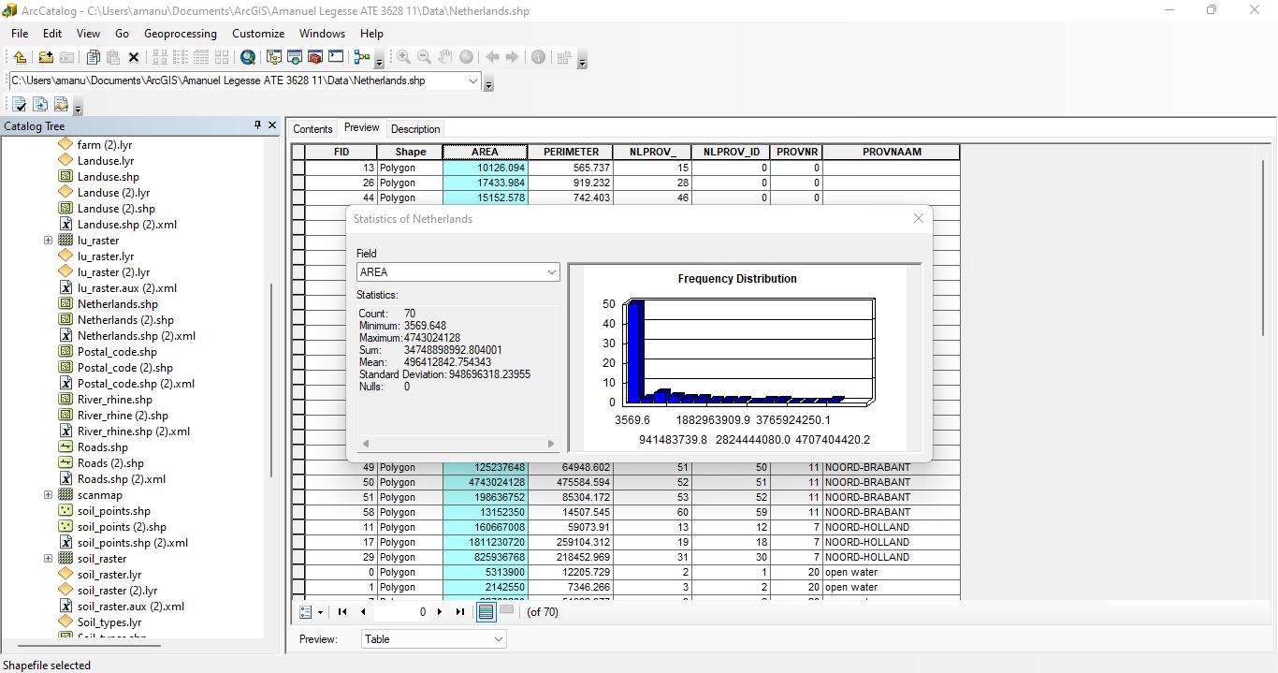

* The total area of Netherlands is 34748898992.804001

**2.F:**

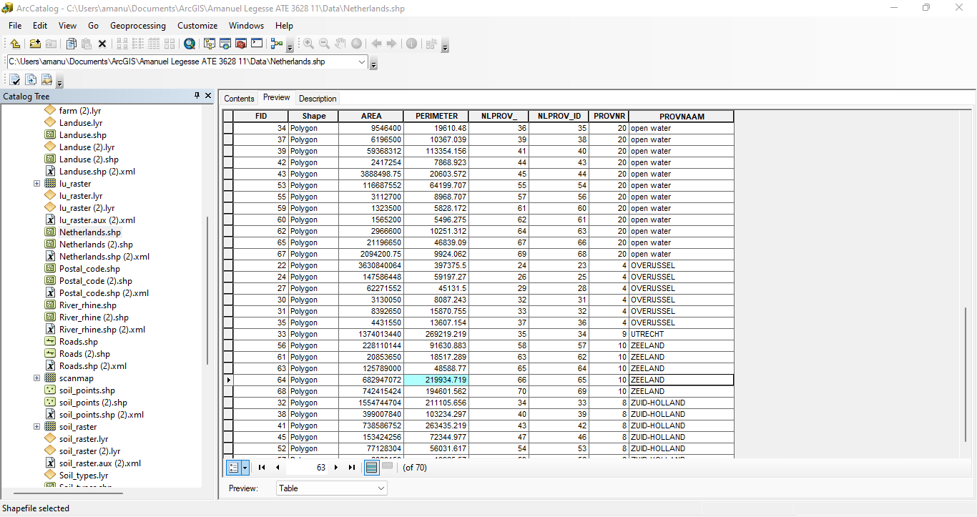

* ZEELAND province contains a feature that has a perimeter of 219934.719 meters.
* The value of the attribute ‘FID’ is 64.

**2.G :**

* ‘FID’ represents a value that uniquely identifies a record or feature.

**Exploring the metadata of a spatial dataset**

**3.A:**

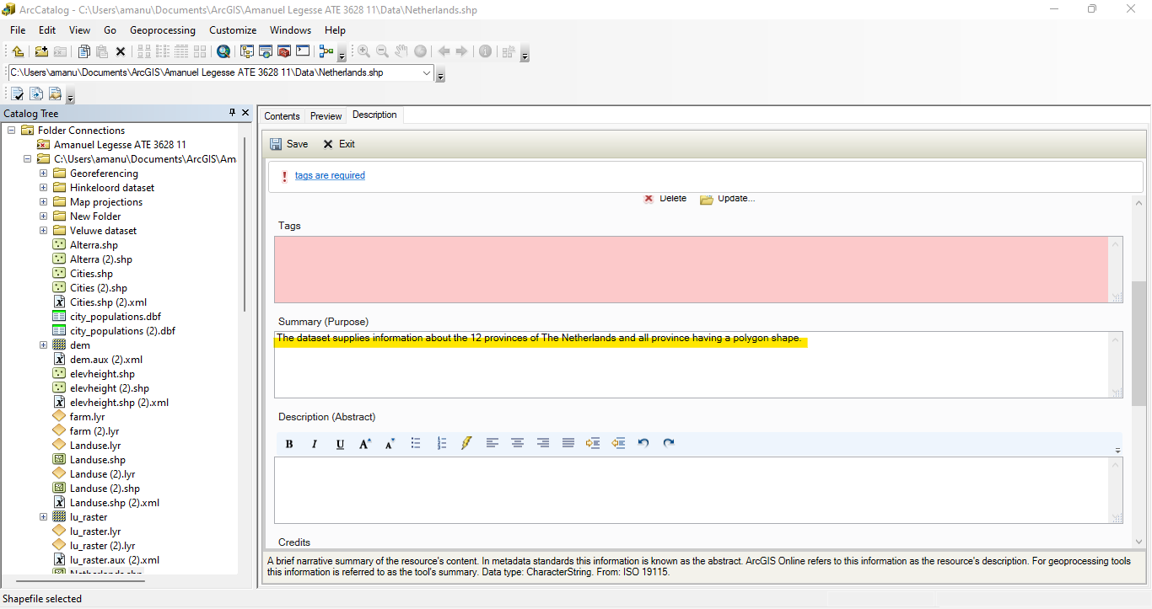

**3.B:**

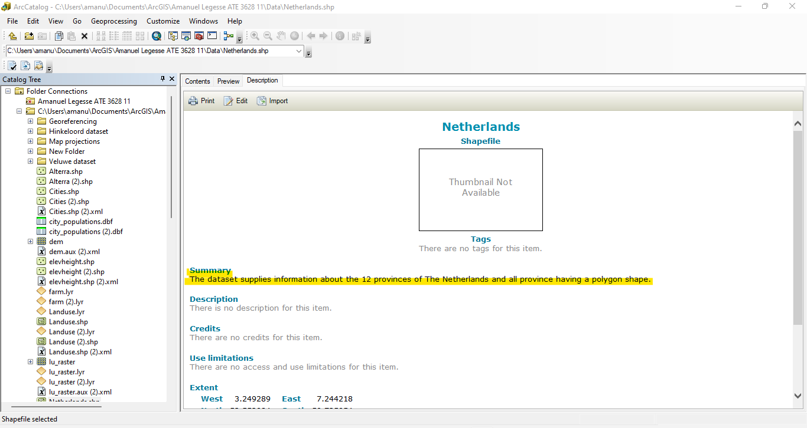

**3.C:**

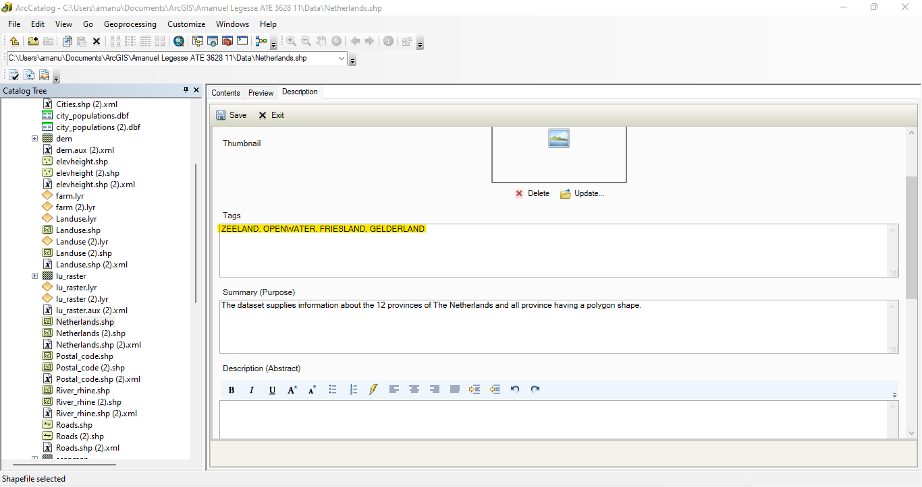

**3.D:**

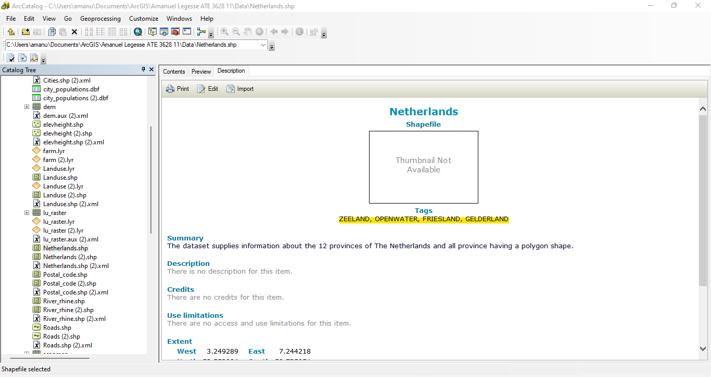

**Working with ArcMap**

**4.A :**

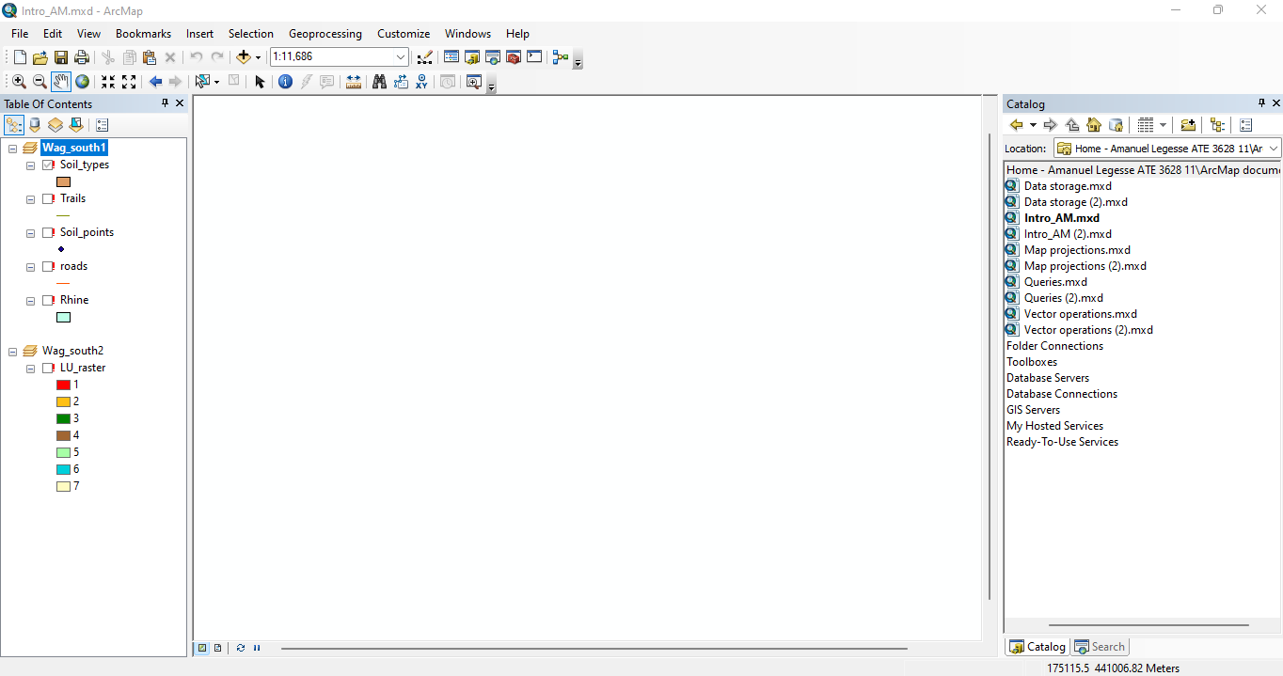

**5.A:**

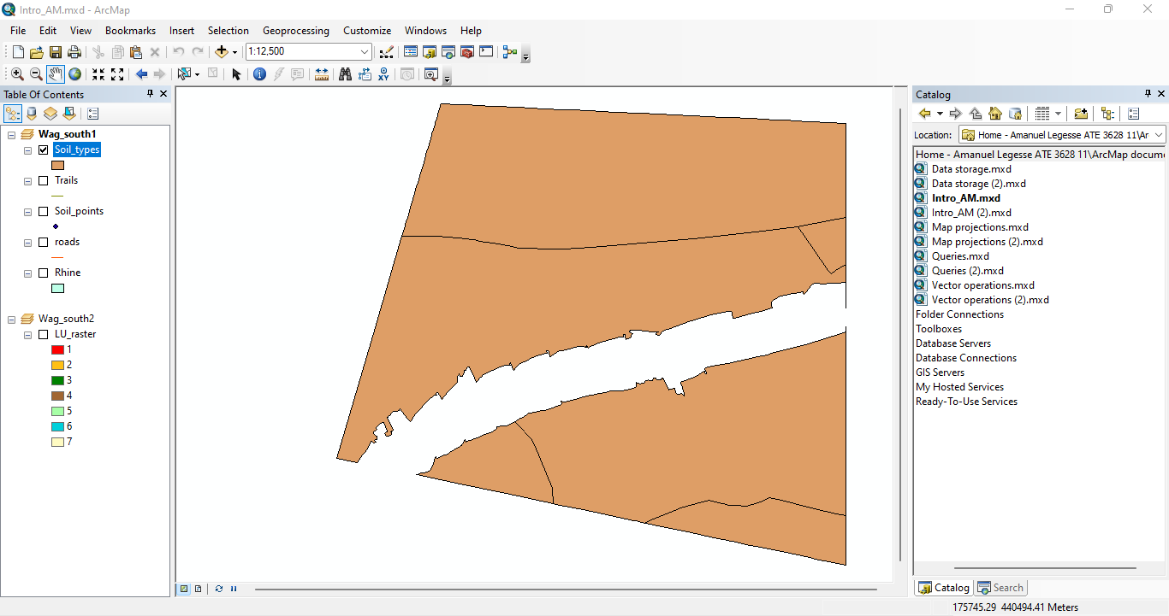

**6.A :** Activate a Data Frame and turn the visibility of a dataset on and off

* Intro_AM.mxd document contains 2 (Wag_south1 and Wag_south2) DataFrames.

**6.B :**

* Wag_south1 contains 5 datasets.

**6.C:**

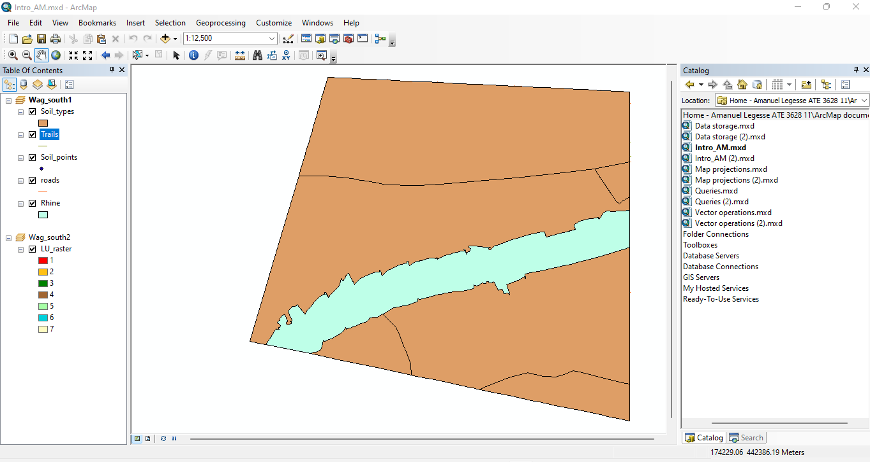

**6.D :**

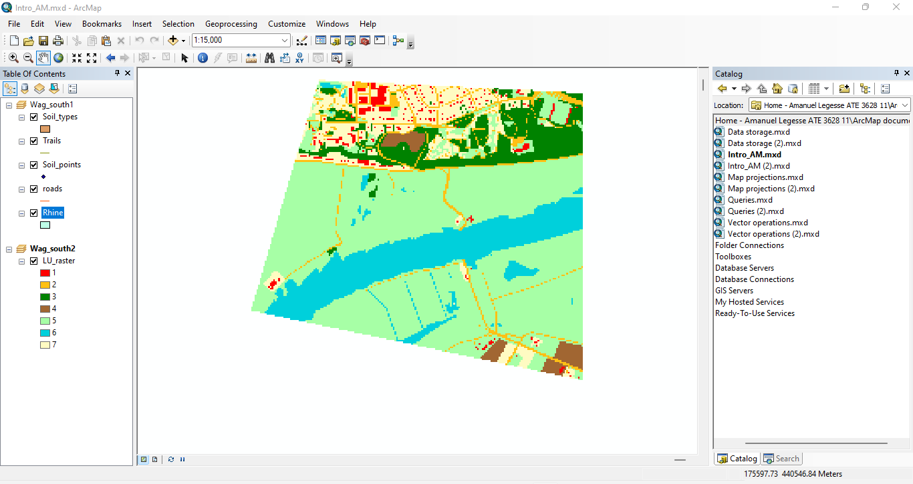

**6.E :**

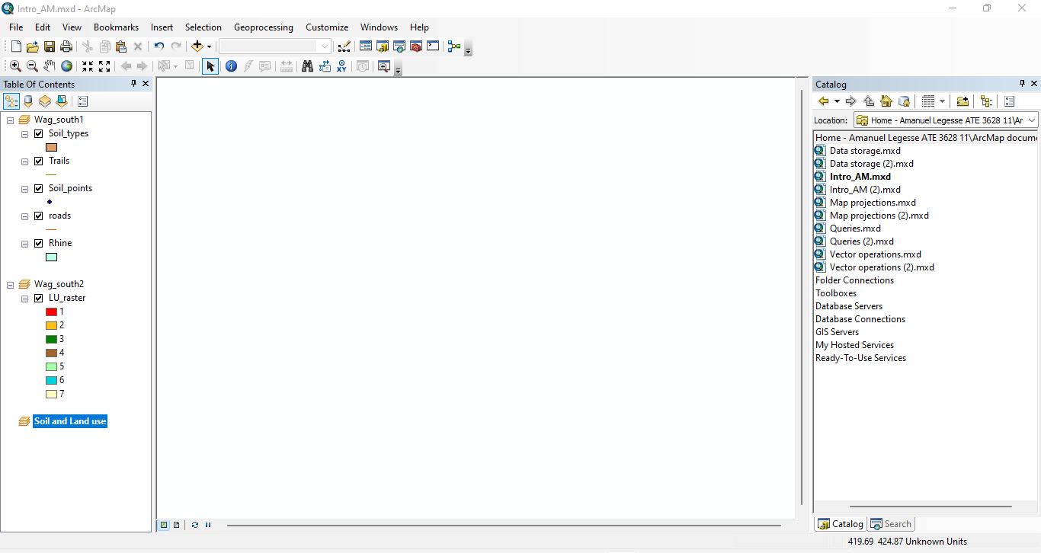

* **Adding datasets**

**7.A :**

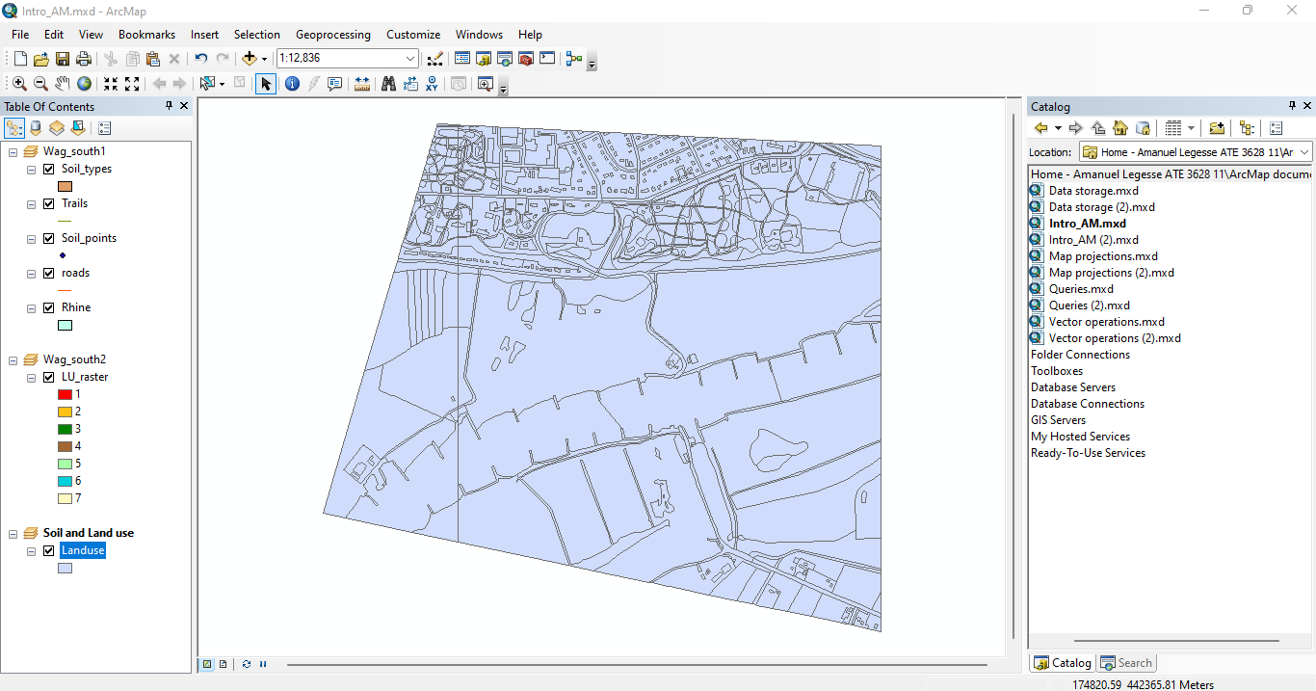

**Working with layer files**

**8.A :**

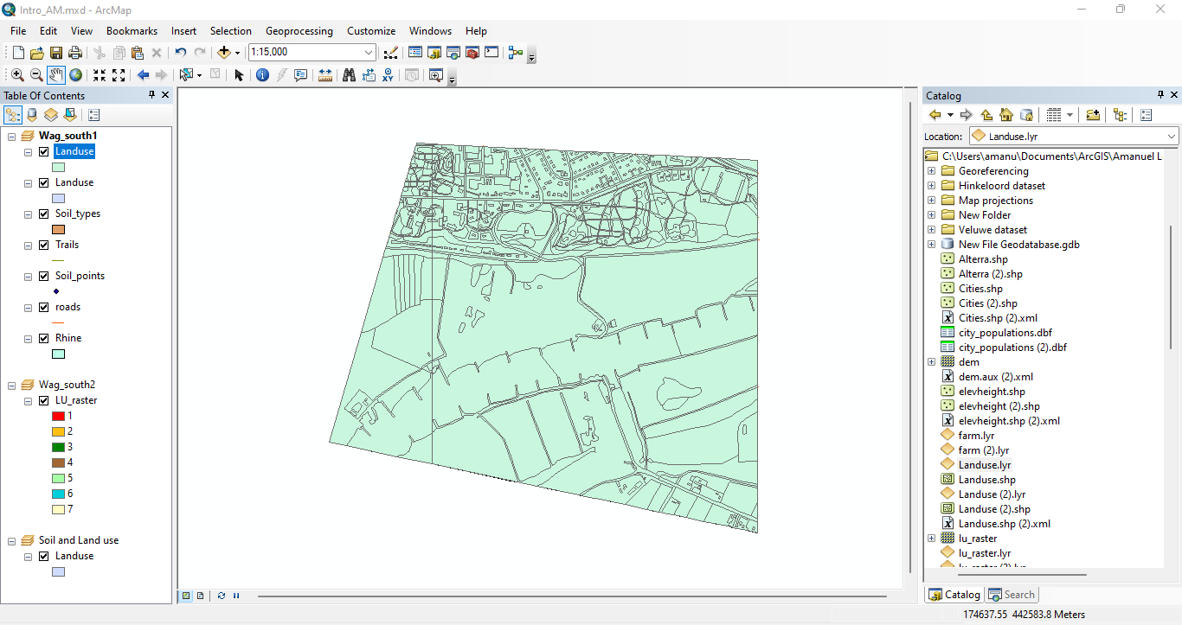

**8.B :**

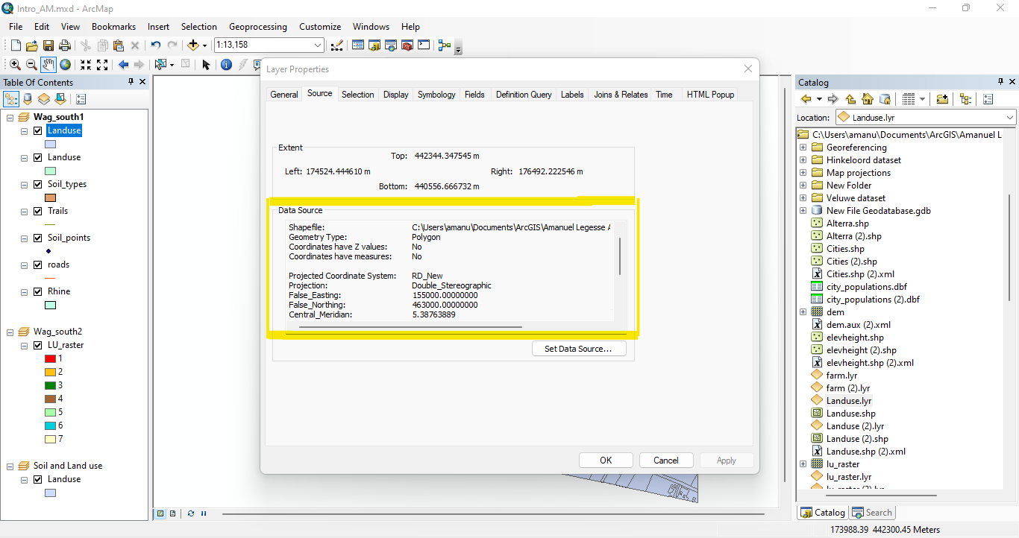

**8.C :** I tried changing the colorin the dataset ‘Landuse.shp’ nothing happens to the layer ‘Landuse.lyr’

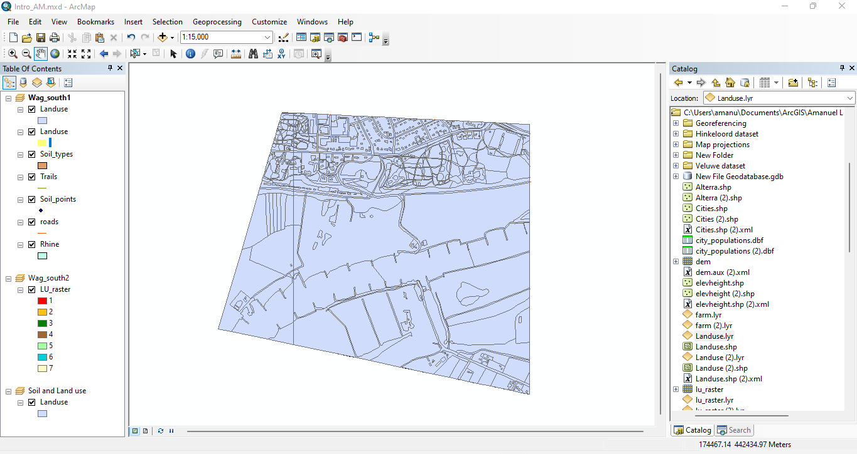

**9.A :**

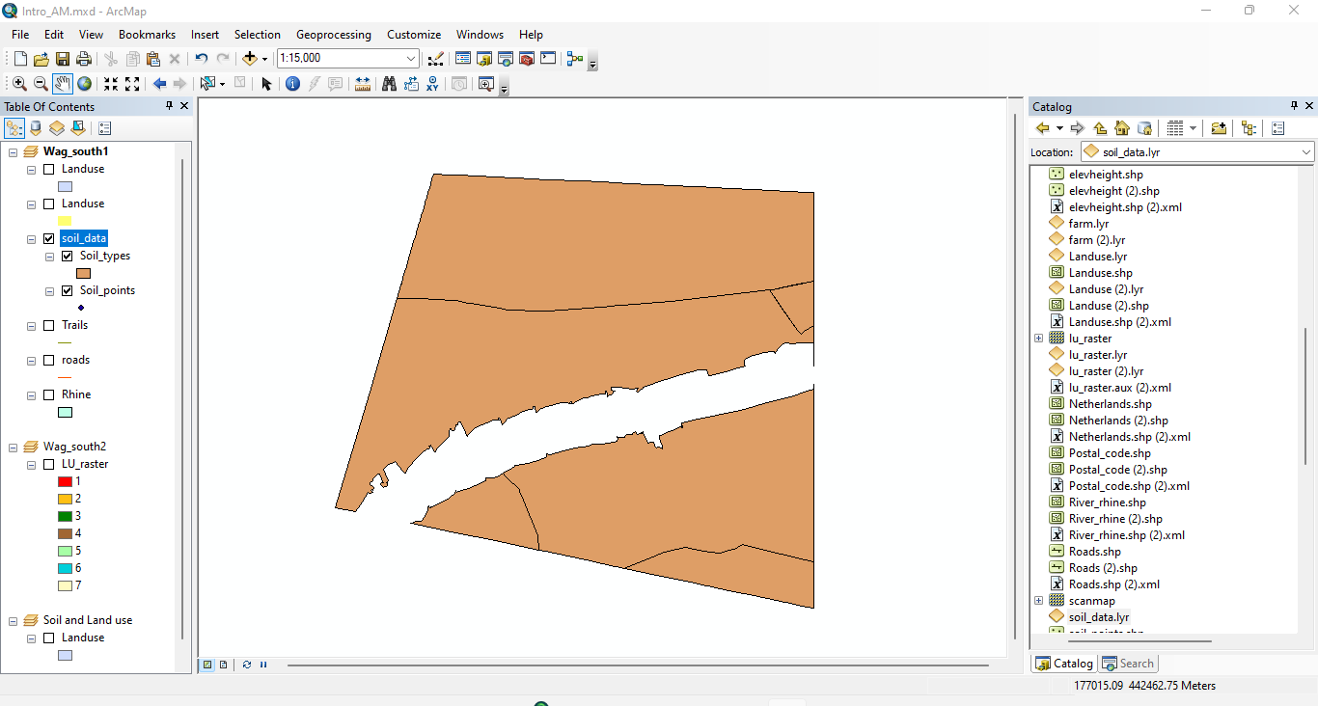

**9.B:**

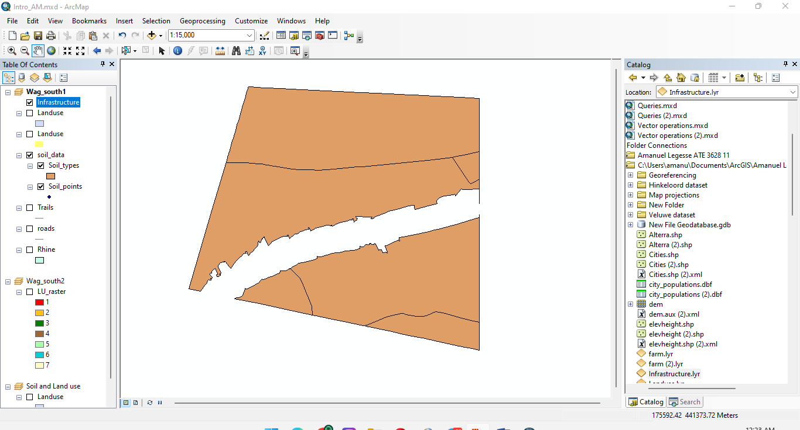

**9.C :**

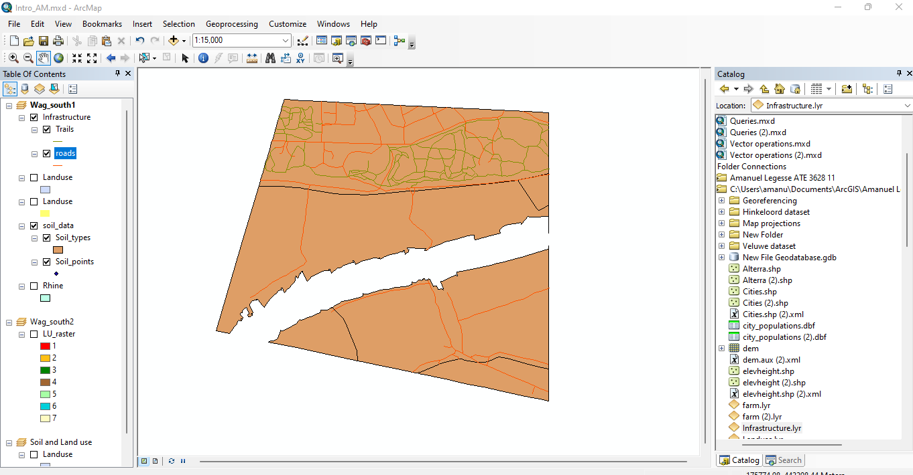

**9.D :** The other layers in the data set will disappear as if they have been deactivated but they are not, solid data will take over the infrastructure making the visibility on top hiding the other data sets

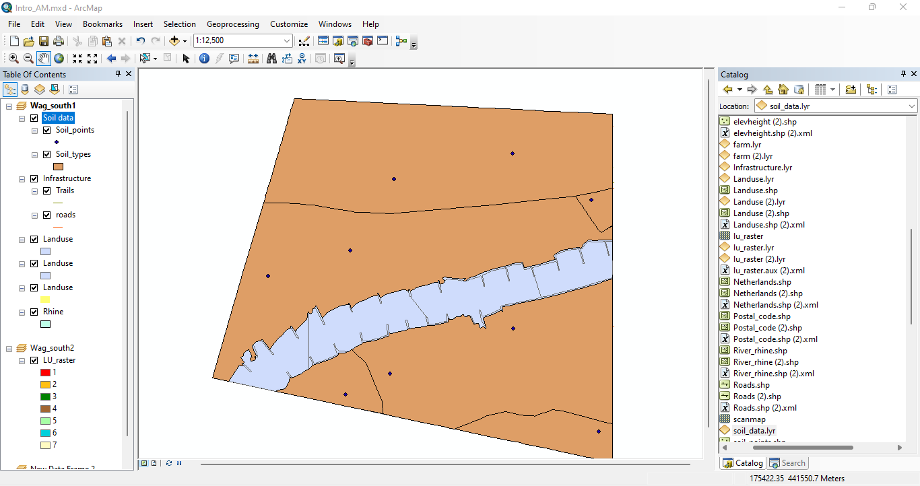

**9.E :** Roads and trails become visible because Solid data is deactivated since it was the primary data.

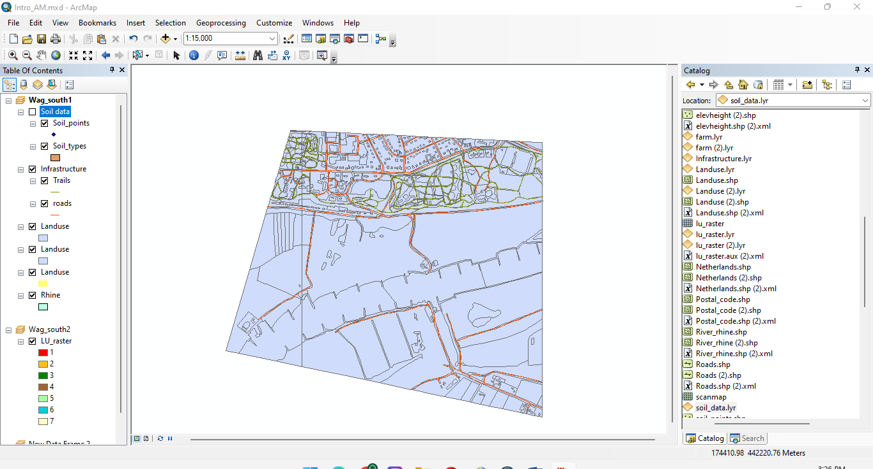

**9.F :**

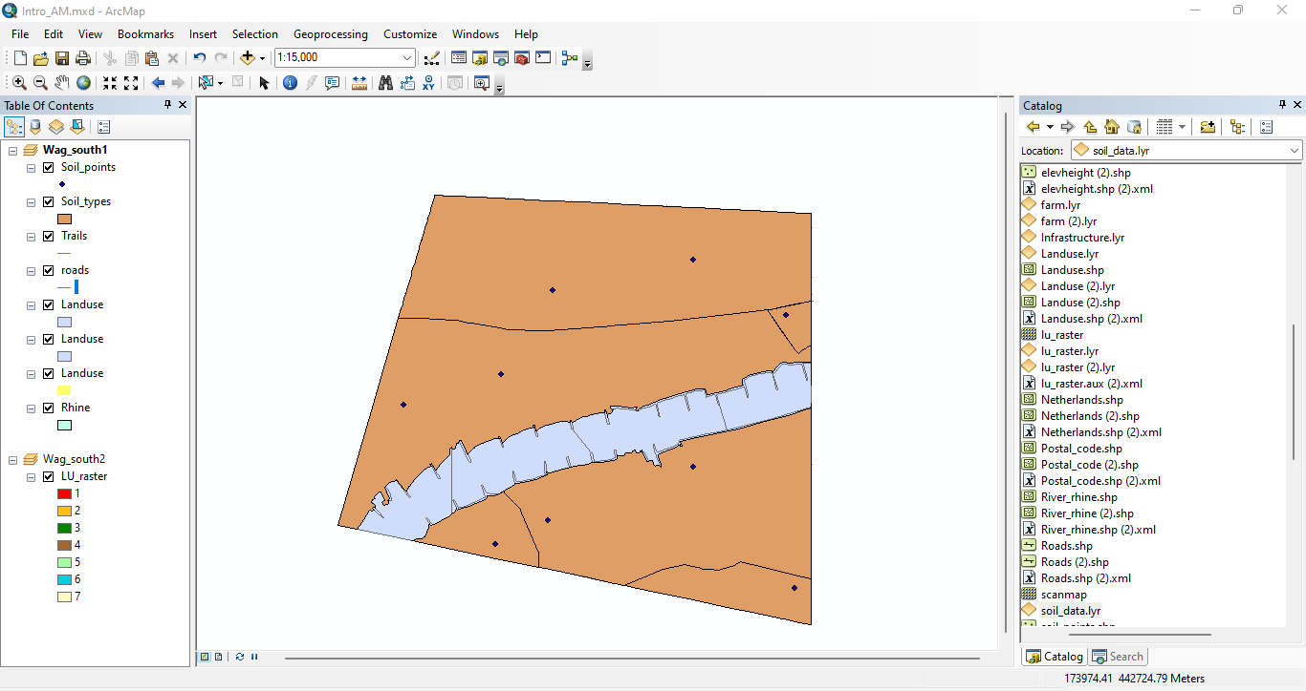

**9.G :**

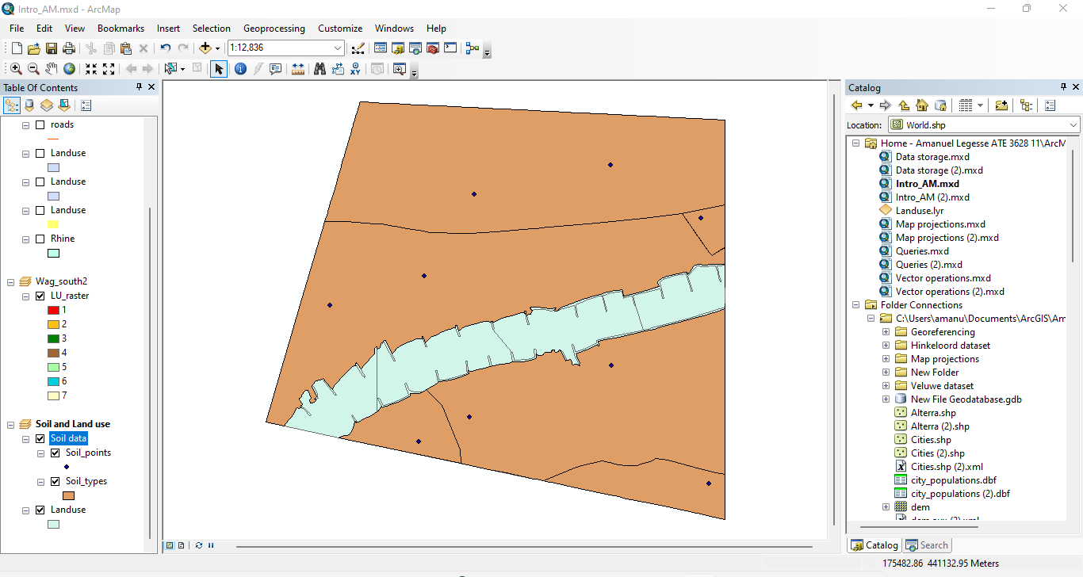

**9.G :** Removed the Data Frame ‘Soils and Land use’ from the ArcMap document.

**Zooming in and out**

**10.A :**

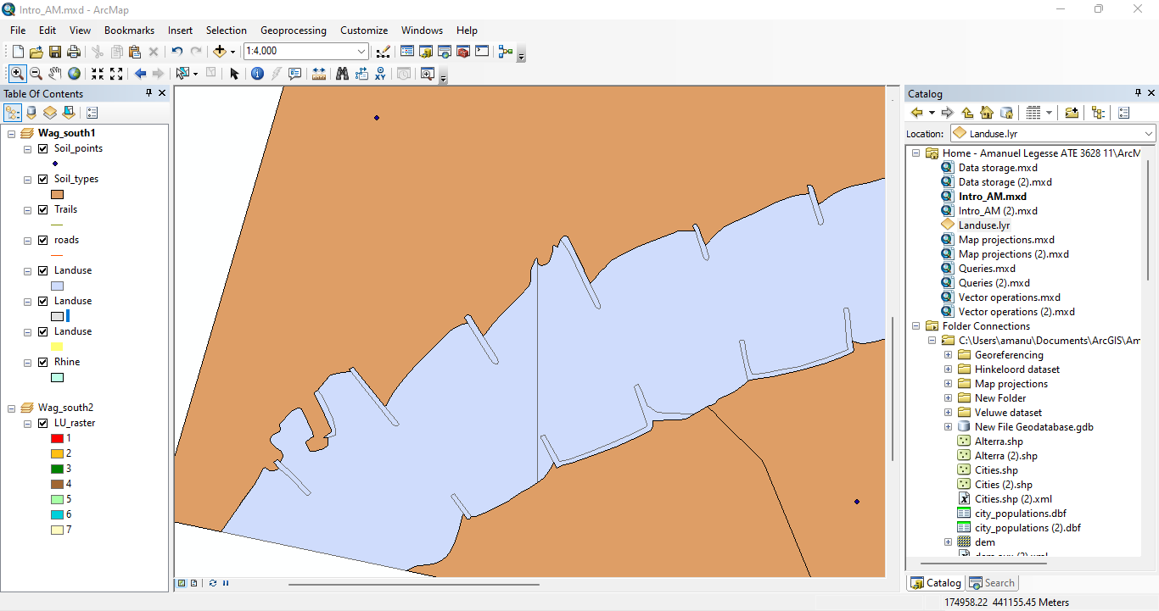

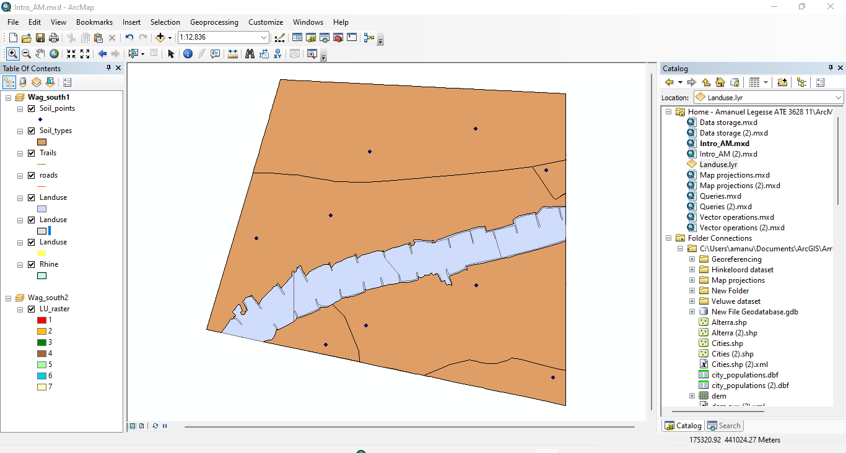

**Viewing a dataset’s attribute table**

**11.A :**

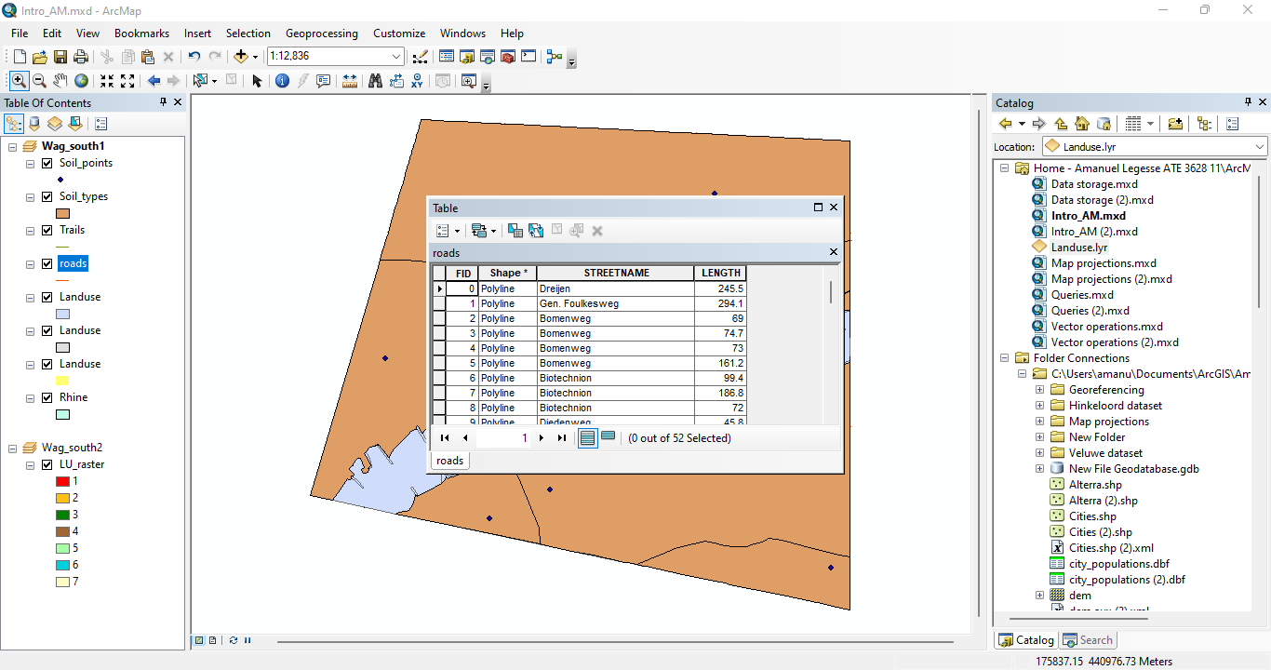

**A.1**

* The table contains a polyline feature type.

**A.2**

* There are 4 attributes. FID, shape, street name and length.

**A.3**

* The table contains 52 records.

**11.A.1 :**

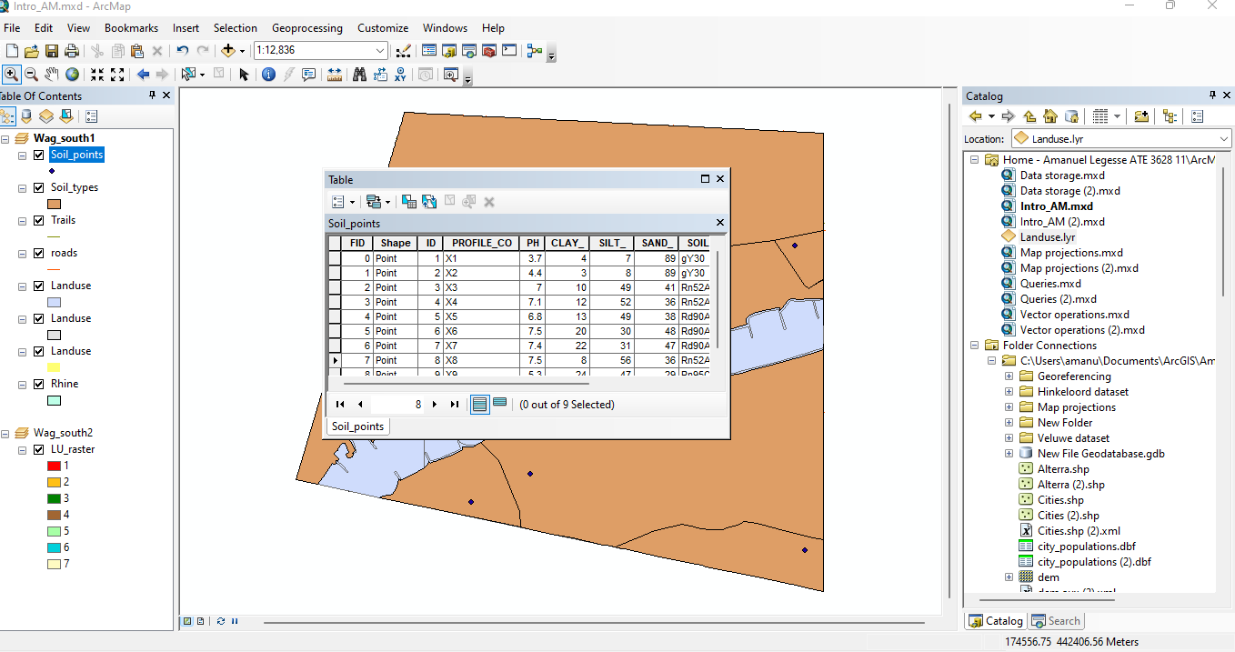

**B.1**

* The table contains a points feature type.

**B.2**

* There are 10 attributes. FID, ID, shape, profile_co, PPH, clay, silt, sand, soilcode and sc_ratio.

**B.3**

* The table contains 9 records.

**11.B.1 :**

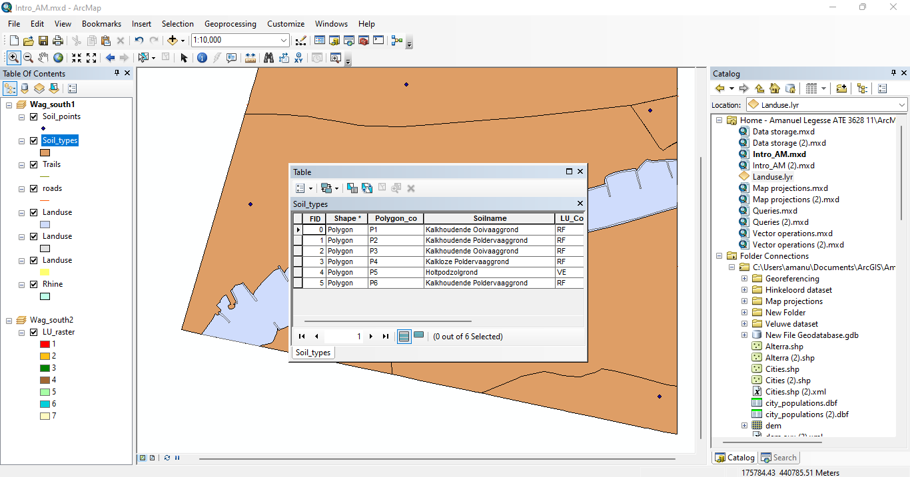

**B.1.1**

* The table contains a polygon feature type.

**B.2.1**

* There are 8 attributes. FID, ID, shape, polygon_co, soliname, solicode, lu_code, A.

**B.3.1**

* The table contains 6 records.

**11.C**

* Each column represents a field of the record. Rows and columns intersect to form cells, which contain a specific value for one field in a record.

**11.D :**

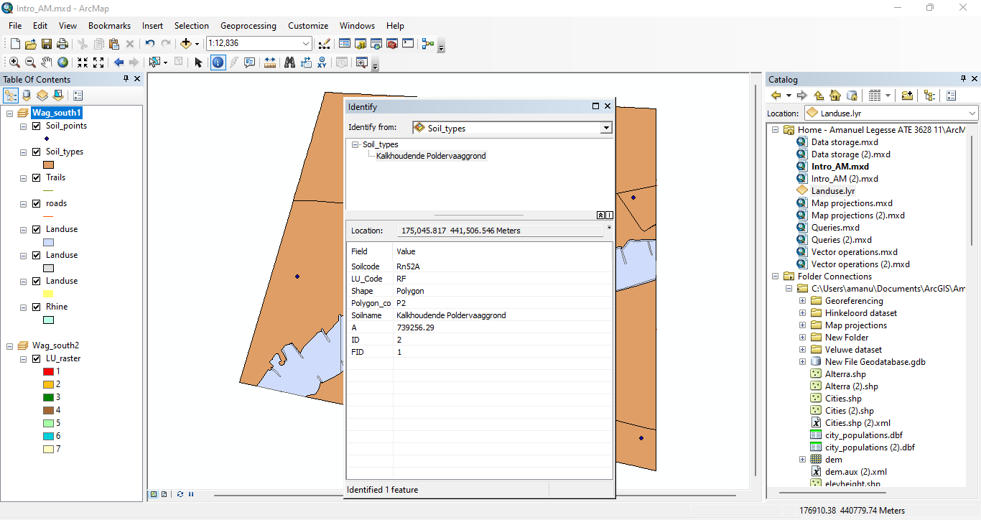

**12.A :**

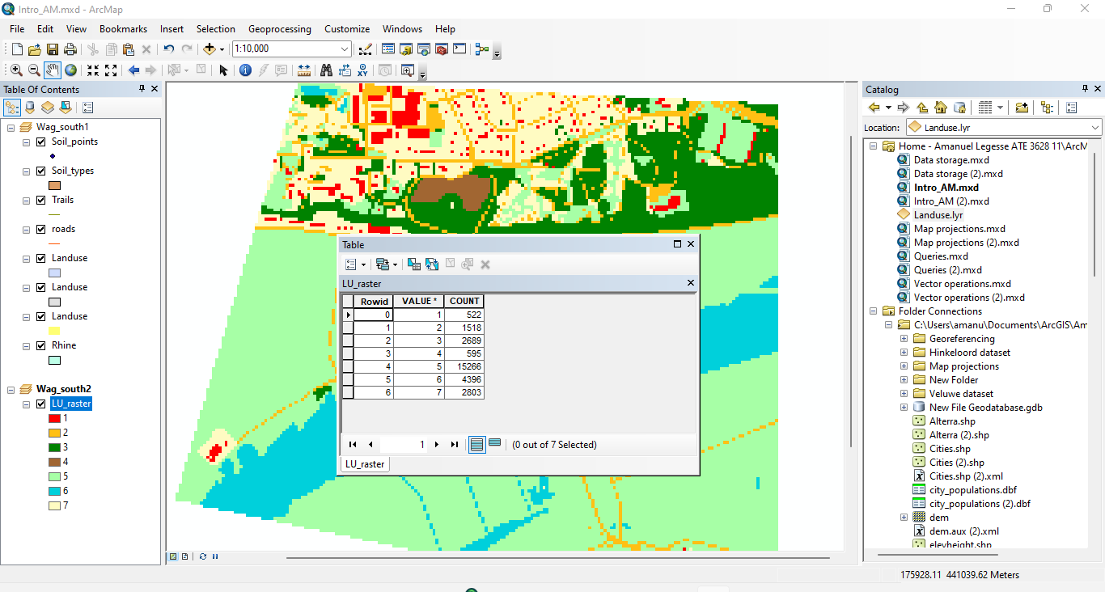

* There are 3 attributes. Rowid, Value and count.

**12.B:**

* The table contains 7 records.

**12.C:**

* **Count** command allows you to view the number of features in the map based on feature classes and subtypes.
* **Value** is a measurable quantity that may be passed to a function. Values are either assigned or determined by calculation.

**12.D :**

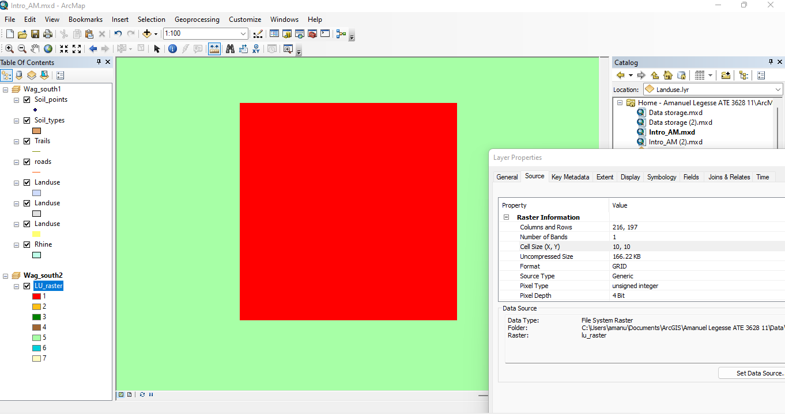

**Symbolizing spatial vector data**

**13.A :**

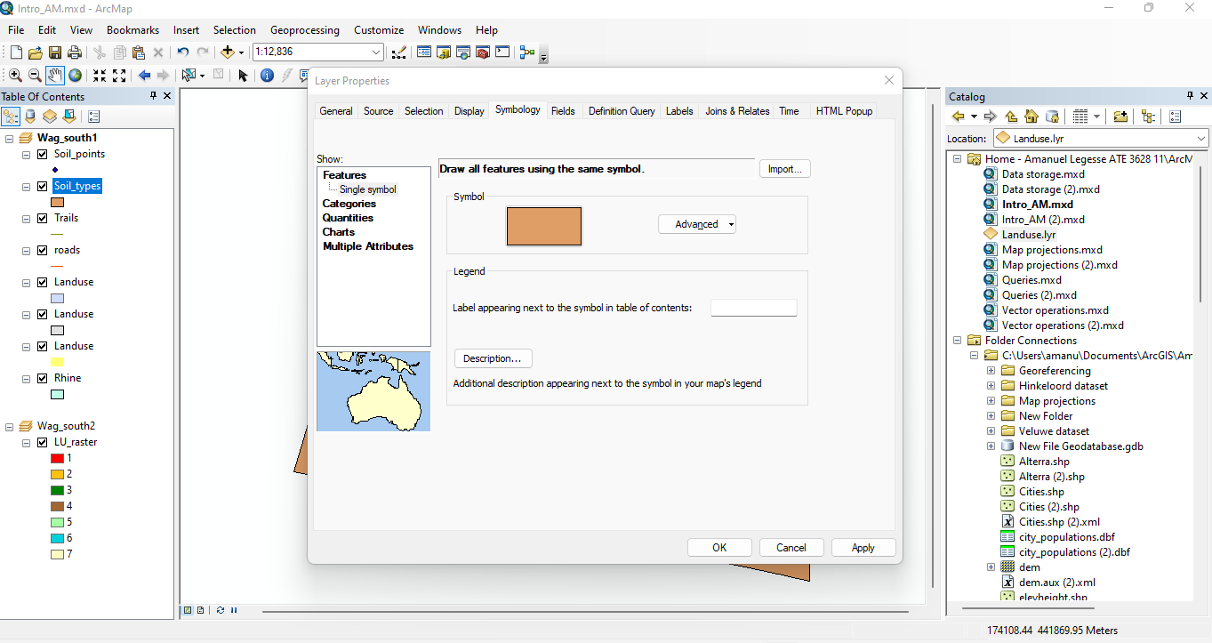

* The map type used is features.

**13.B :**

* I used the catagories – unique values map in order to choose the attribute to display on my map.

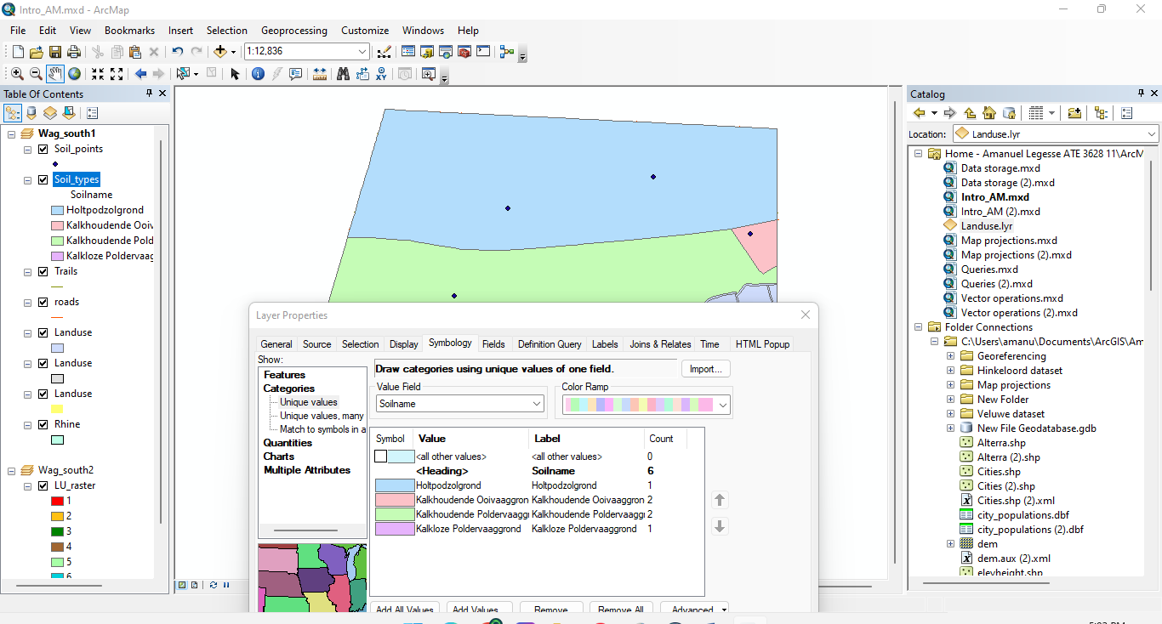

**13.C :**

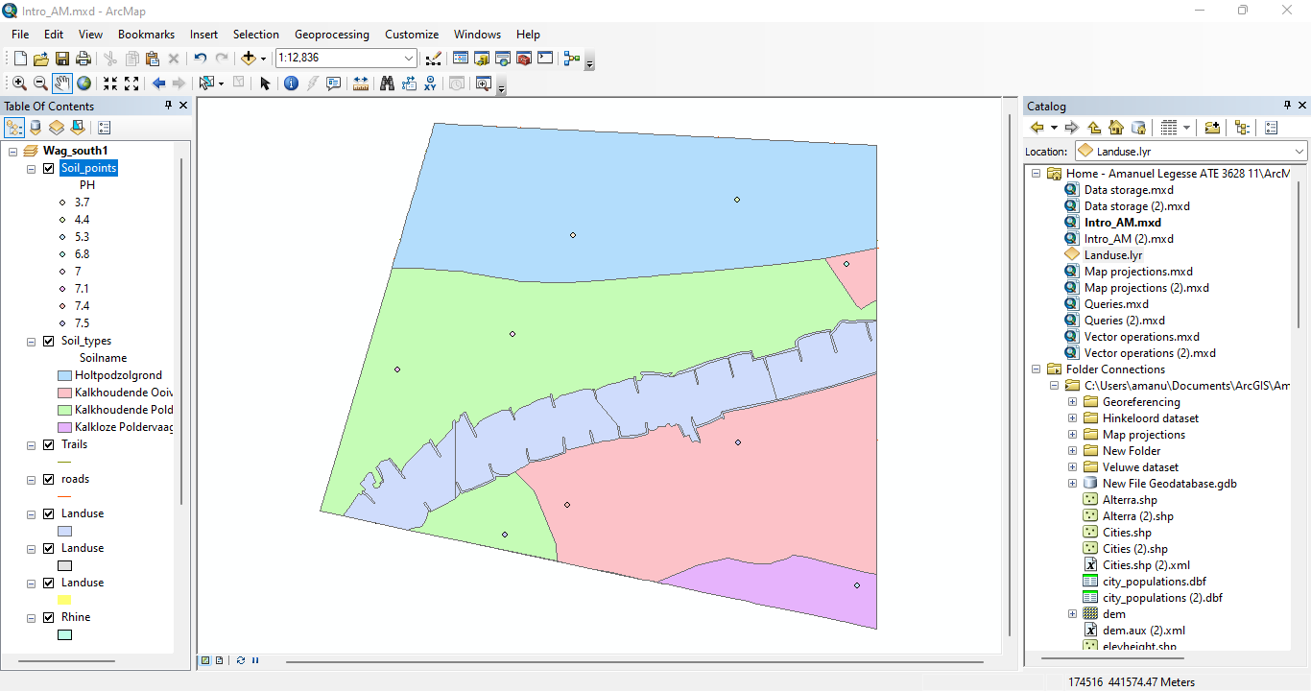

**13.D :**

* I used the catagories – unique values map in order to choose the attribute to display on my map.

**13.E :**

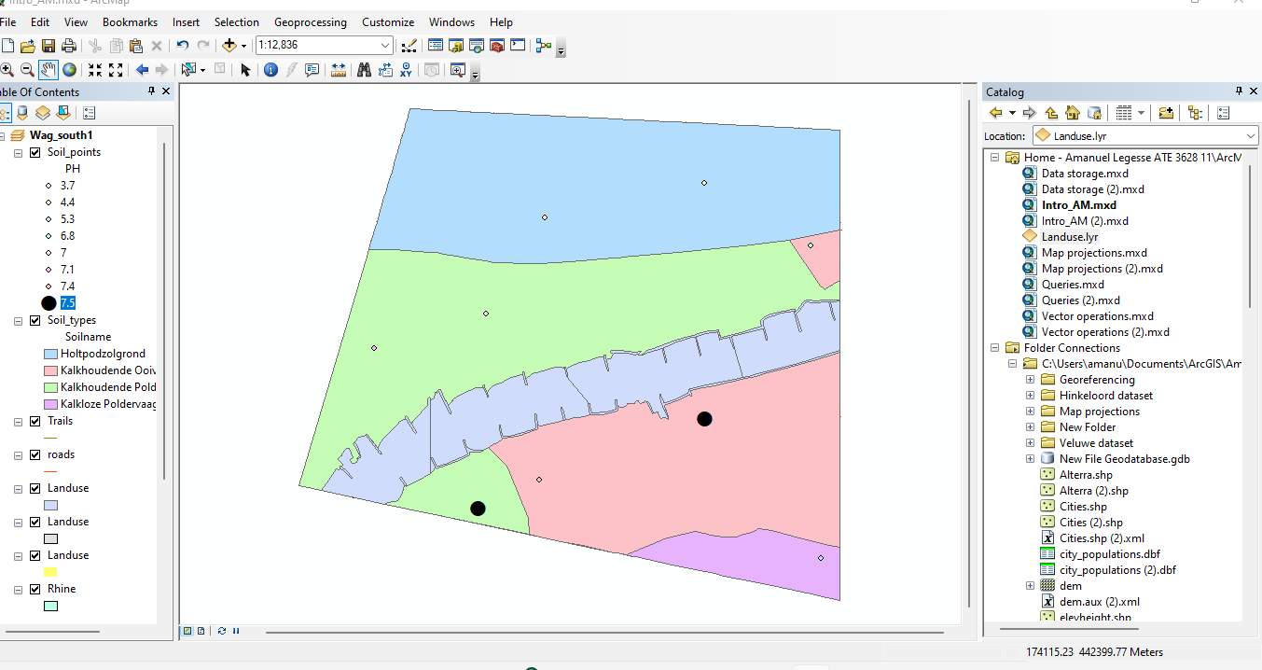

**14.A :** 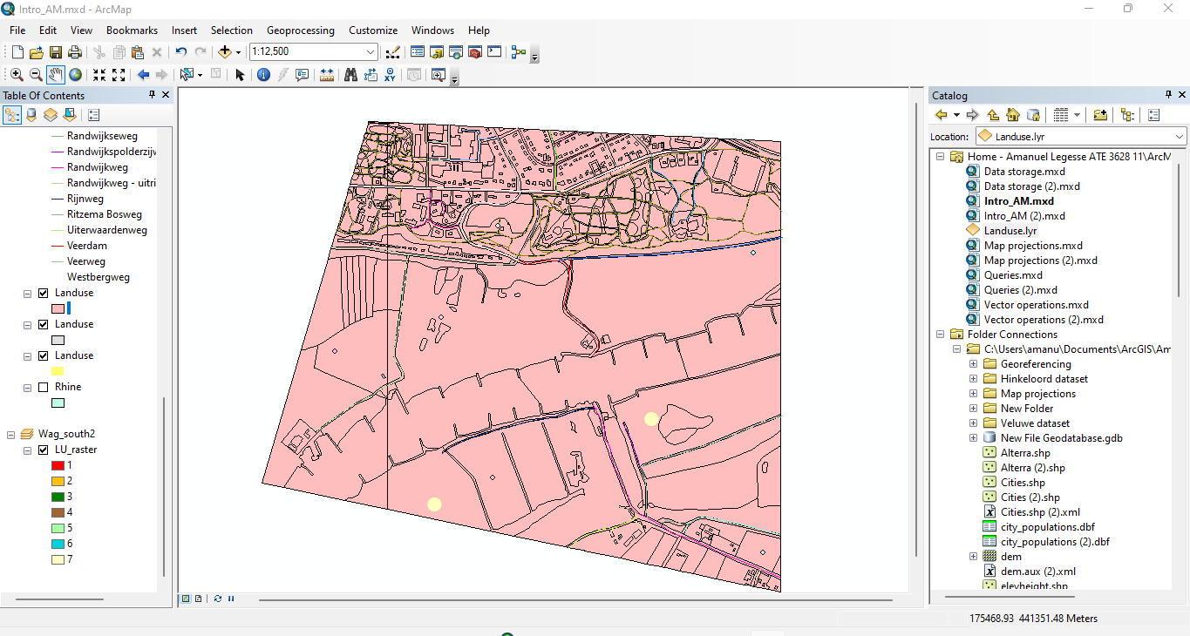

**14.B**

* The dataset contains 30 street names.

**14.C:**

* All the road features are polyline because features don’t depend on street names.

**15.A :**

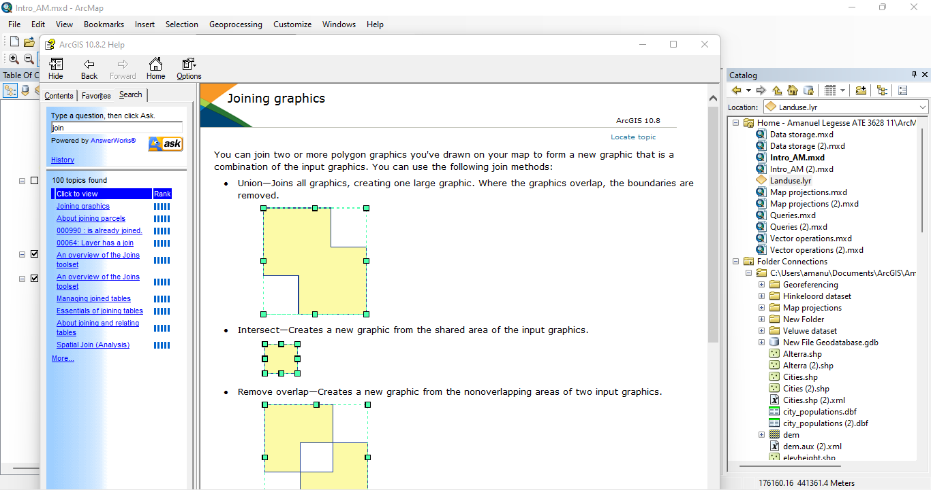

**15.B:**

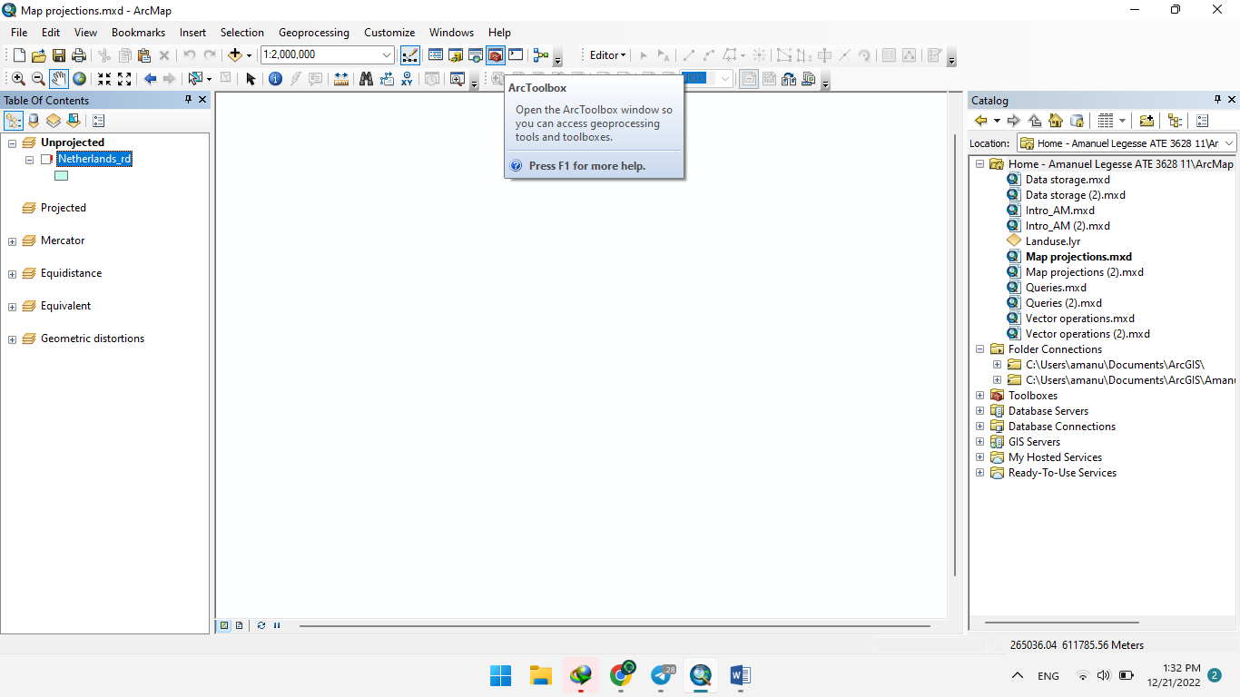

**ARC-GIS**

**EXCERCISE: 2**



**ACREATING A**

**DATASET**

* 1. 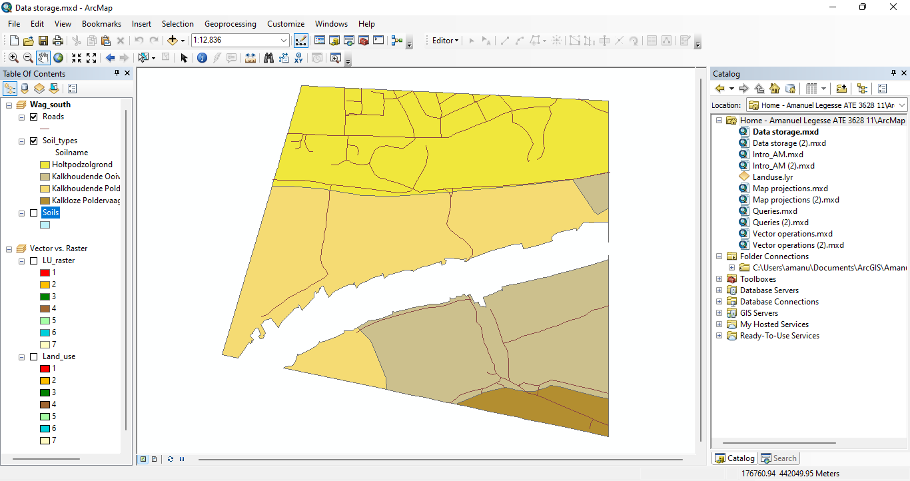:

**1.A**: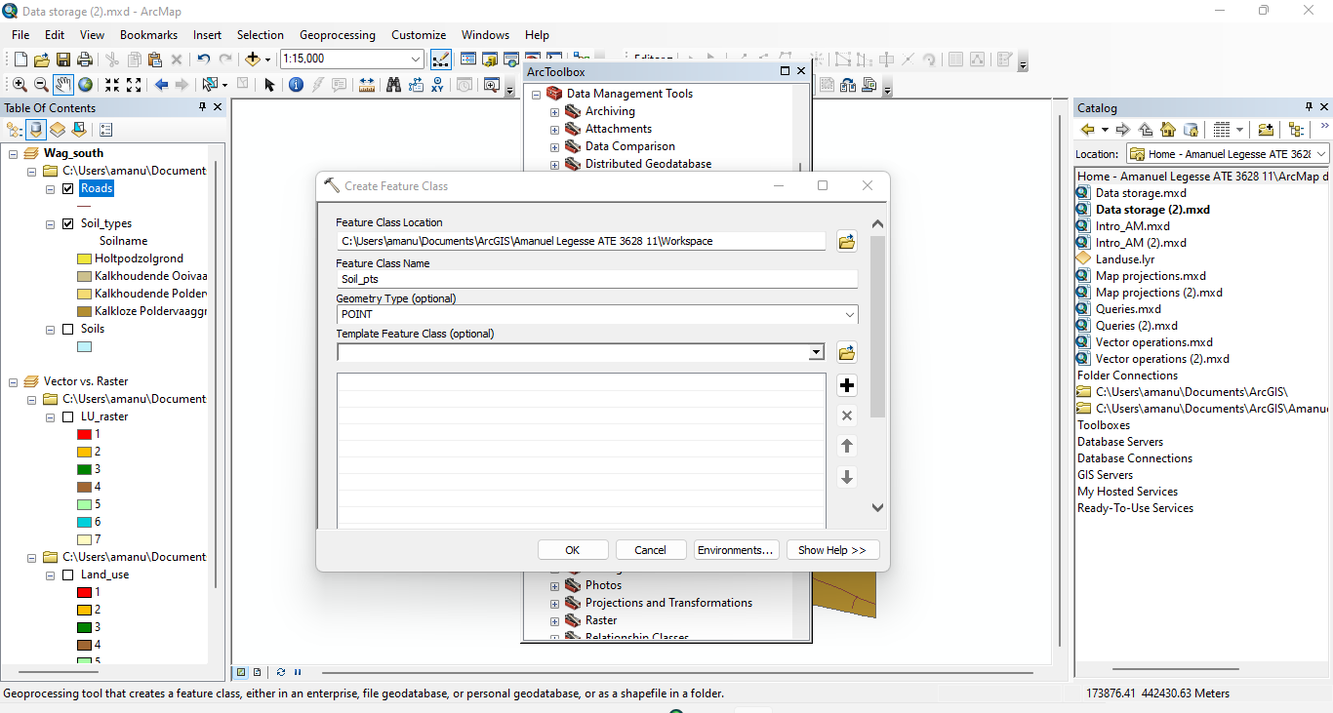

**1.B:**

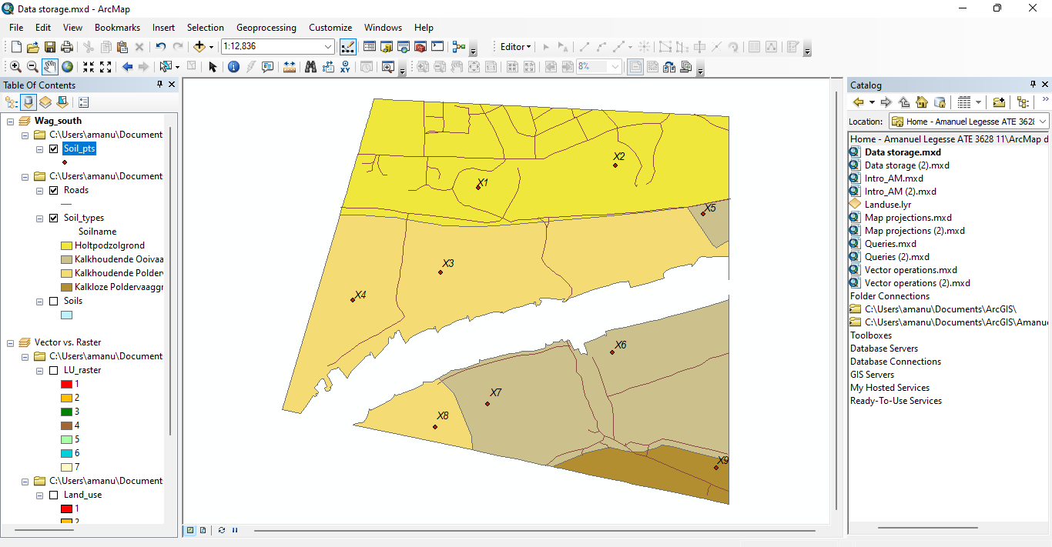

**1.C:**  The attribute table of dataset ‘Soil_pts’ contains 9 records.

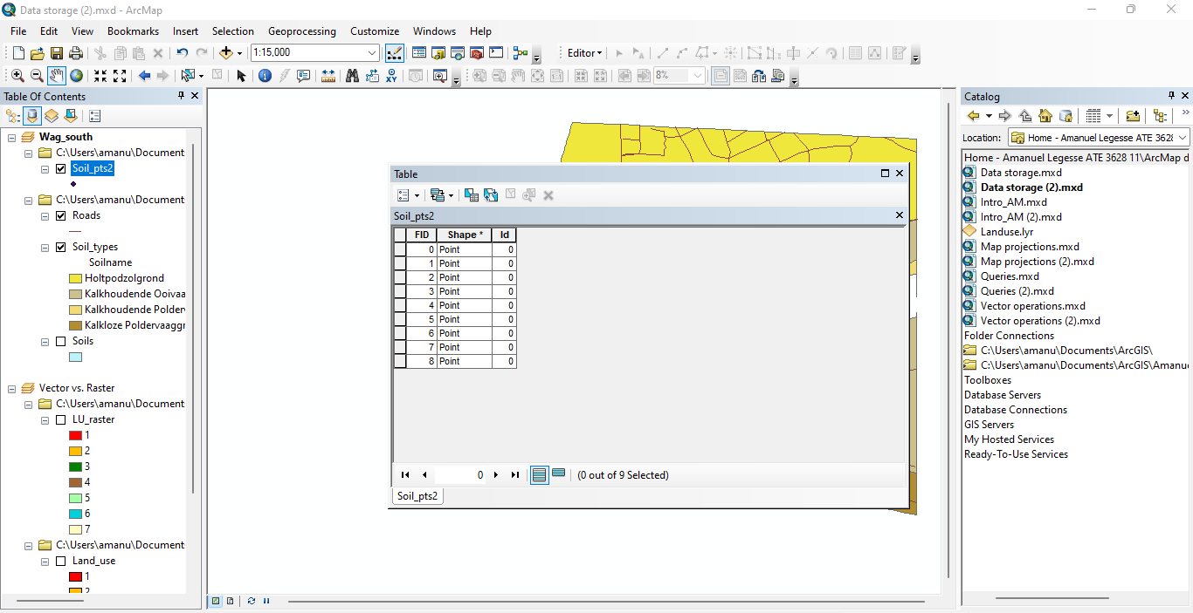

**Adding attributes to point features**

**2.A**

**FLOAT** - Numeric values with fractional values within a specific range

**Integer -** Numeric values without fractional values within specific range

**TEXT data** **-** Type stores any kind of text data. It can contain both single-byte and multi byte characters that the locale supports.

The date data type **can store dates, times, or dates and times**. The default format in which the information is presented is mm/dd/yyyy hh:mm:ss and a specification of AM or PM.

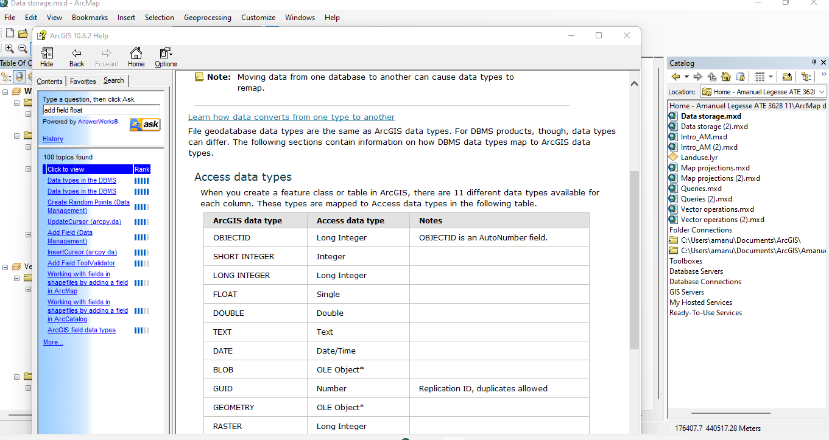

**2.B:**

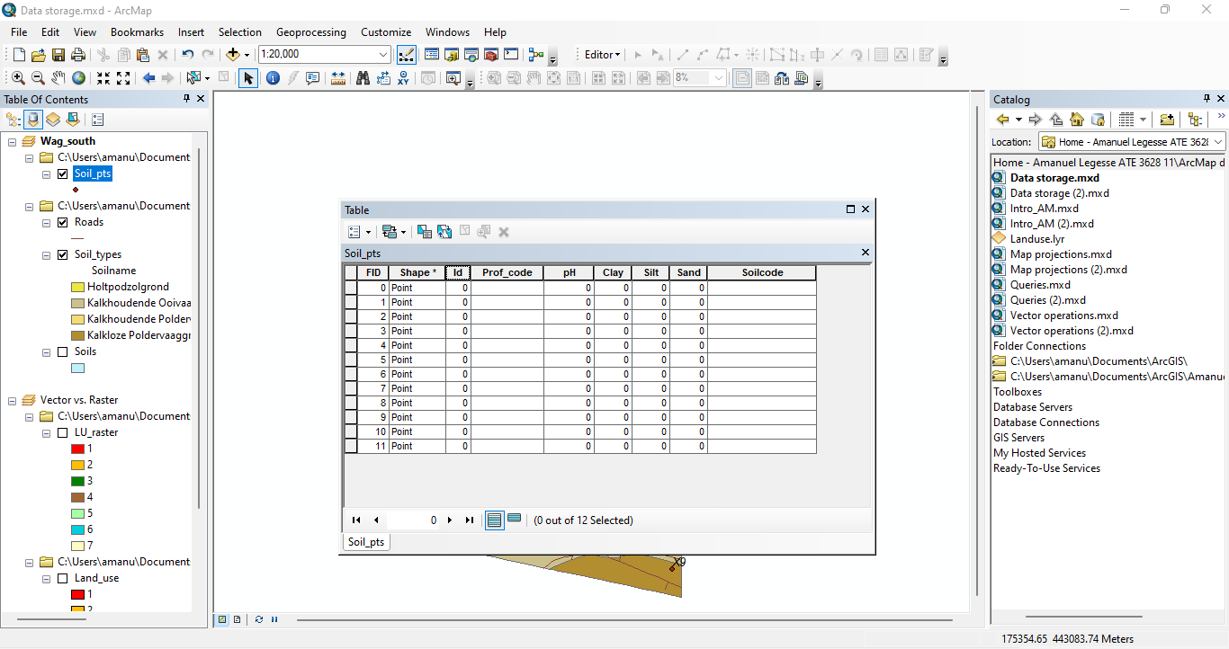

**2.C:**

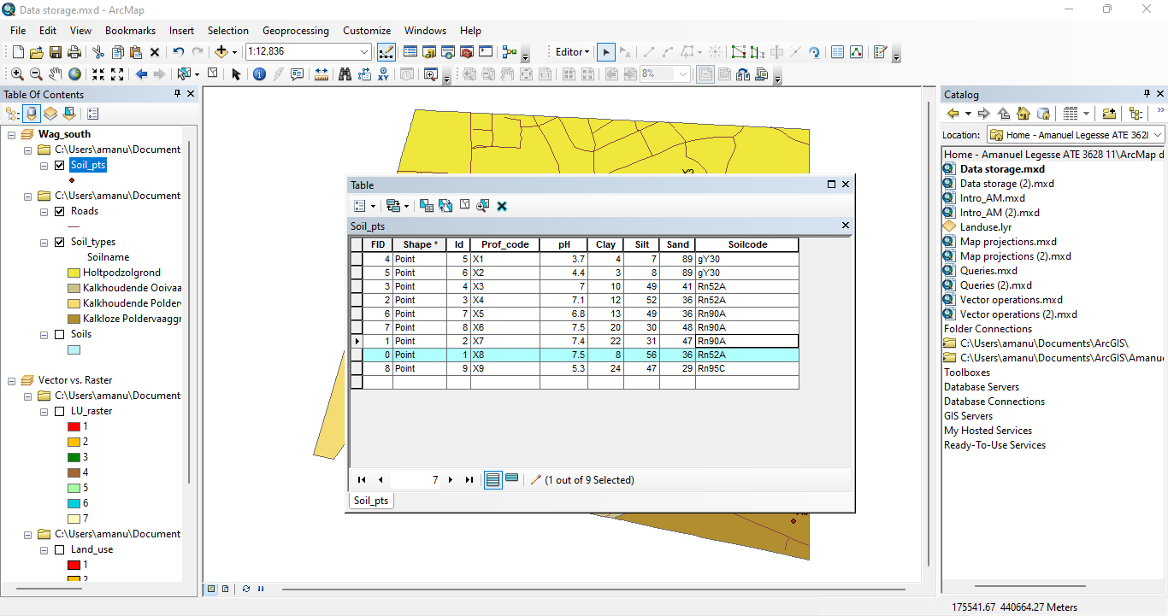

**Calculating the area of polygon features**

**3.A:**

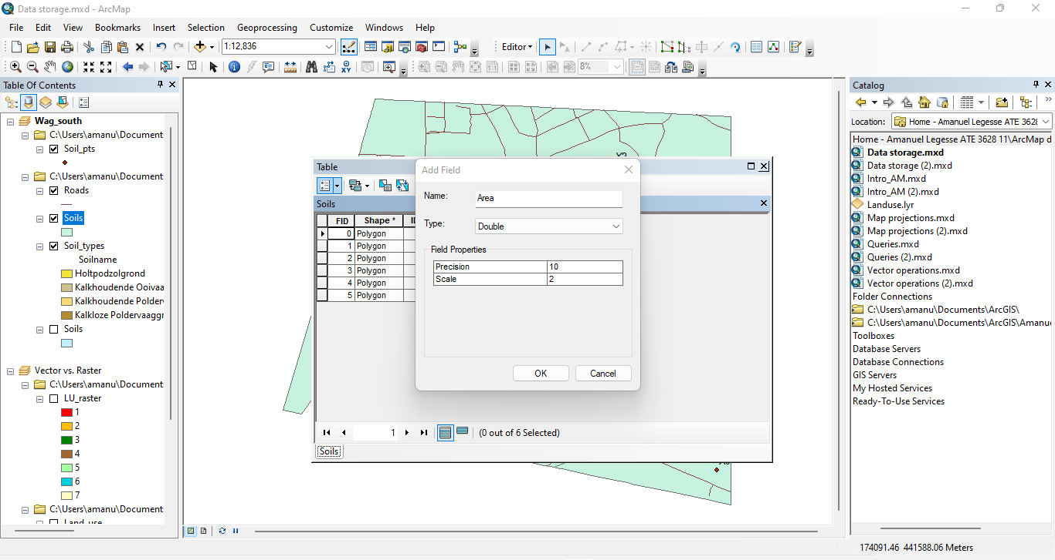

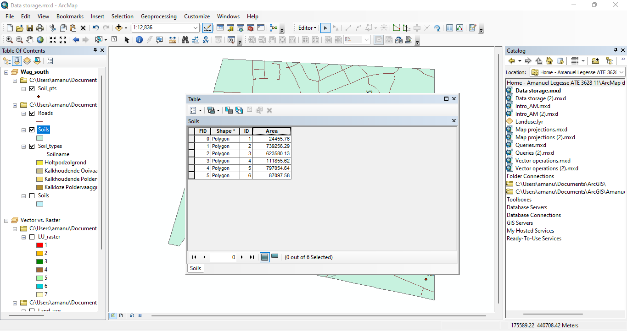

**Creating a new table**

**4.A:**

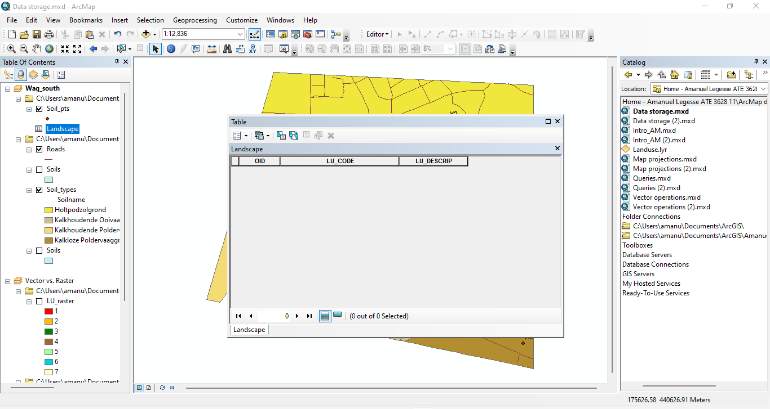

**4.B:**

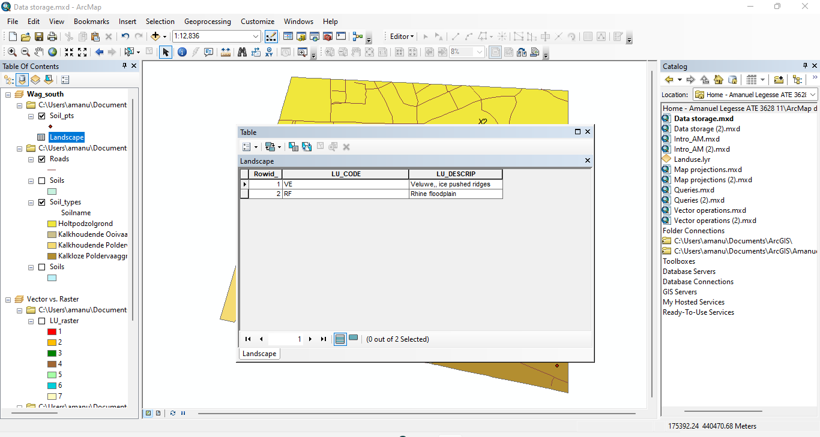

**Joining tables**

**5.A:**

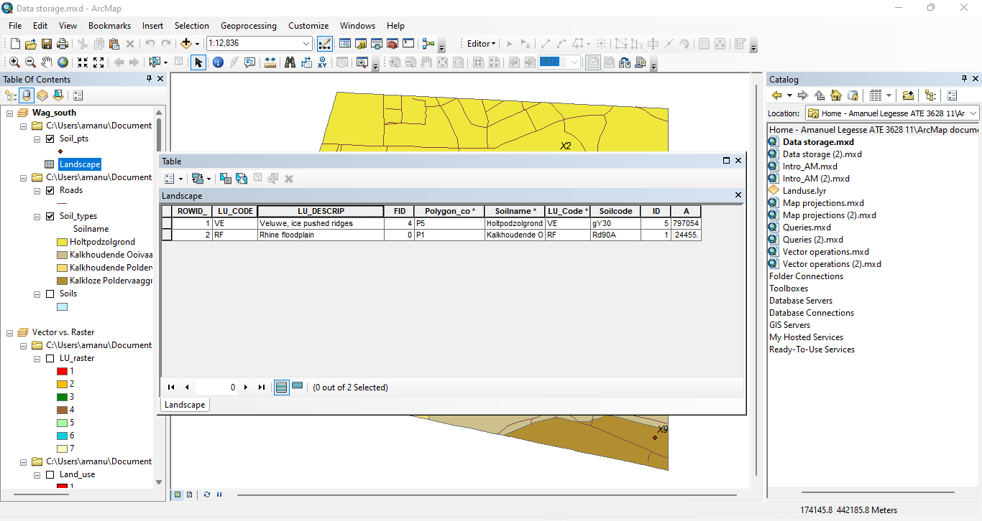

**5.B**

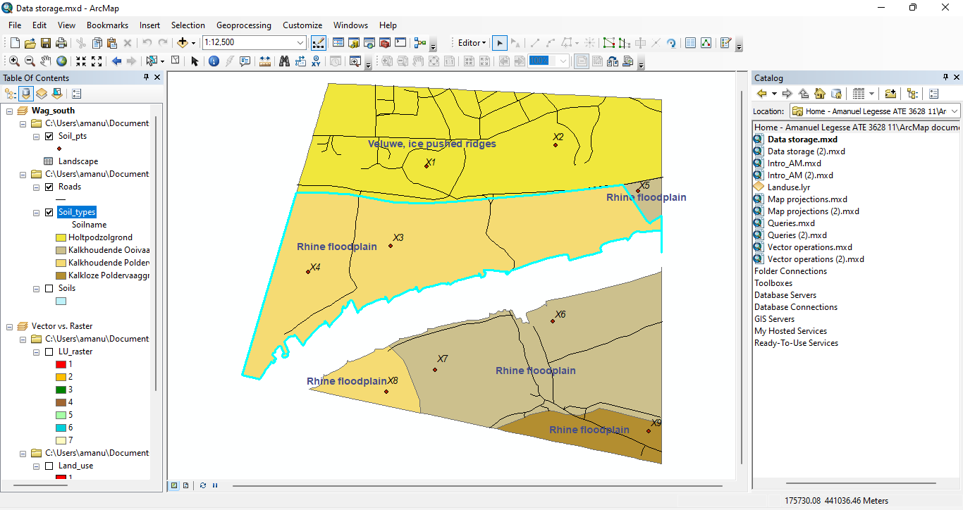

**Data structure of a raster dataset**

**6.A:** The raster attributes of ‘LU_raster’ are create out integer having an associated raster cell value attribute table.

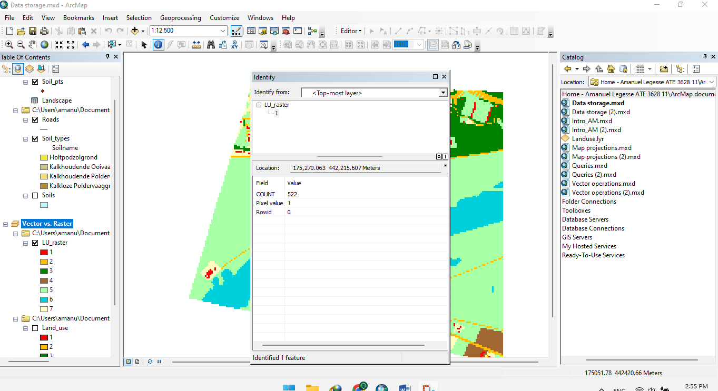

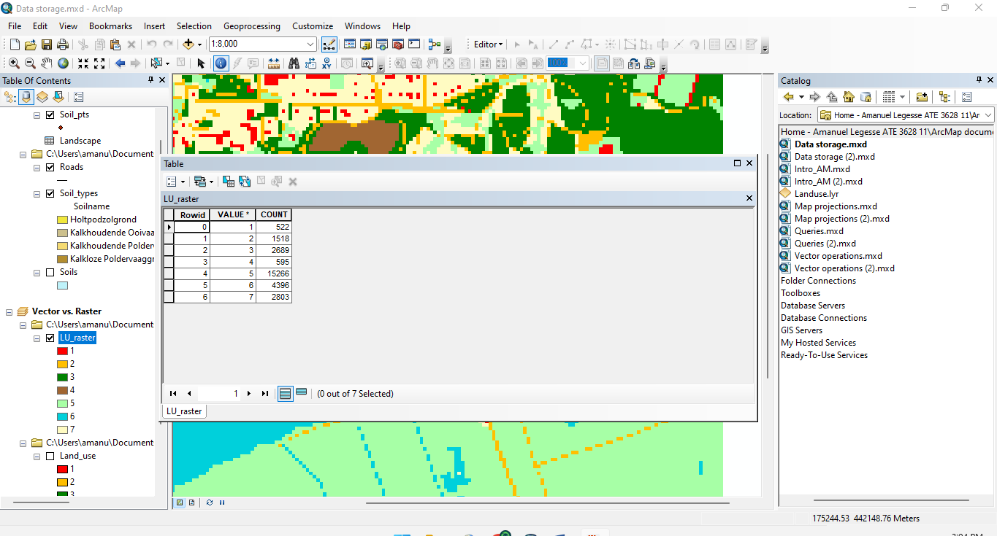

**6.B**: LU_raster is a discrete geographic features that have definable boundaries because it features lakes, lands, buildings, roads…

**6.C:** The attribute table of ‘LU_raster’ contains 7 values

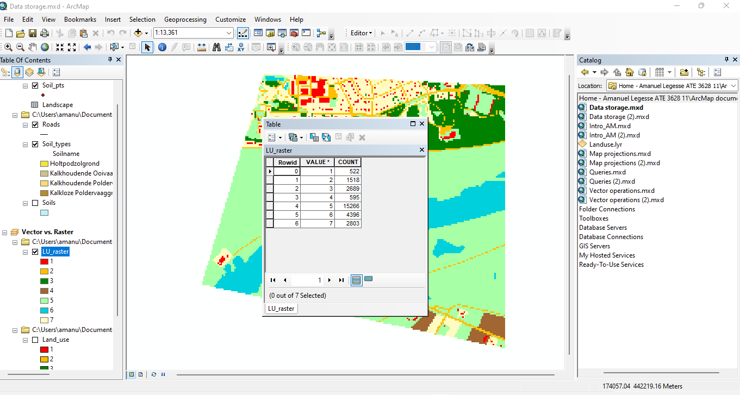

**Zone vs. region in raster**

**7.** Zones because it represent all geographic objects with the same value and in the attribute table the values represent the zones.

**8.** Land_Use is a type of attribute with fields specifying the area, perimeter and shape of the land mainly focusing on just the lands where Land_raster specifies the values and counts of that raster.

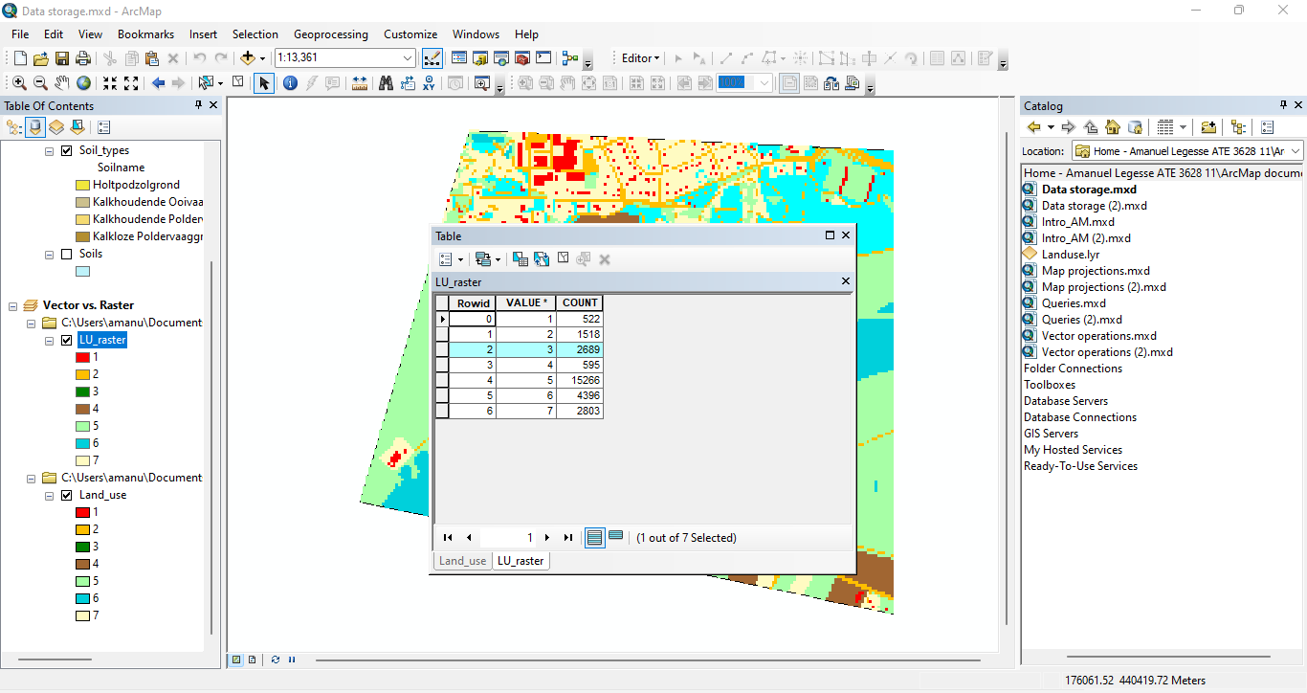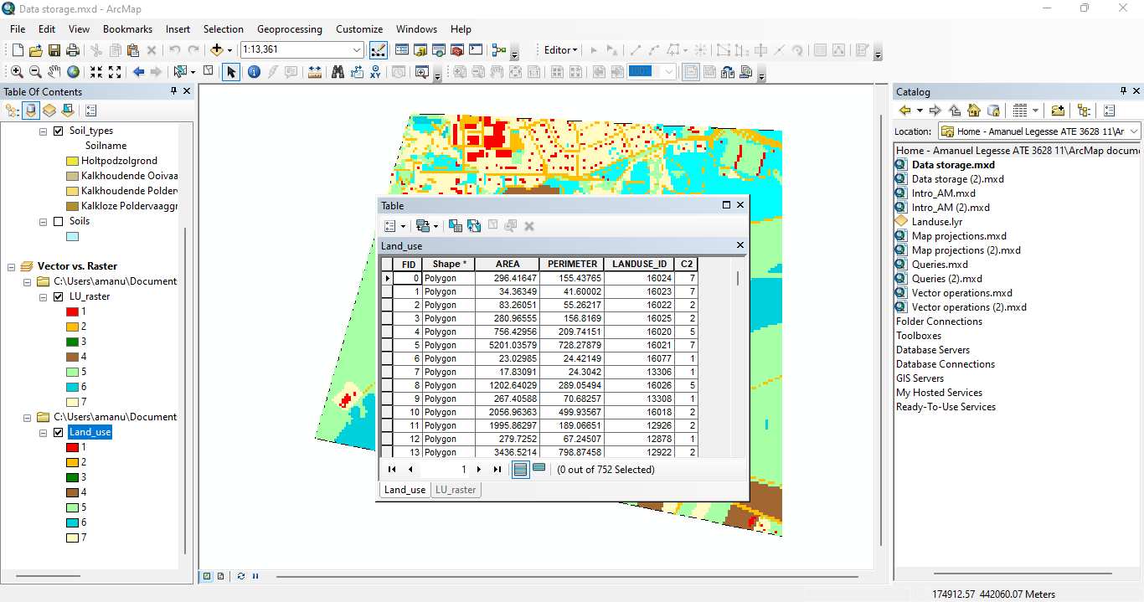

**ARC-GIS**

**EXCERCISE: 3**



**PROJECTING SPATIAL**

**DATASET**

**1.A:**

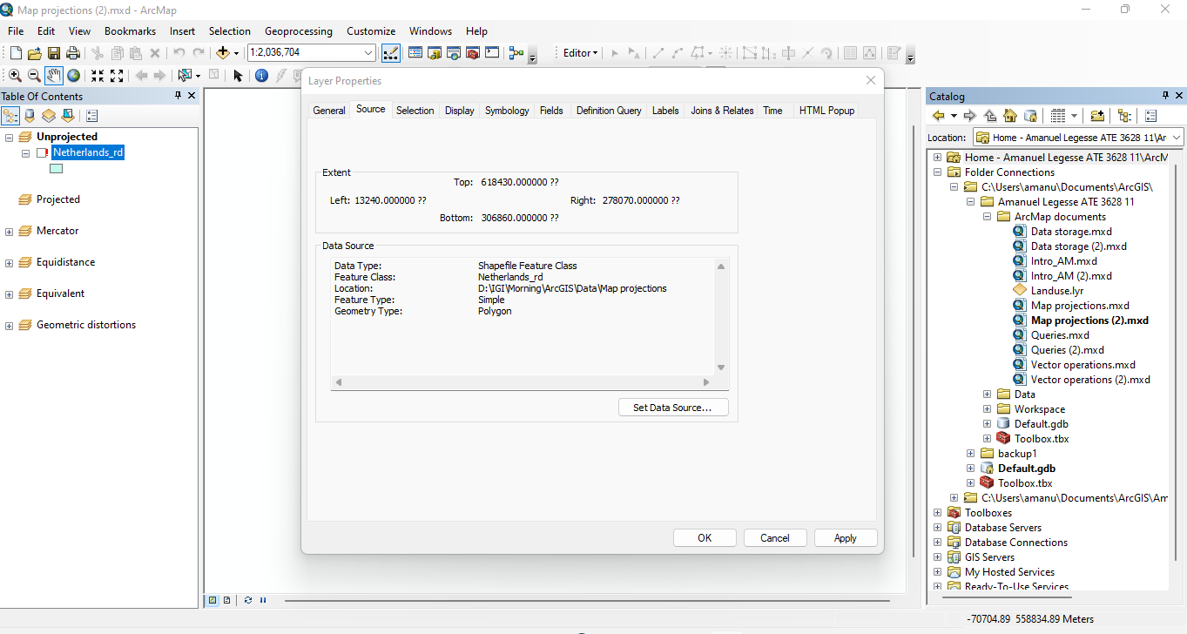

**1.B:**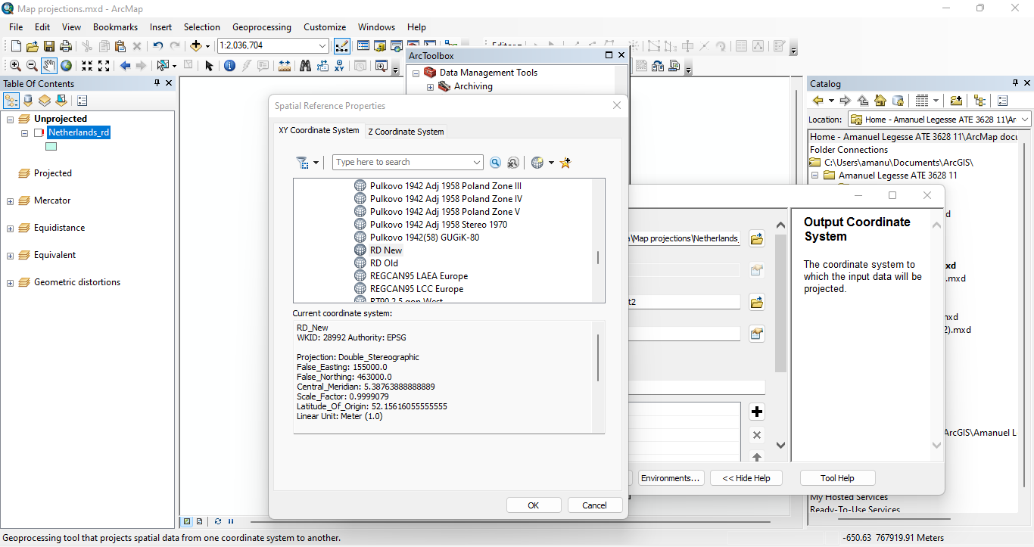

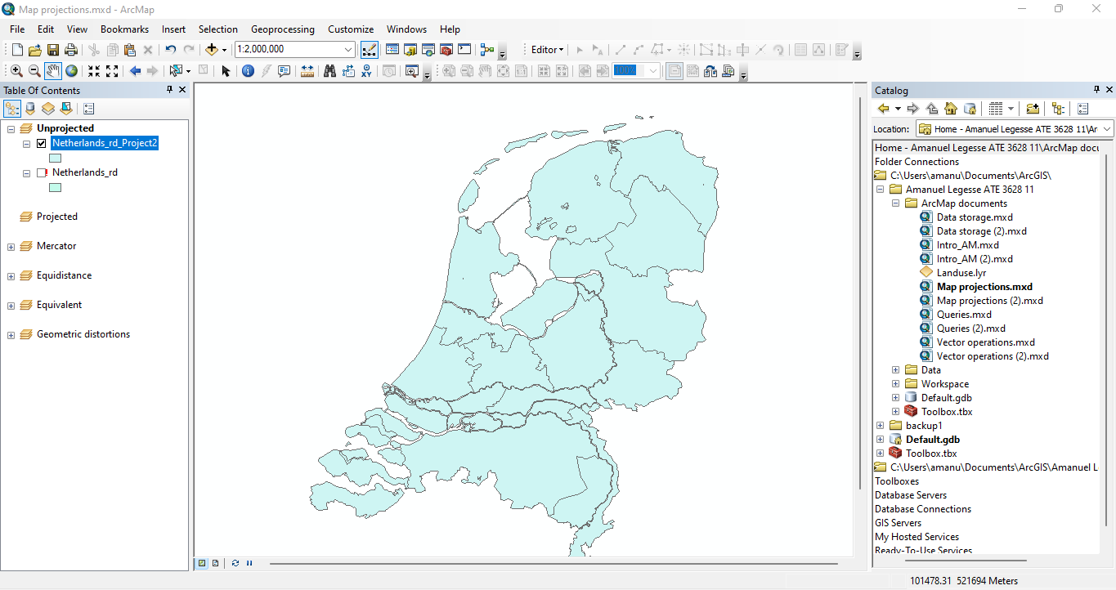

**1.C:** The projection is coordinate system based

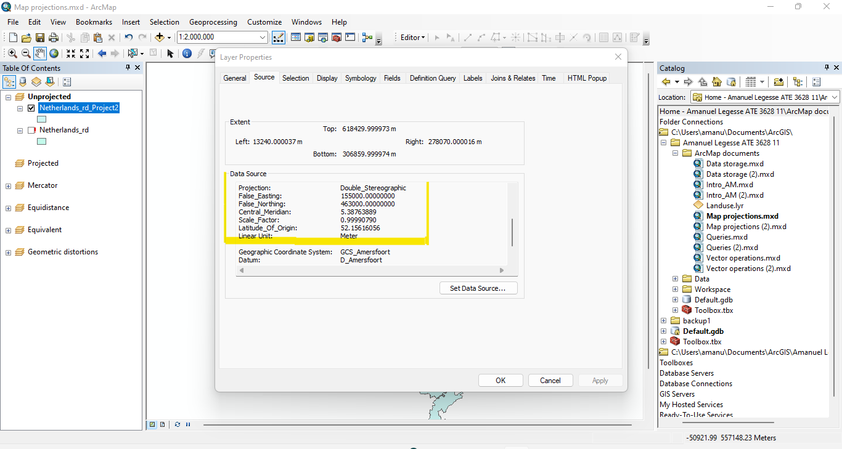

**1.D:**  The Linear unit is in Meter.

**Reprojecting spatial datasets**

**2.A:**

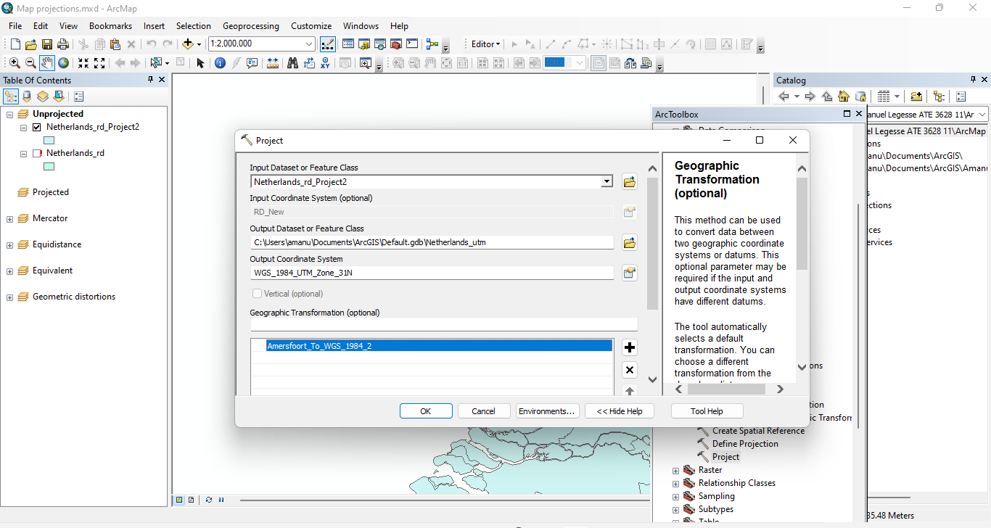

**2.B:**

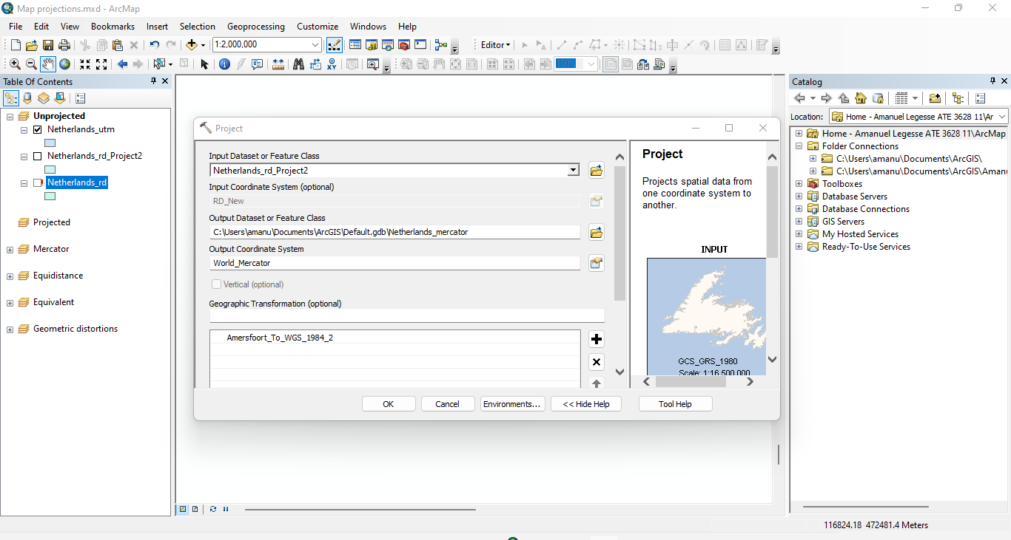

**2.C:** The three datasets don’t overlap because of their map projection towards the coordinate system placing each dataset in different parts of the world

(Example map projection UTM was placed in the Northern Hemisphere).

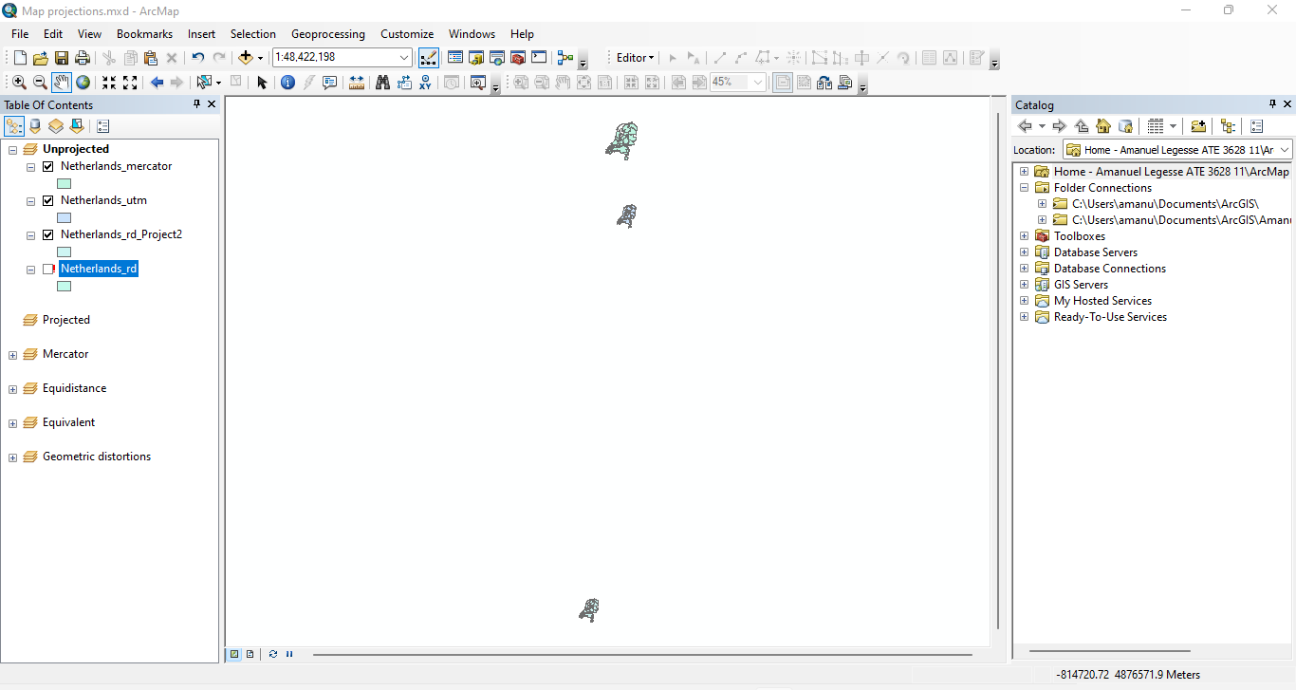

**Projection of the Data Frame**

**3.A:** As seen below after the projection of the Data Frame was changed to ‘RD New’ the map becomes in full view and clear.

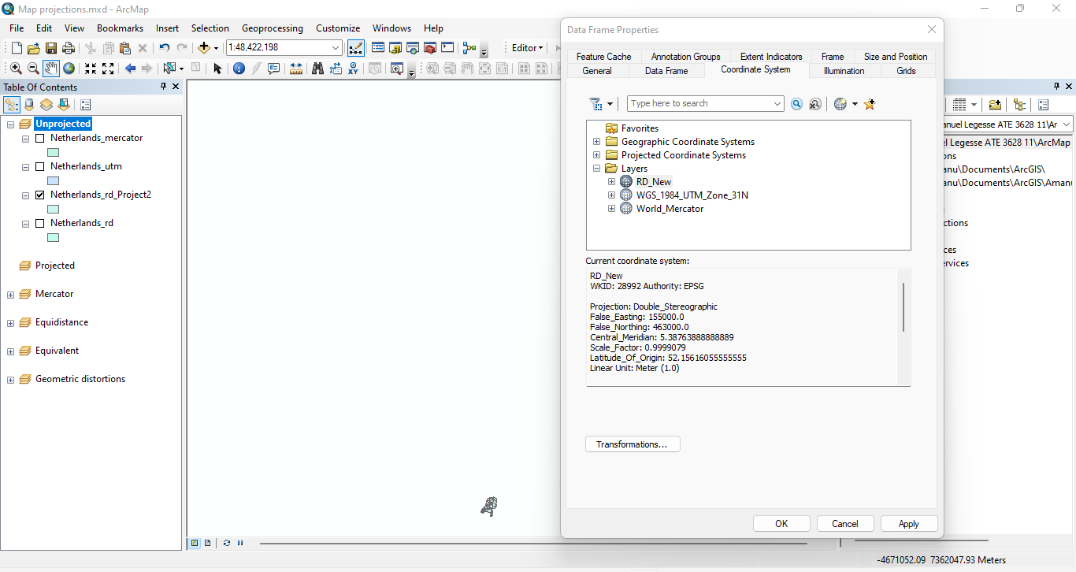

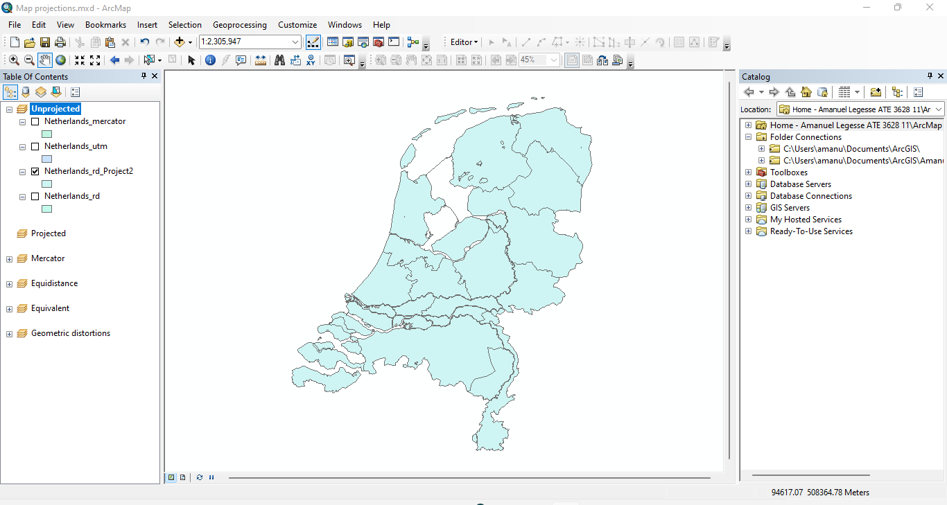

**3.B:** The is no coordinate system.

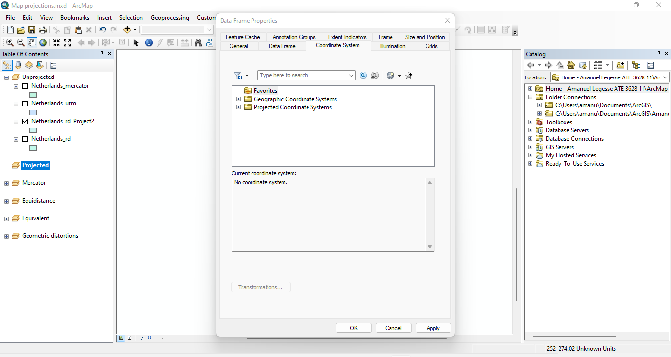

**3.C:**

* Projected Coordinate System: World_Mercator
* Projection: Mercator
* Geographic Coordinate System: GCS_WGS_1984

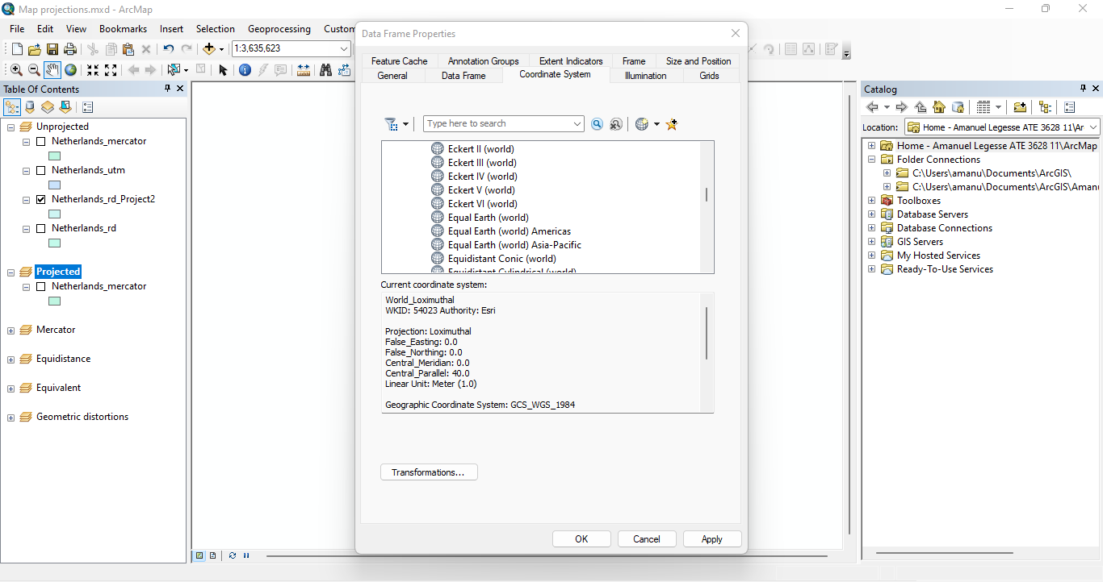

**3.D:**

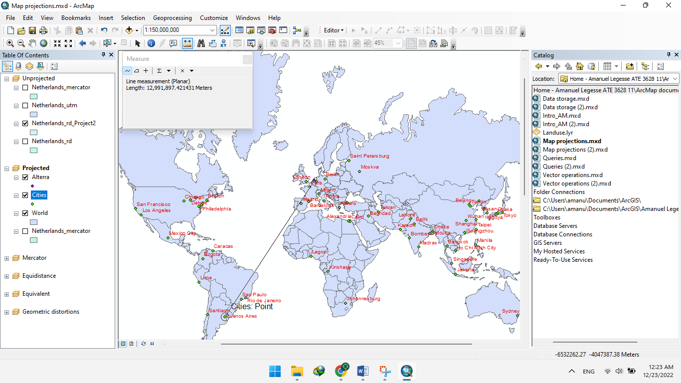

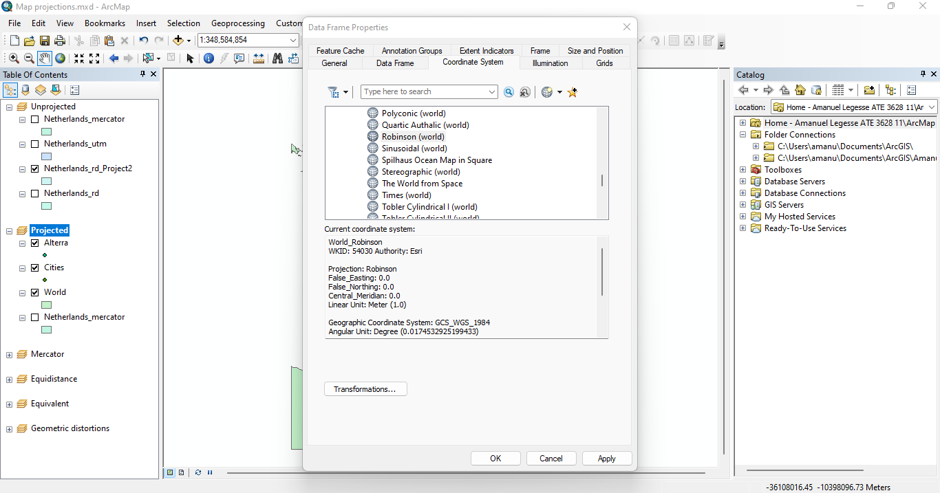

* Yes the distance differ from the previous measurement because the projected coordinate system was changed to Robinson.

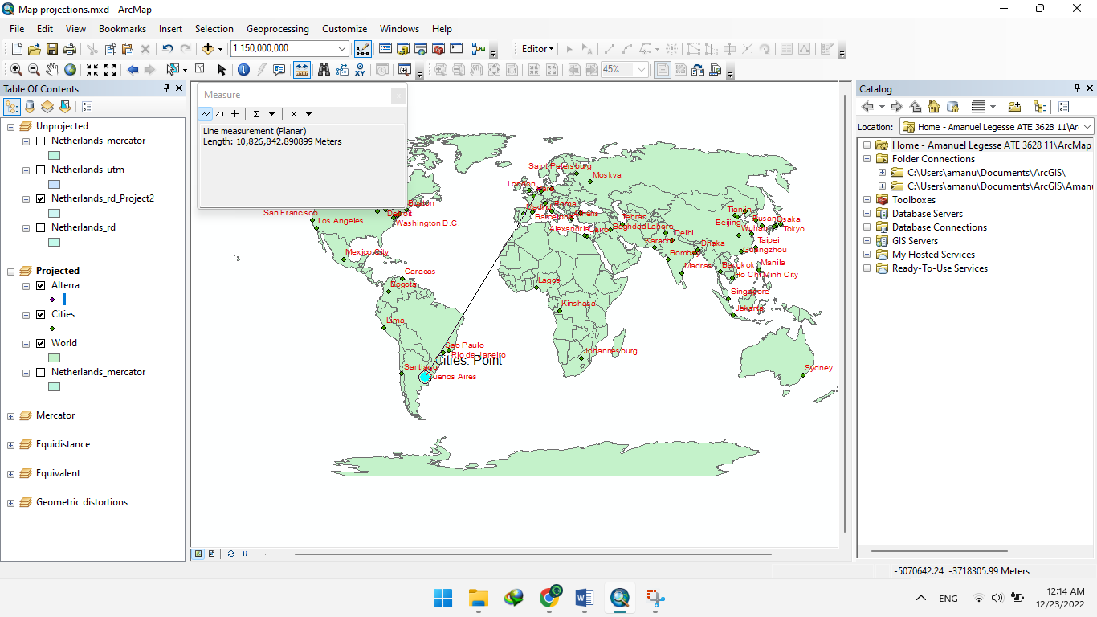

**Geometric distortions**

**4.A: Mercator**

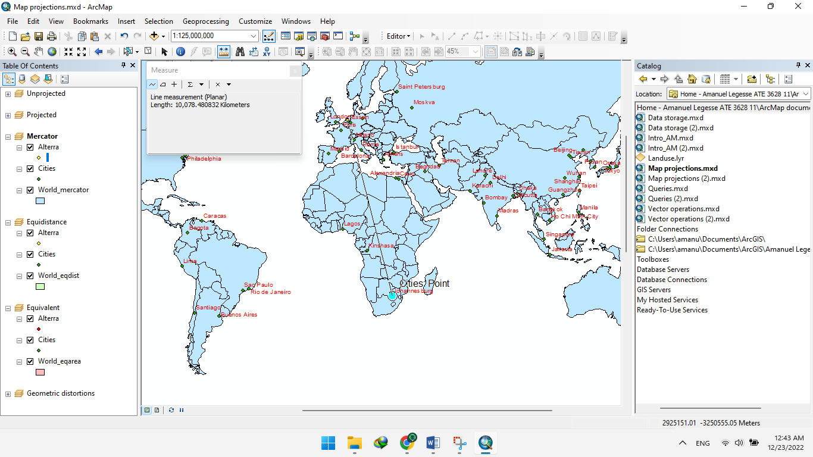

**Figure:** Alterra – Johannesburg (km)

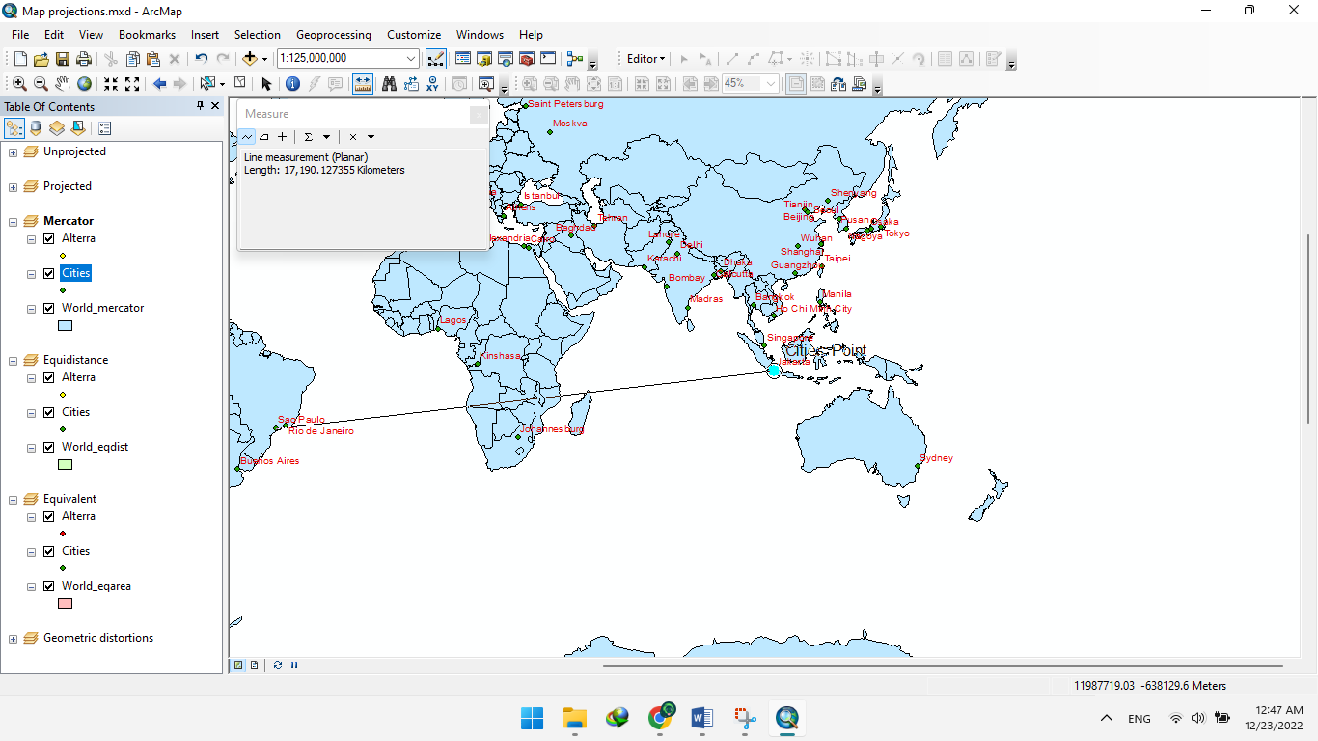

**Figure:** São Paulo – Jakarta (km)

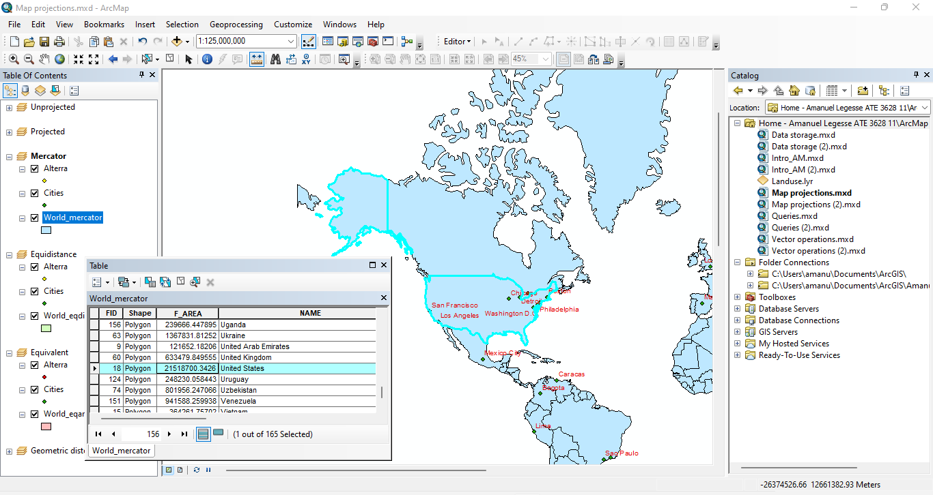

**Figure:** Area USA (km²)

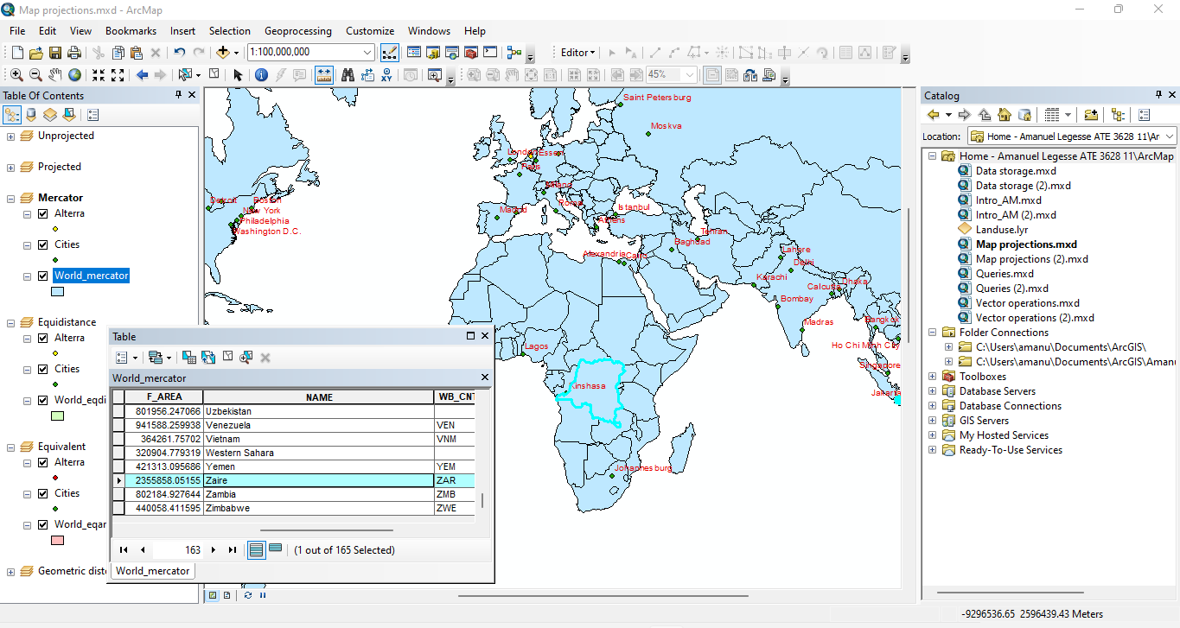

**Figure:** Area Dem. Rep. Congo (km²)

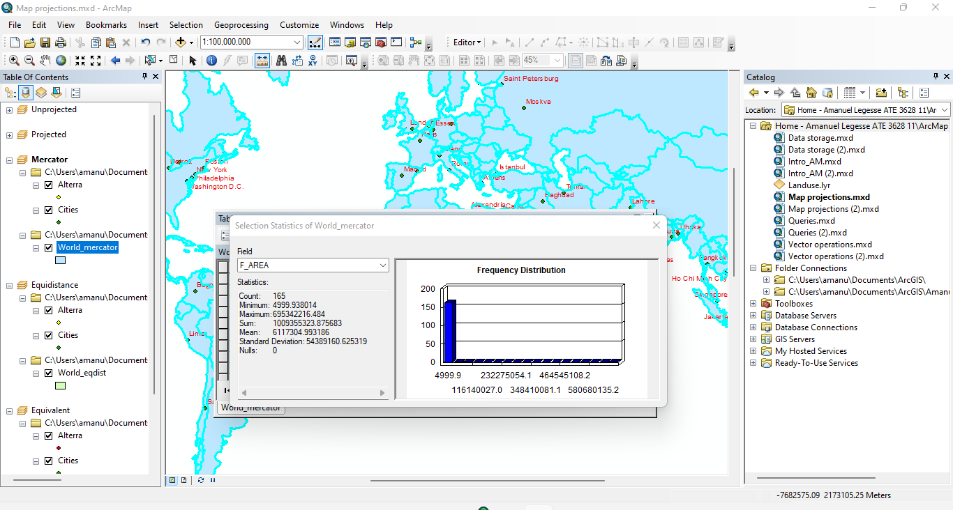

**Figure:** Area World (km²)

**4.B: Equidistant**

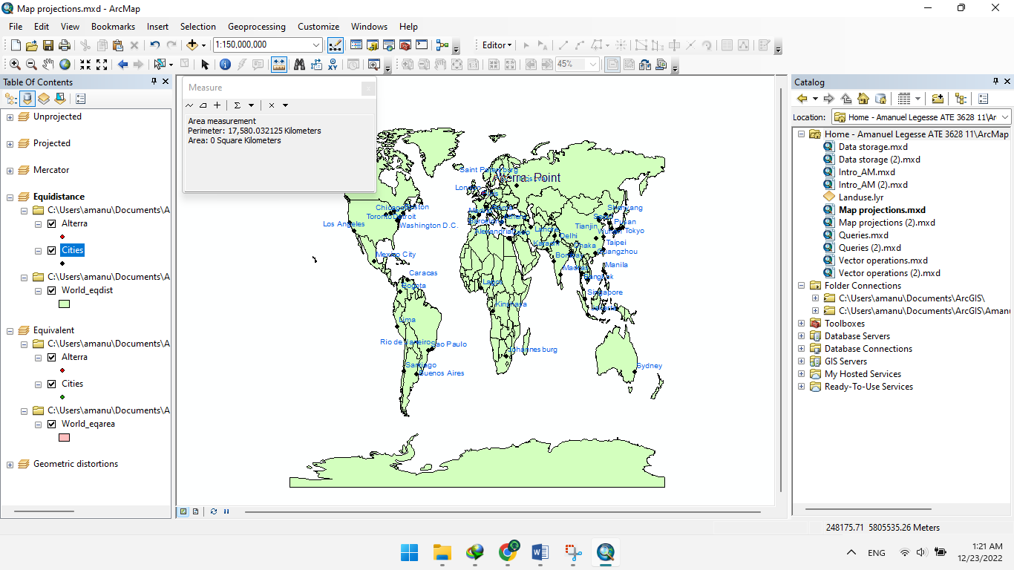

**Figure:** Alterra – Johannesburg (km)

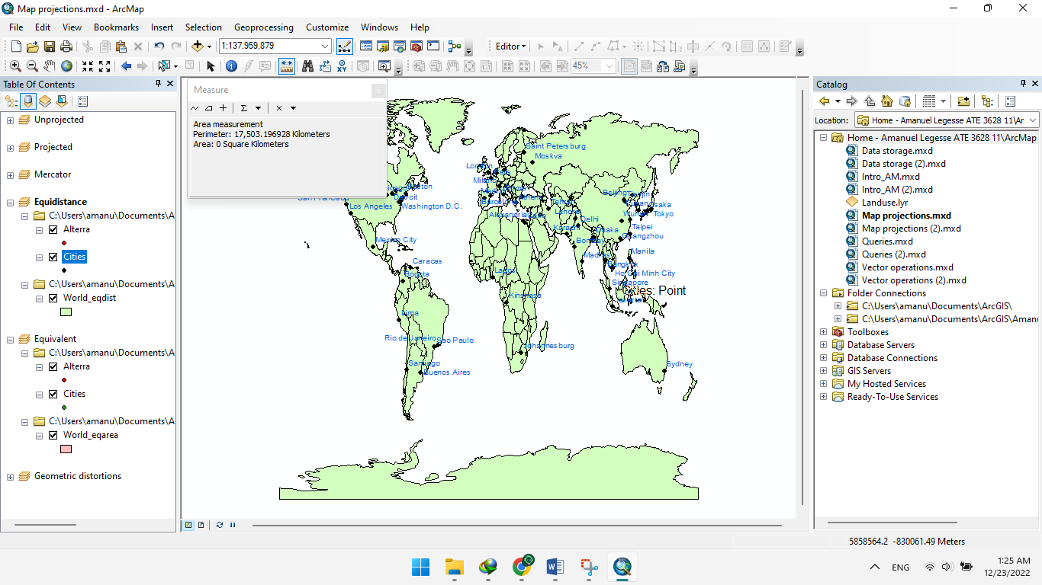

**Figure:** São Paulo – Jakarta (km)

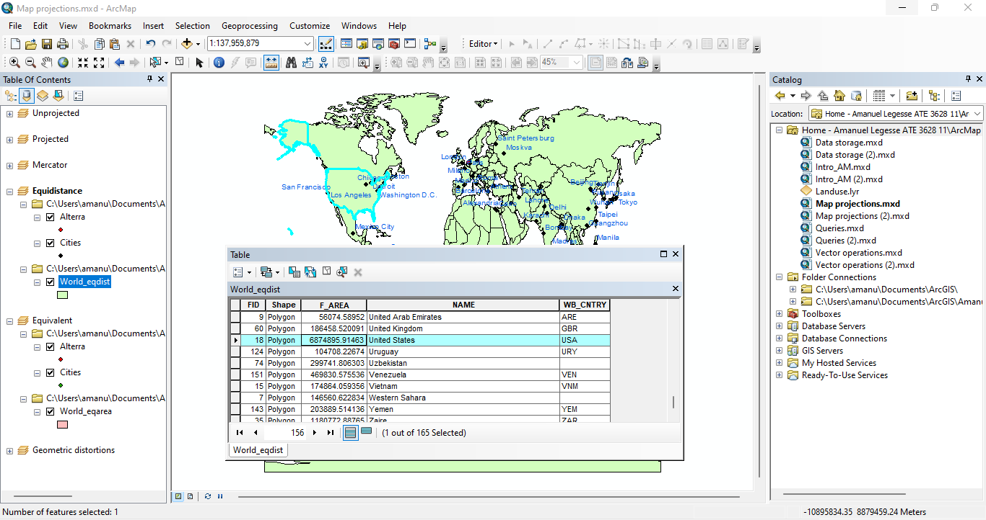

**Figure:** Area USA (km²)

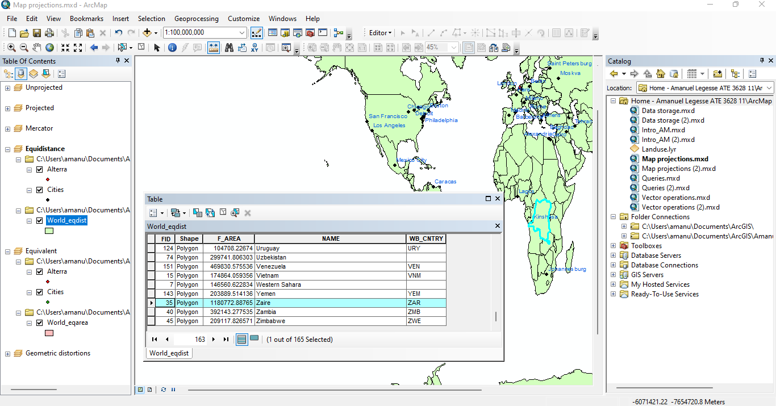

**Figure:** Area Dem. Rep. Congo (km²)

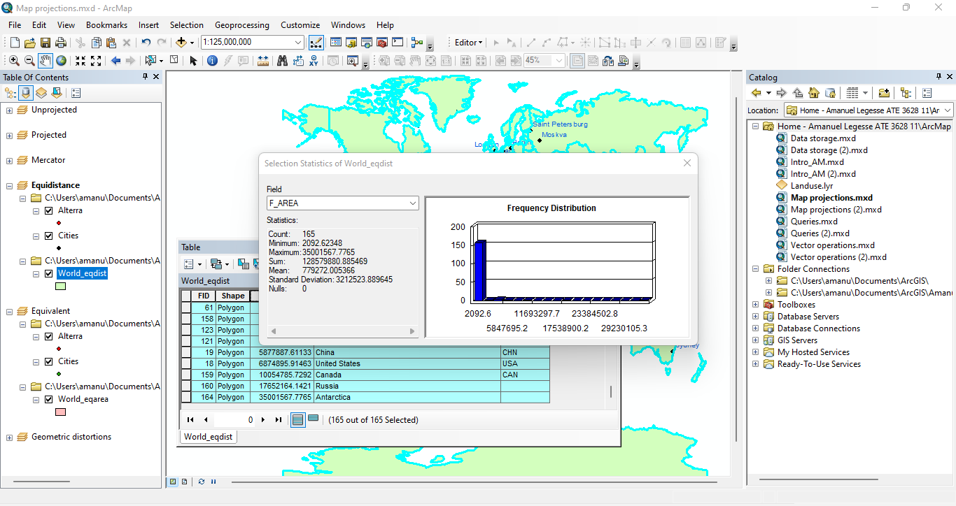

**Figure:** Area World (km²)

**4.C: Equivalent**

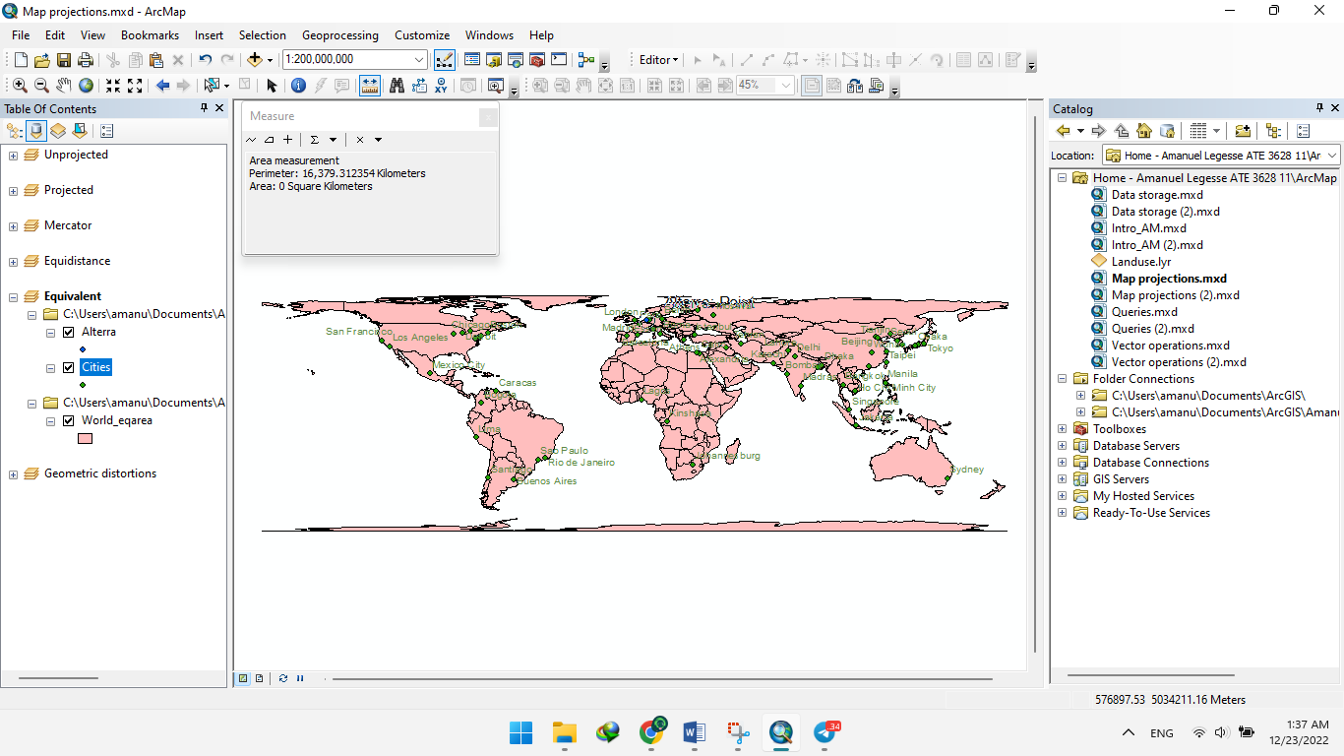

**Figure:** Alterra – Johannesburg (km)

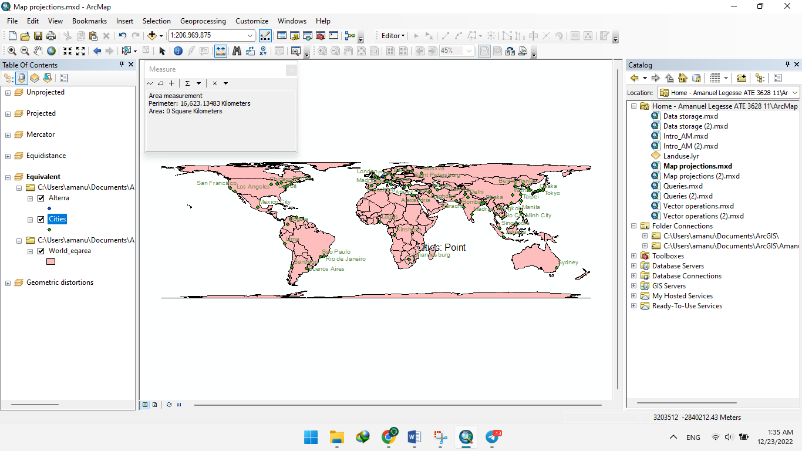

**Figure:** São Paulo – Jakarta (km)

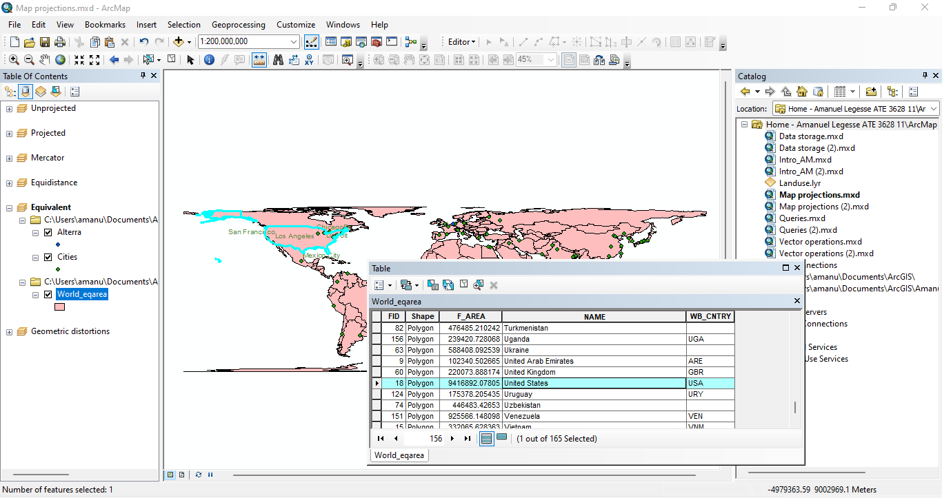

**Figure:** Area USA (km²)

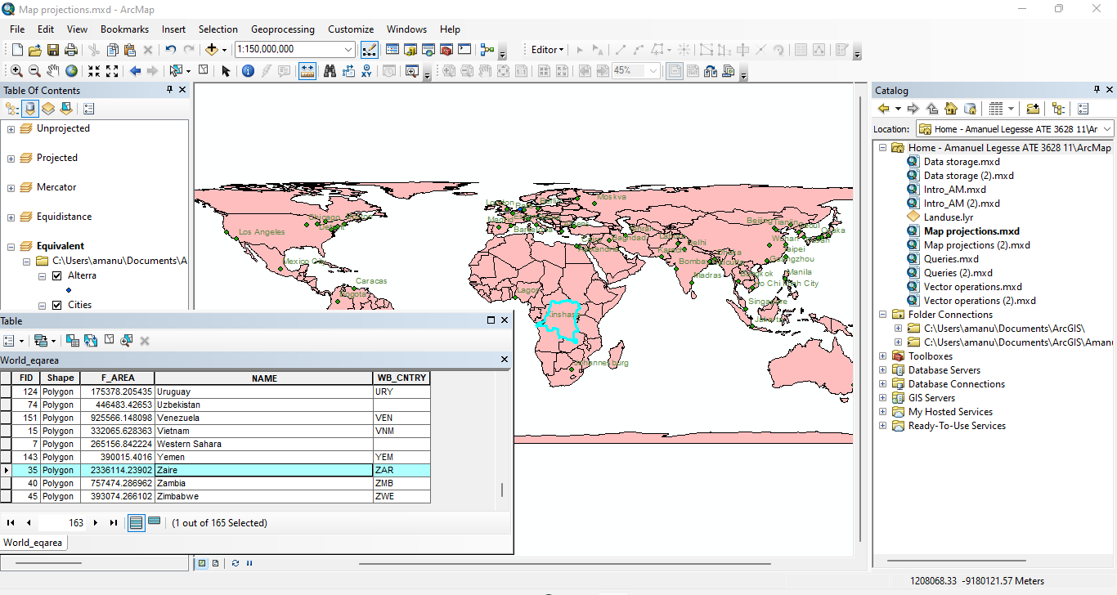

**Figure:** Area Dem. Rep. Congo (km²)

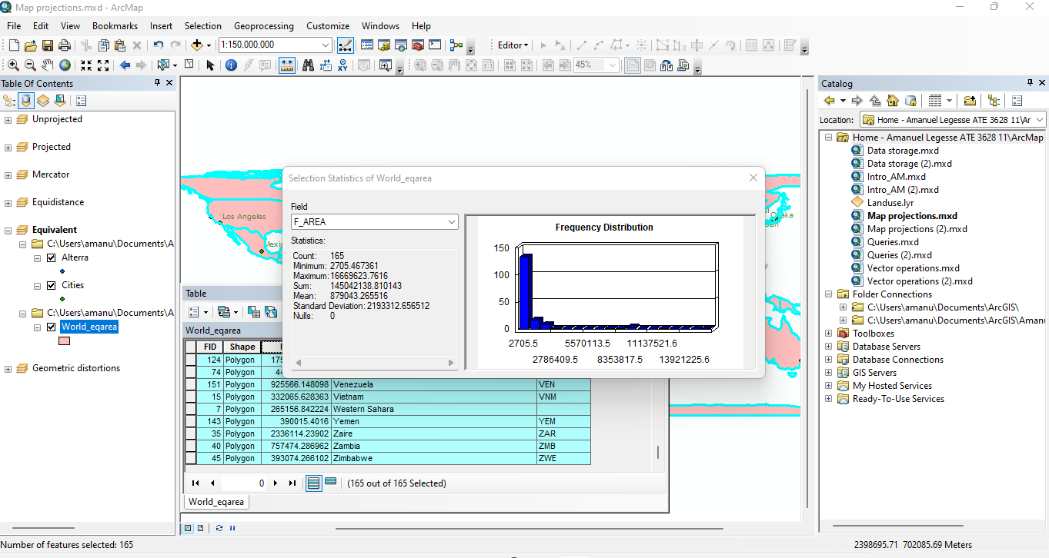

**Figure:** Area World (km²)

|  |  |  |  |  |
| --- | --- | --- | --- | --- |
|  | Mercator | Equidistant | Equivalent | Equivalent True dist./ area |
| Alterra – Johannesburg (km) | 10,078.480832 | 17,508.032125 | 16,379.312354 | 8,979 |
| São Paulo – Jakarta (km) | 17,190.127355 | 17,503.196928 | 16,623.13483 | 15,646 |
| Area USA (km² ) | 21518700.3426 | 6874895.91463 | 9416892.07805 | 9,631,418 |
| Area Dem. Rep. Congo (km² ) | 2355858.05155 | 1180772.88765 | 2336114.23902 | 2,345,410 |
| Area World (km² ) | 1009355323.875683 | 128579880.885469 | 145042138.810143 | 148,939,100 |

**Table:** Distance and area comparison using different projections

**ARC-GIS**

**EXCERCISE: 4**



**VISUALIZING DATA IN**

**ARCGIS**

**Creating a map Layout using ArcMap**

* Step 1 Start ArcMap and open a map document:
* 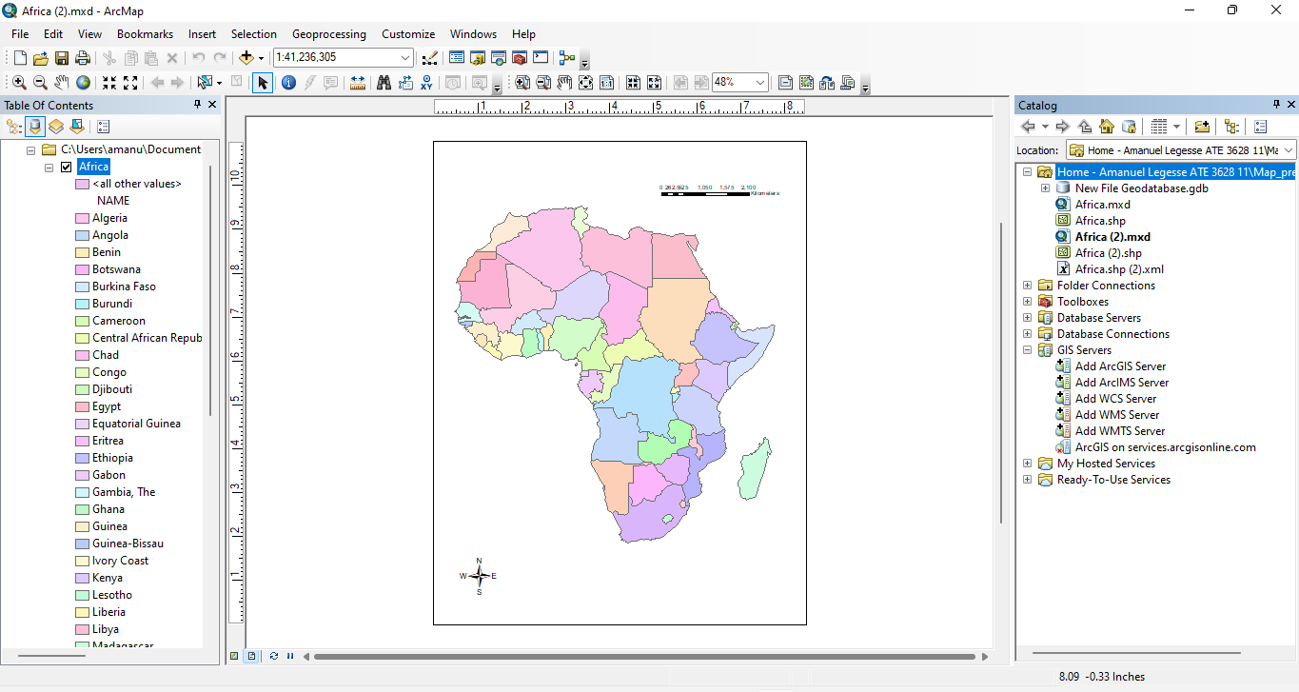 Had to navigate to the folder and select Africa.shp to preview the map.
* Step 2 Change the size of the data frame in the layout
* The scale of the data frame was changed to 1:60,000,000.

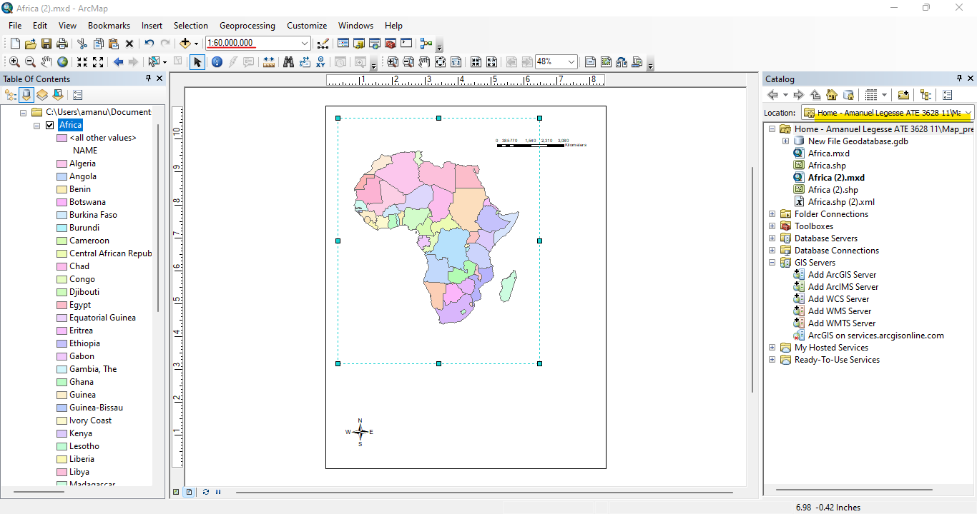

* Step 3 Create a map inset
* When creating a copy of the data frame its seen that a new data frame is added to the table of contents

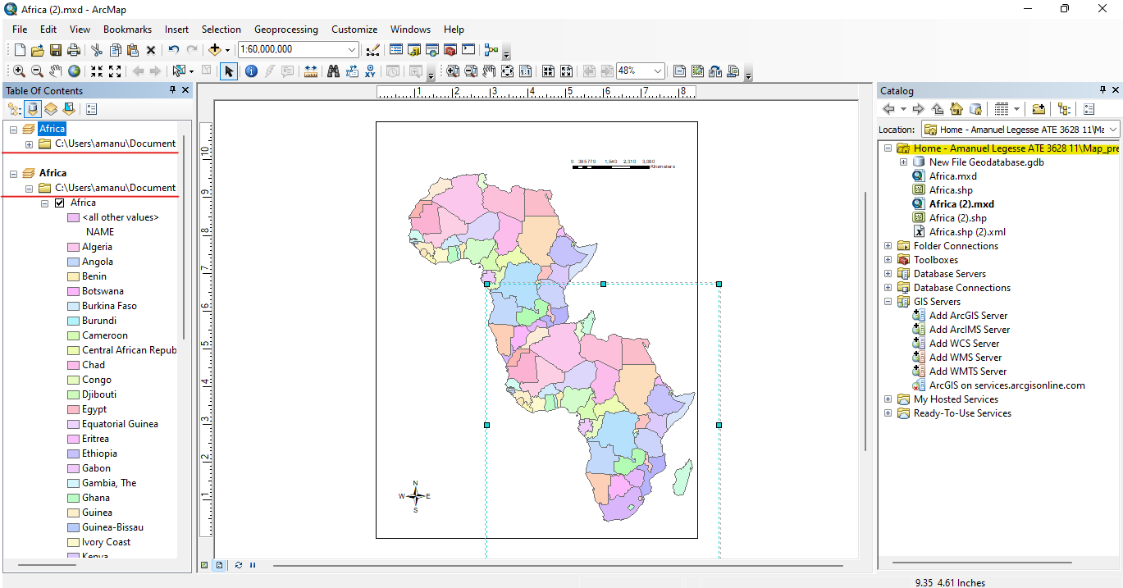

* The value of the width and height was changed to 40%

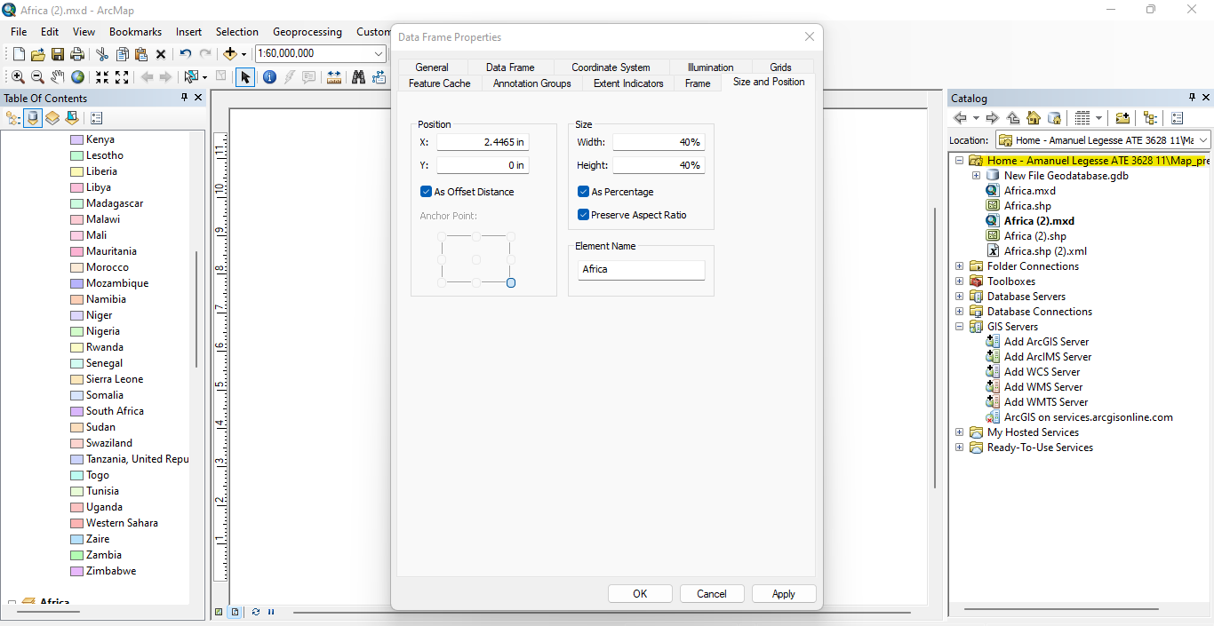

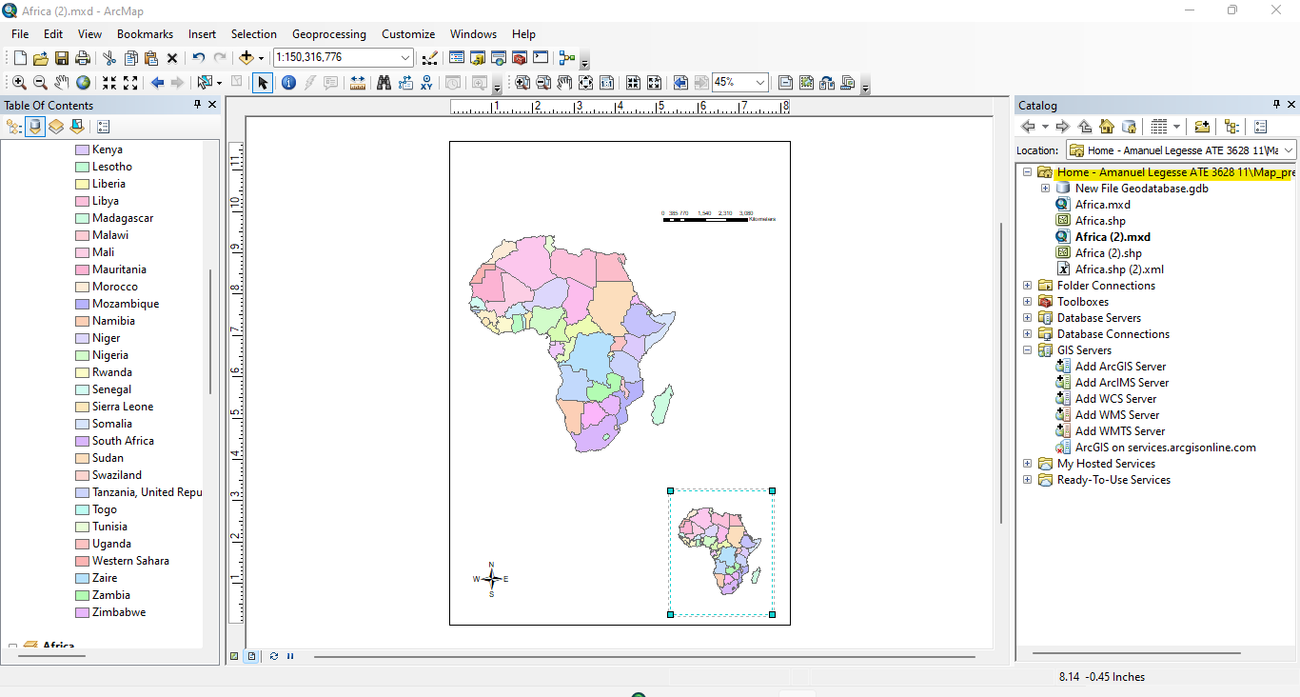

* Step 4 Symbolize the map inset
* Quantities of the Graduated colors Fields area POP2000 was chosen and the Color was changed to yellow to red shade ramp.

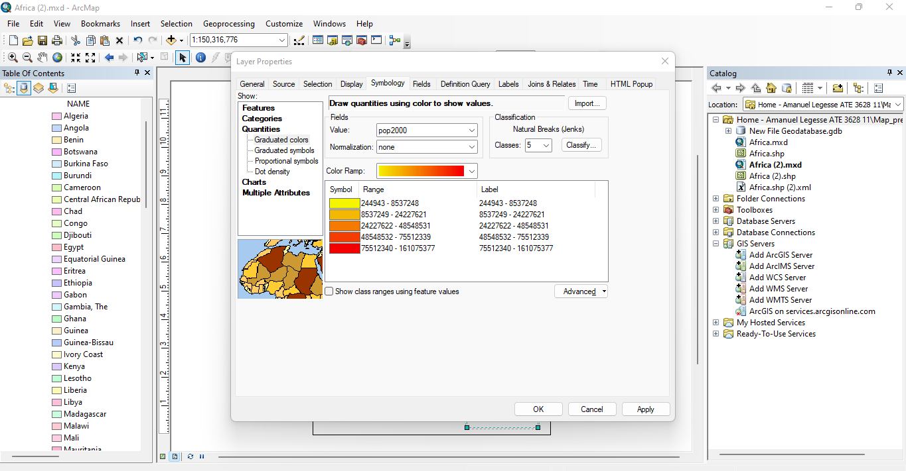

* The name of the new data frame is changed to Africa population.

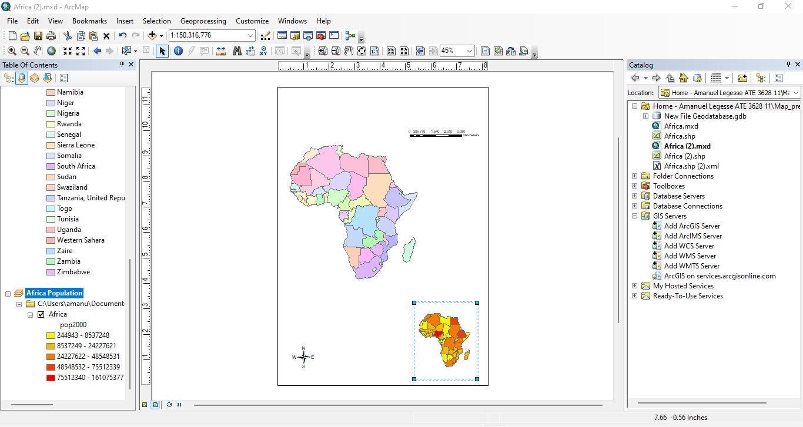

* Step 5 Refine the appearance of the data frames
* Changed the frame boarder and colors.

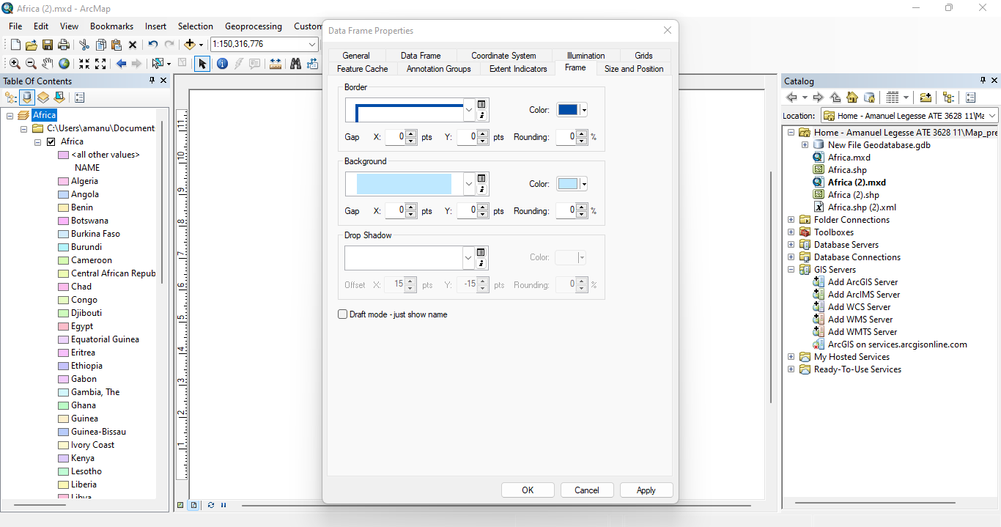

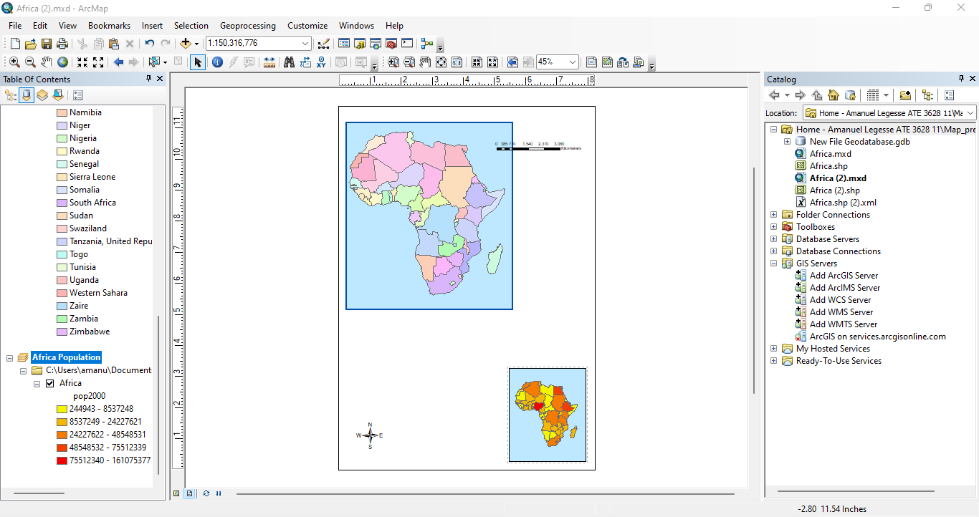

* Step 6 Add a title to the layout
* The title is now changed to AFRICA.

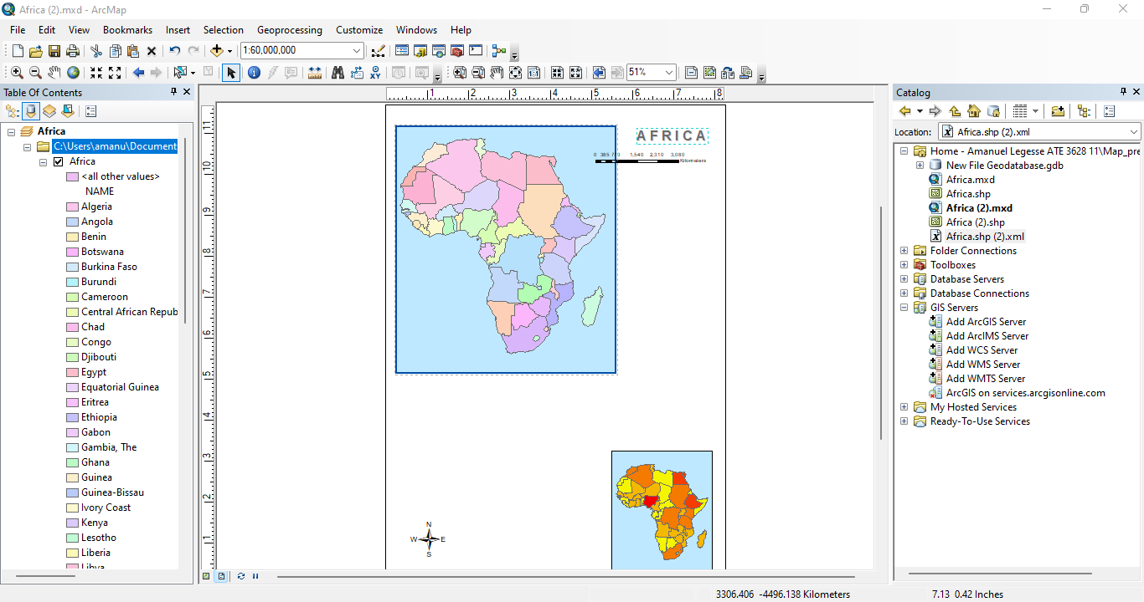

* Step 7 Add a legend to the layout
* The following legend has been added to the data frame using the size and position to be placed next to the Africa data frame.

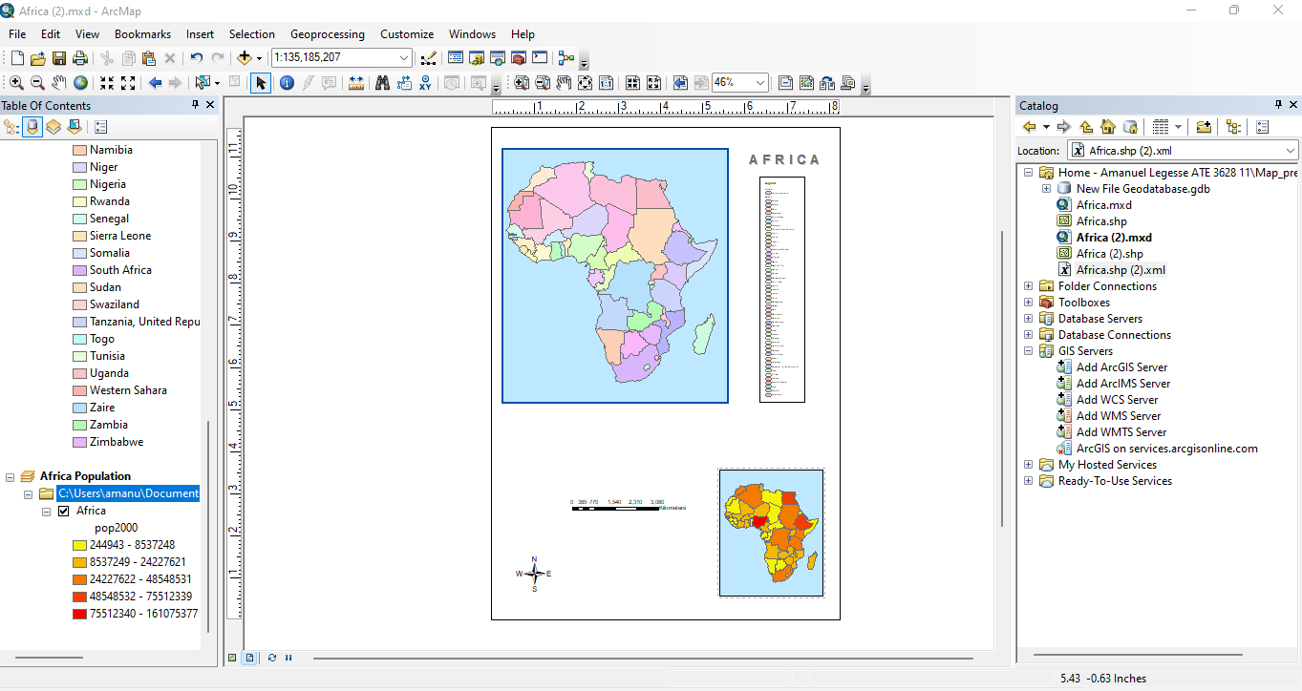

* Unchecking the show button hides the legends title.

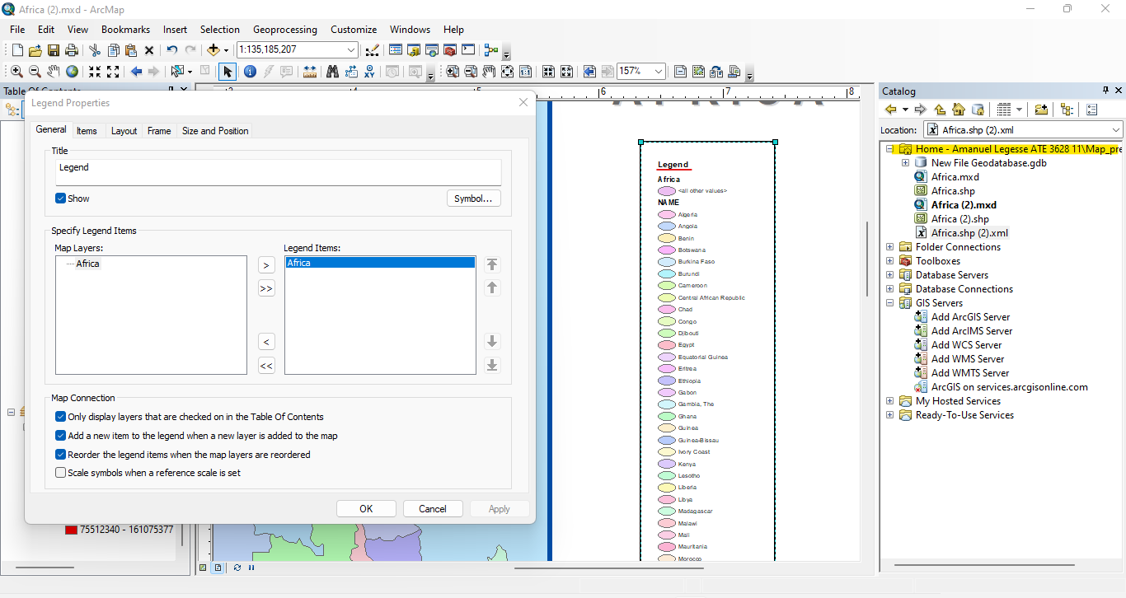

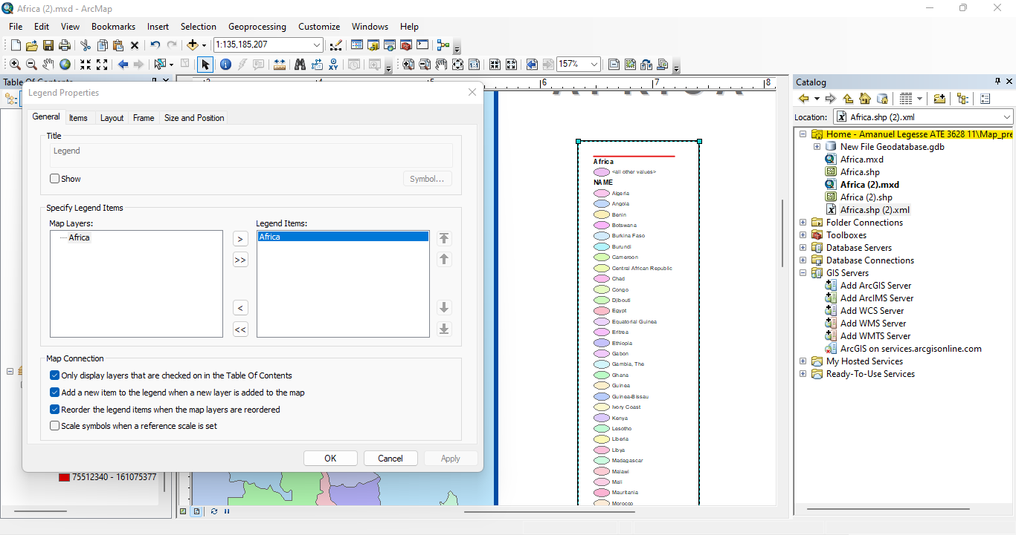

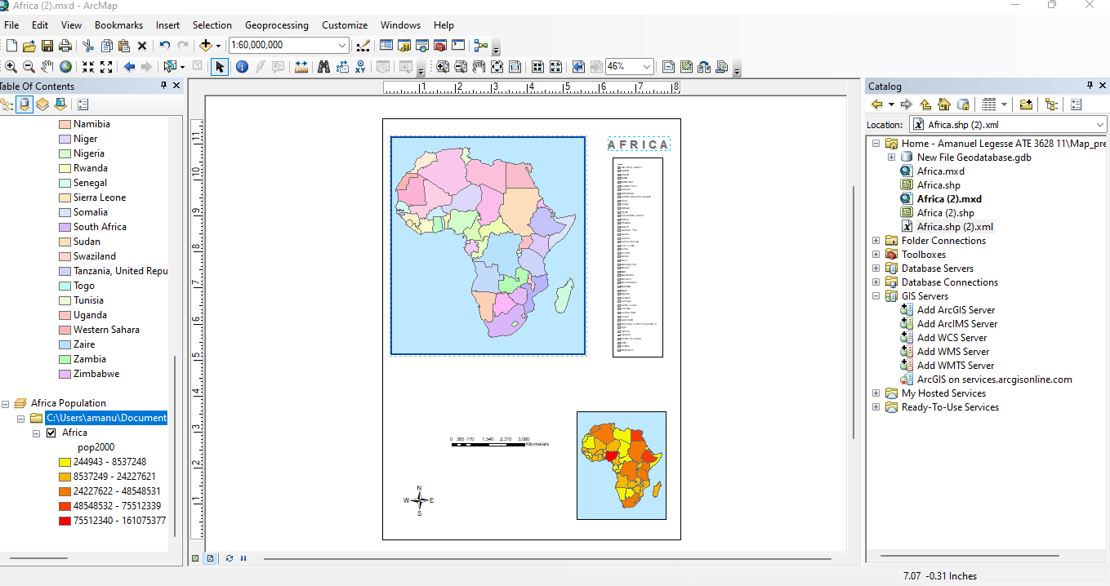

* Step 8 Add a legend for the map inset
* A legend is created with title 2000 population and resized to fit inside the Africa population data frame.

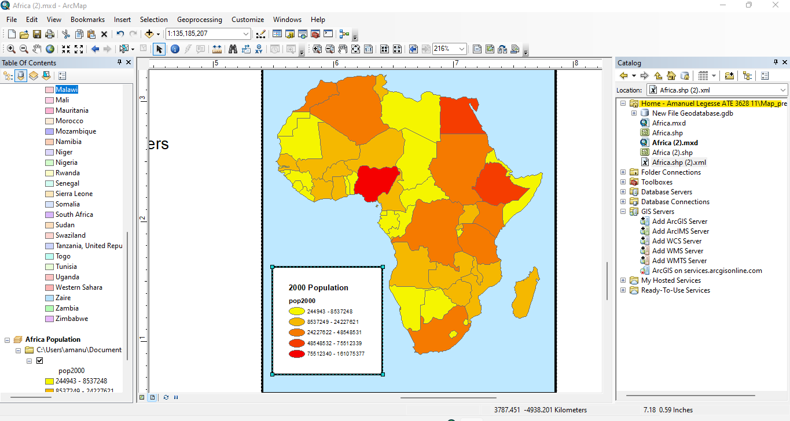

* Changed to color ramp to red to green then flipped it then modified the range values.

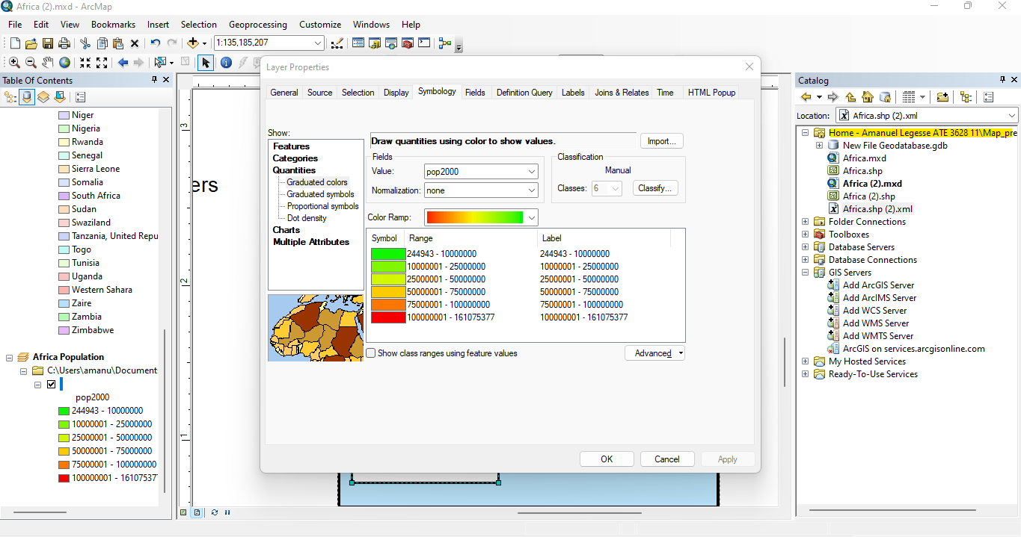

* Step 9 Position the north arrow

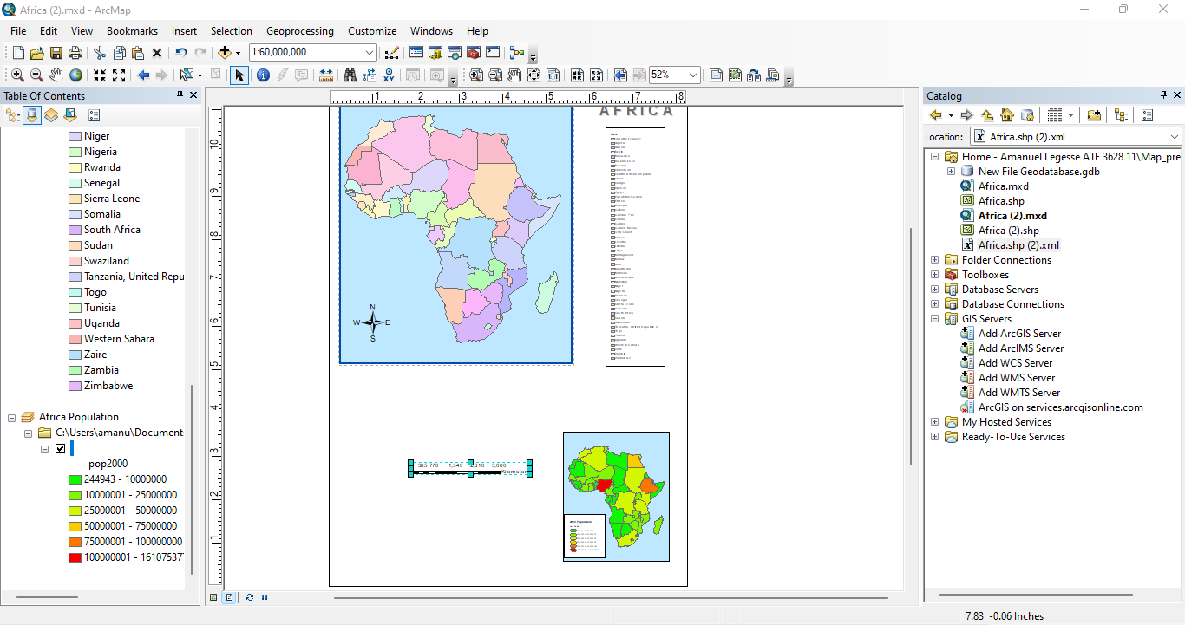

* Step 10 Modify the scale bar and add scale text.

Modified scale km to 1000.

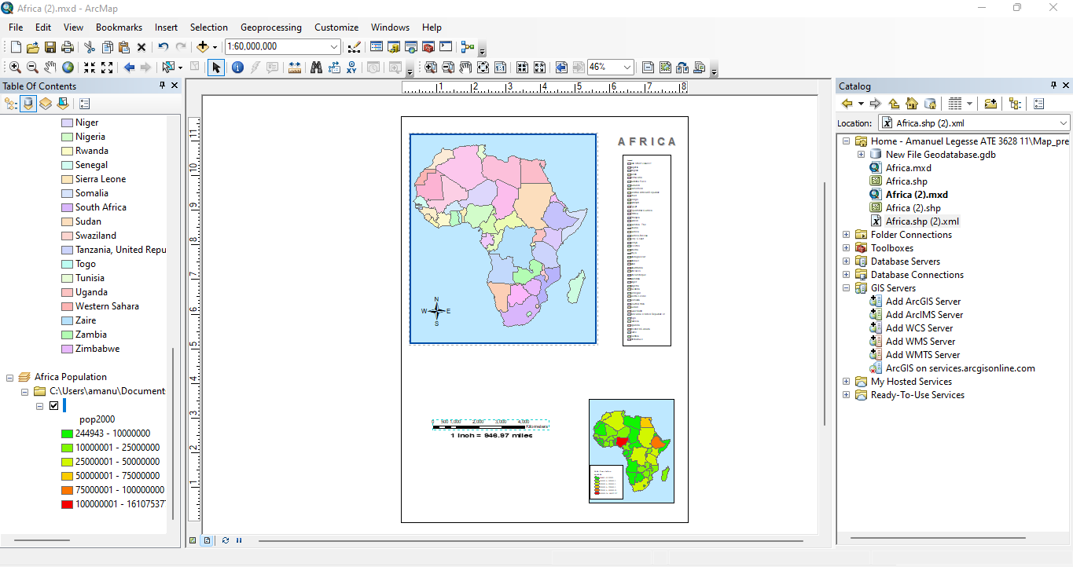

* Step 11 Add a border and background color to your layout
* Added a back ground layout of color sand by inserting Neatline.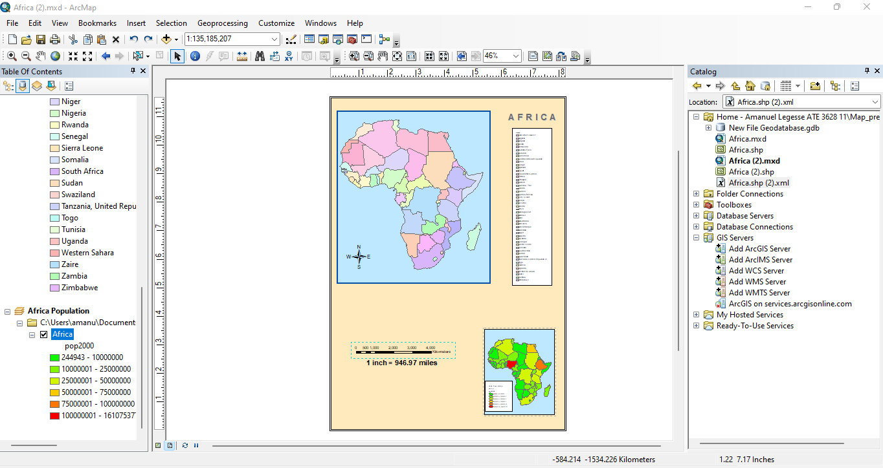
* Step 12 Save your map

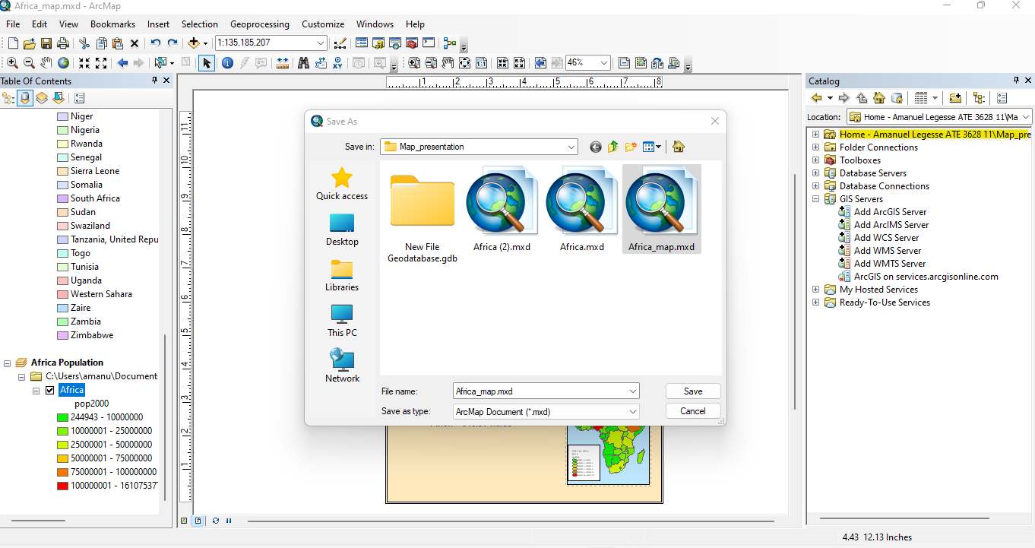

**ARC-GIS**

**EXCERCISE: 5**



**QUERIES**

**Attribute data queries**

1. **A**: 3 records are selected

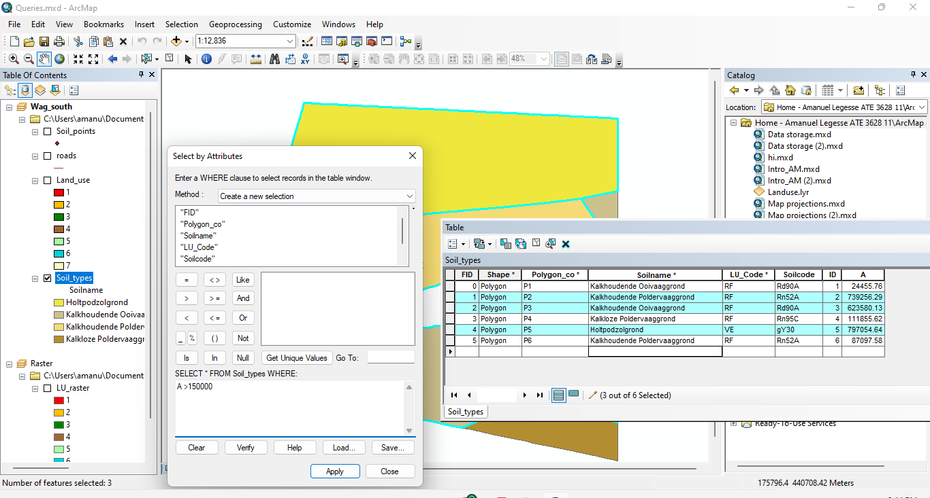

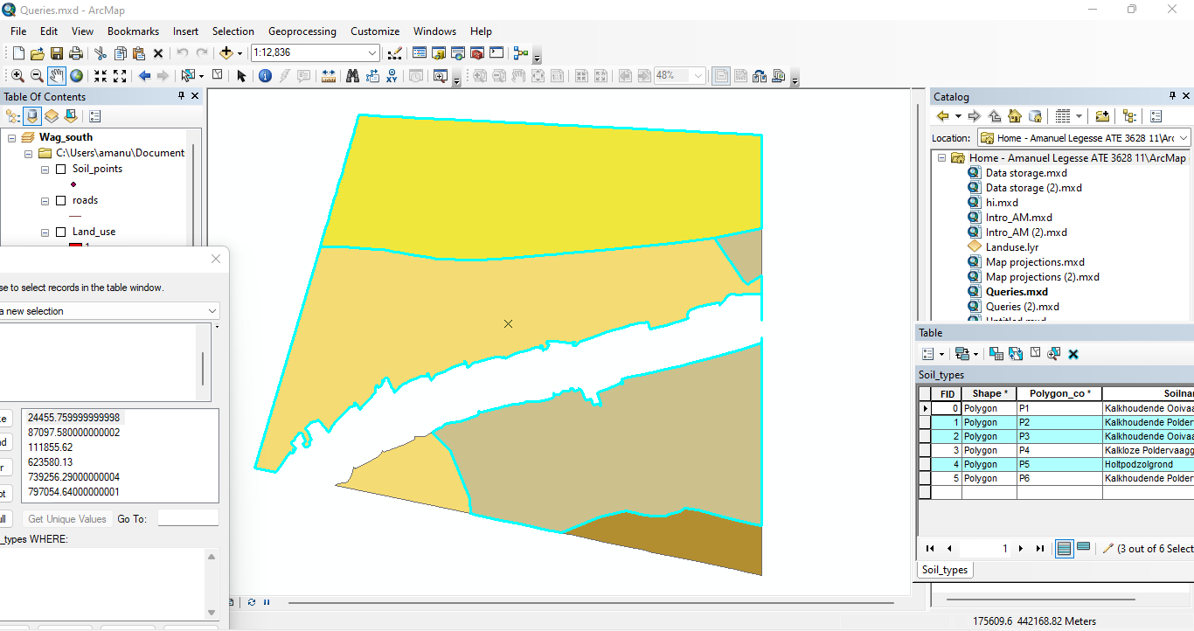

**B**: There is 1 kalkhoudende poldervaaggrond records selected

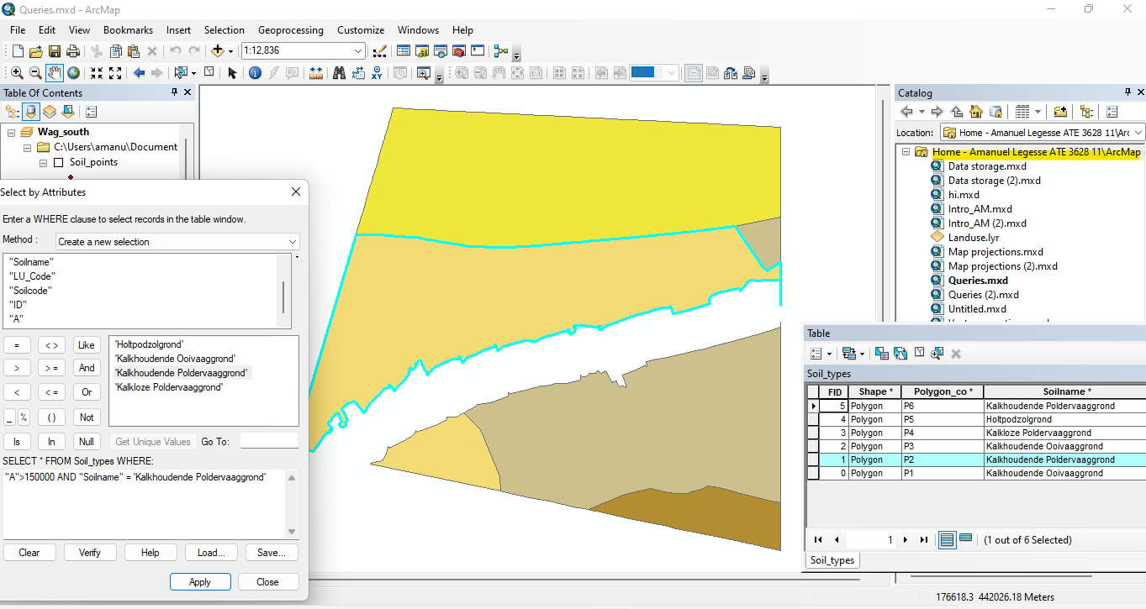

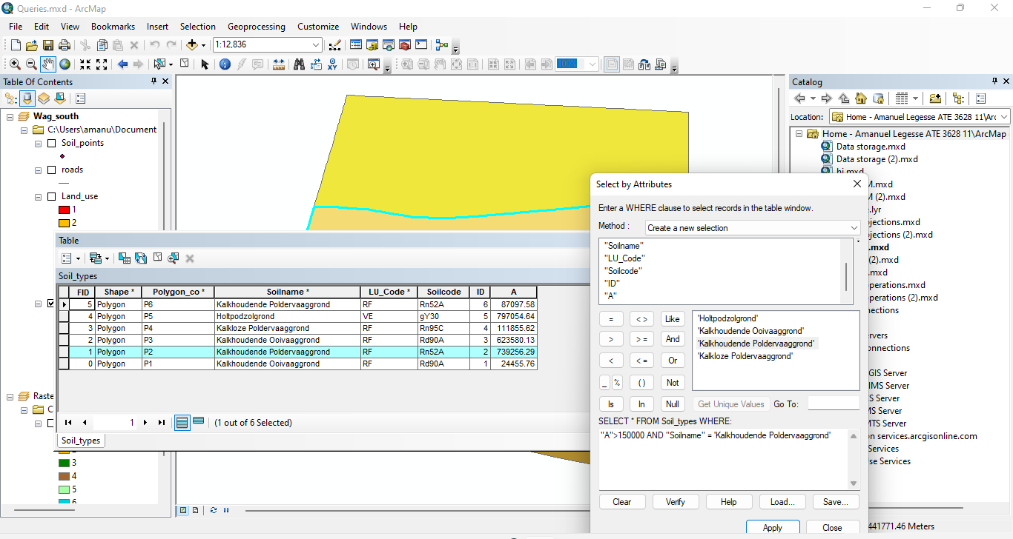

**C**: Yes the selection can be made at once using the Boolean expression AND.

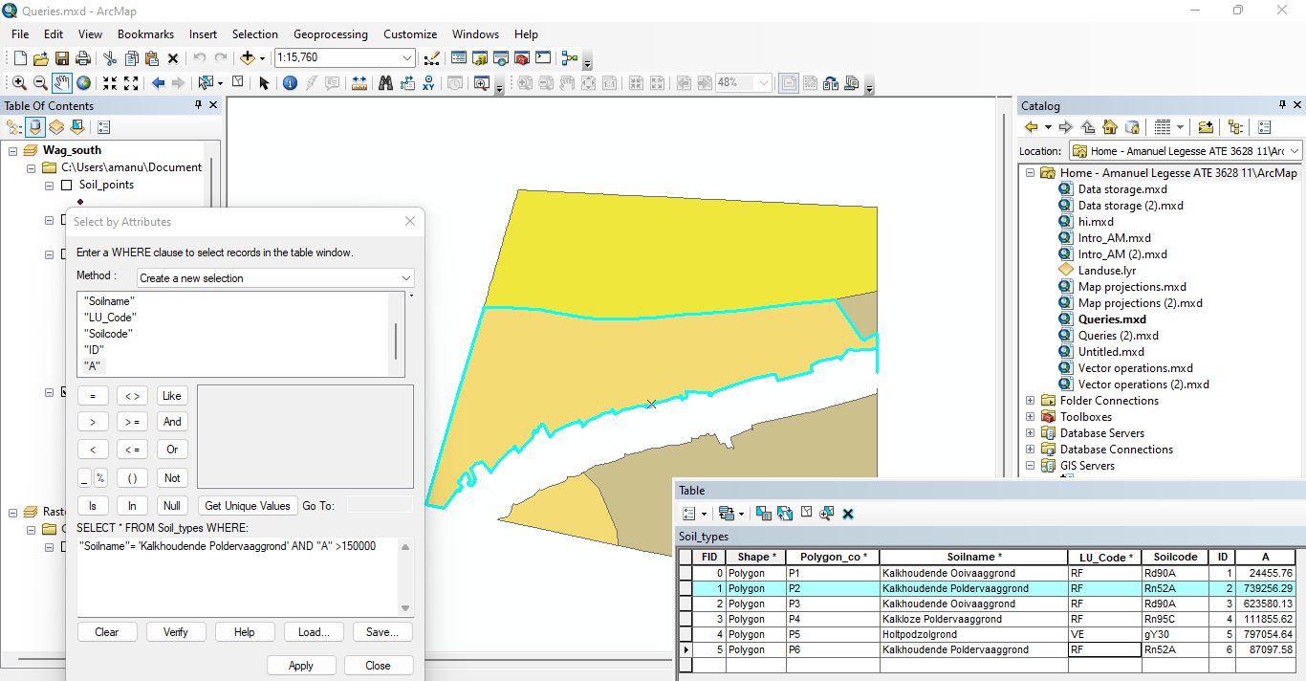

**D**: Select: "Soilname"

From: Soil_types

Where: "Soilname"= 'Kalkhoudende Poldervaaggrond'

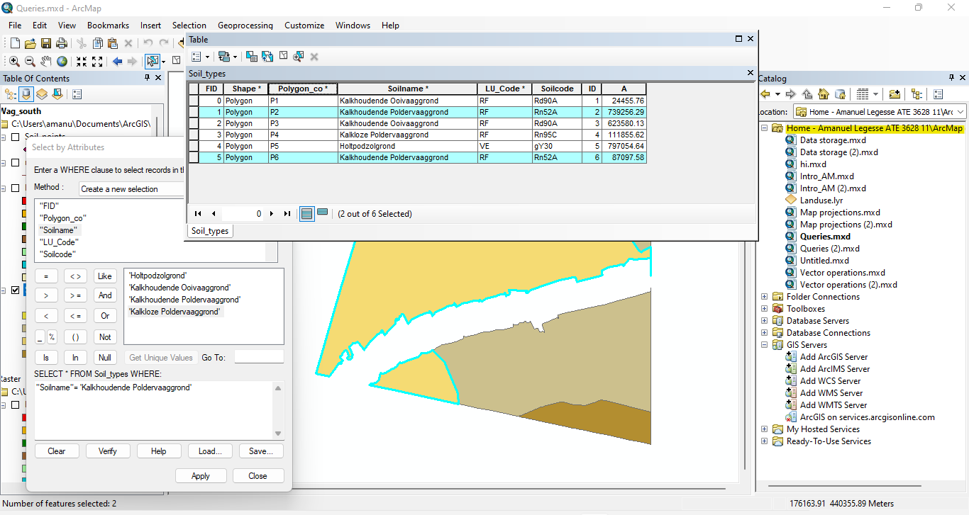

**E**: 3 records are selected after adding features with LU_code ‘VE’

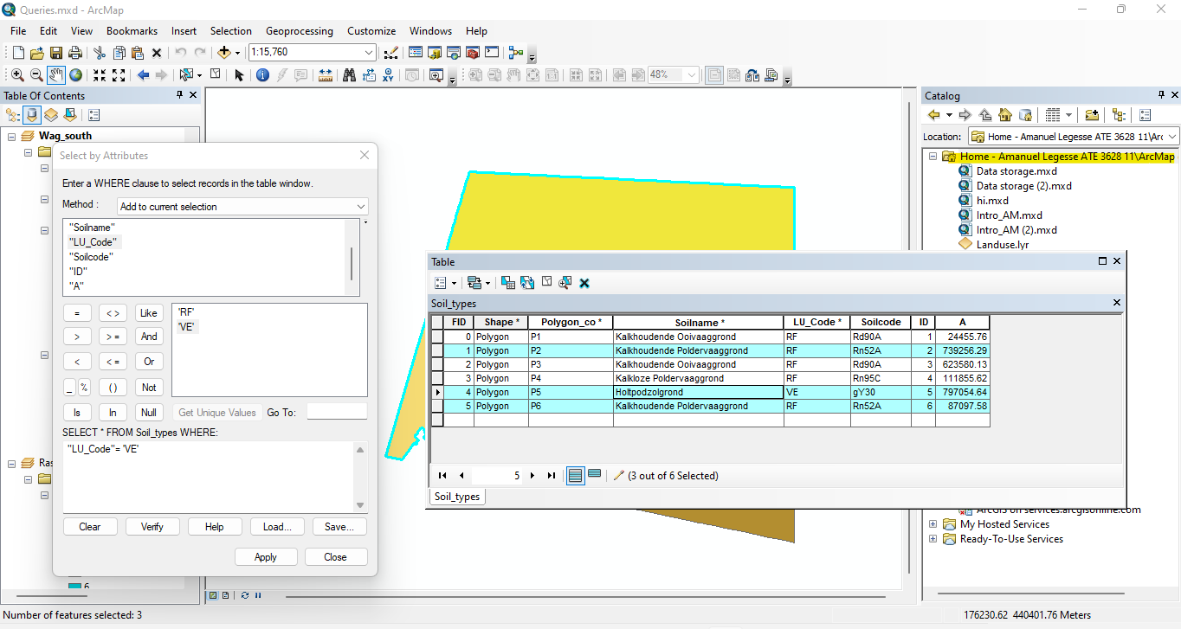

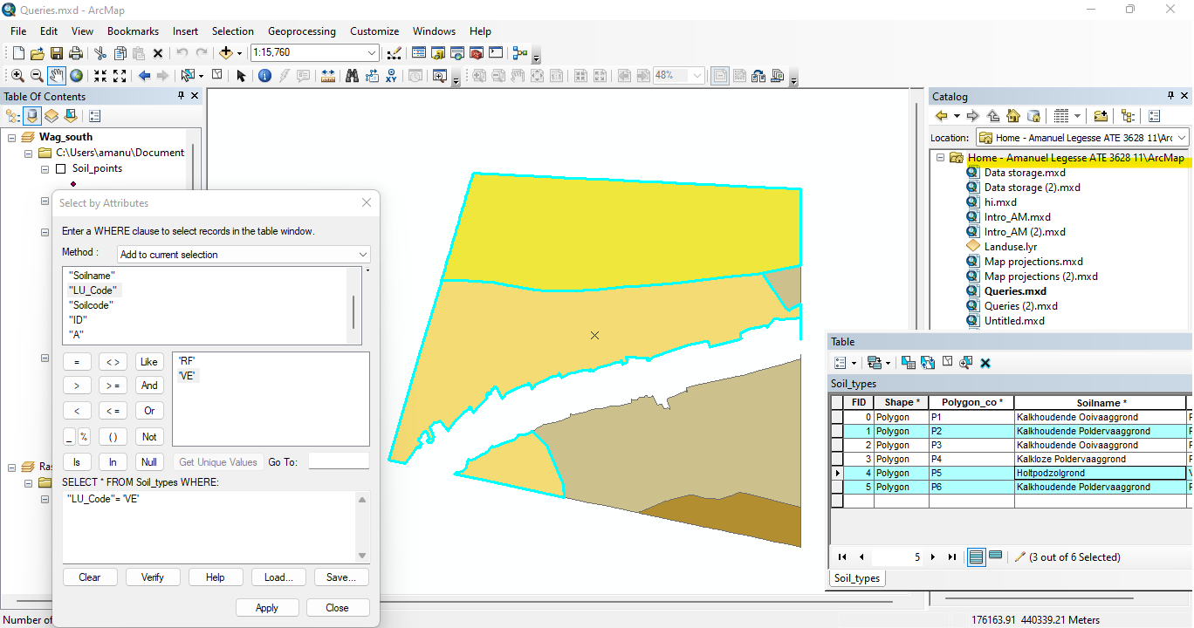

**F**: Yes the selection can be made at once using the Boolean expression OR.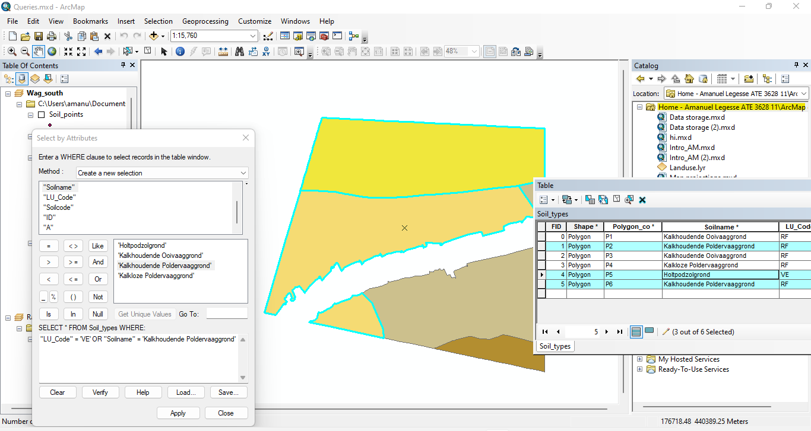

**Sorting attributes**

1. polygon_co is sorted in a descending order as seen below.

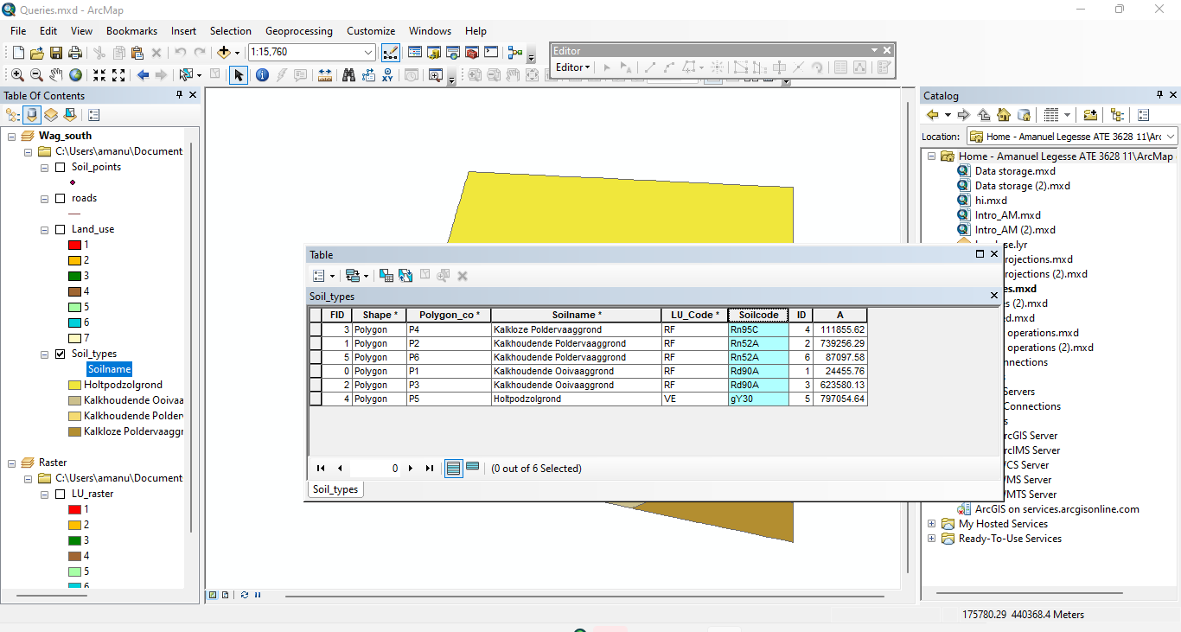

**Feature selection by cursor**

1. **A**: 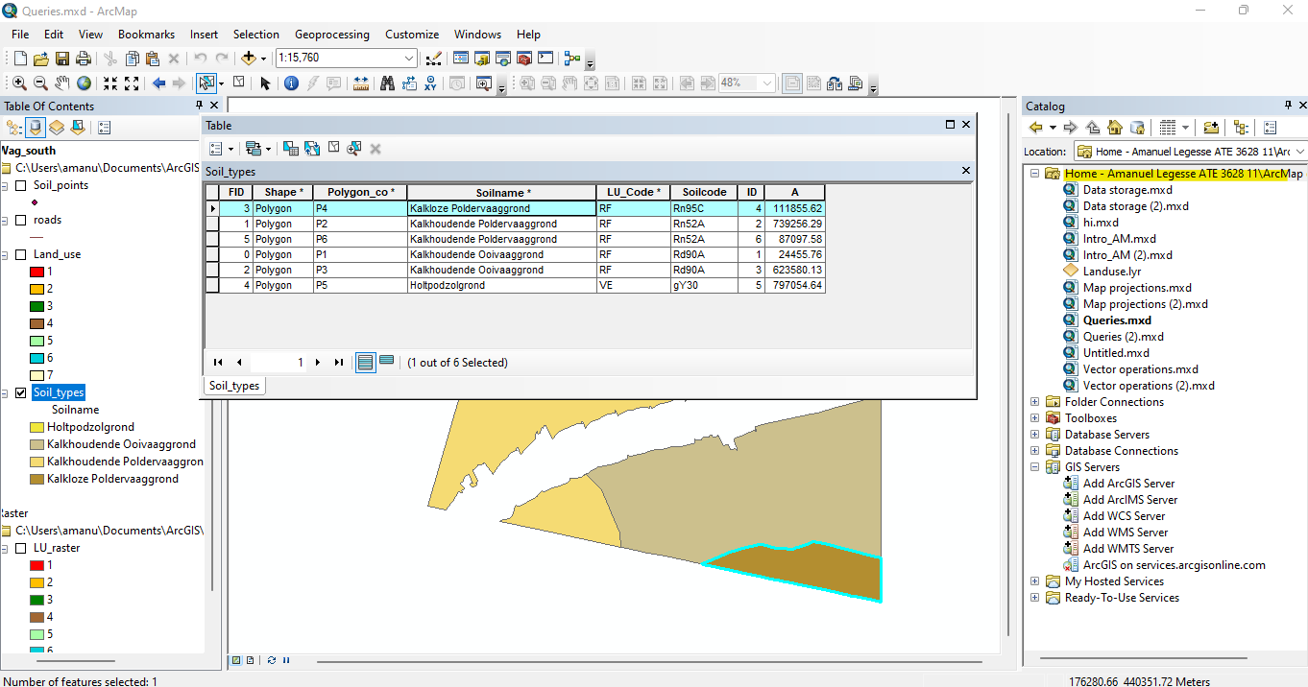

**B**: Select: "Soilname"

From: Soil_types

Where: "Soilname"= ' Kalkloze poldervaaggrond’

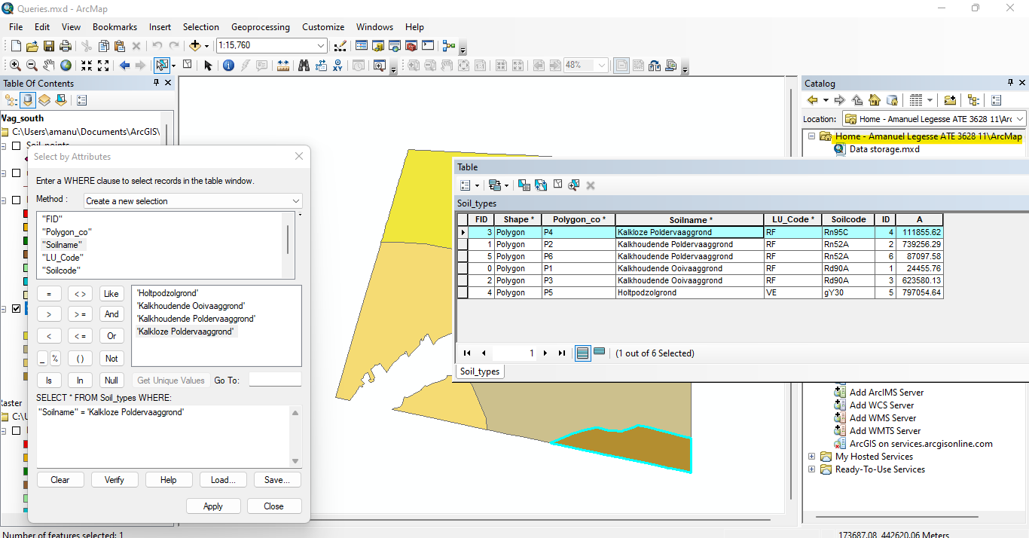

**C**. After removing the most southern soil feature which is 'Kalkloze Poldervaaggrond', the most northern one ('Holtpodzolgrond’) is selected.

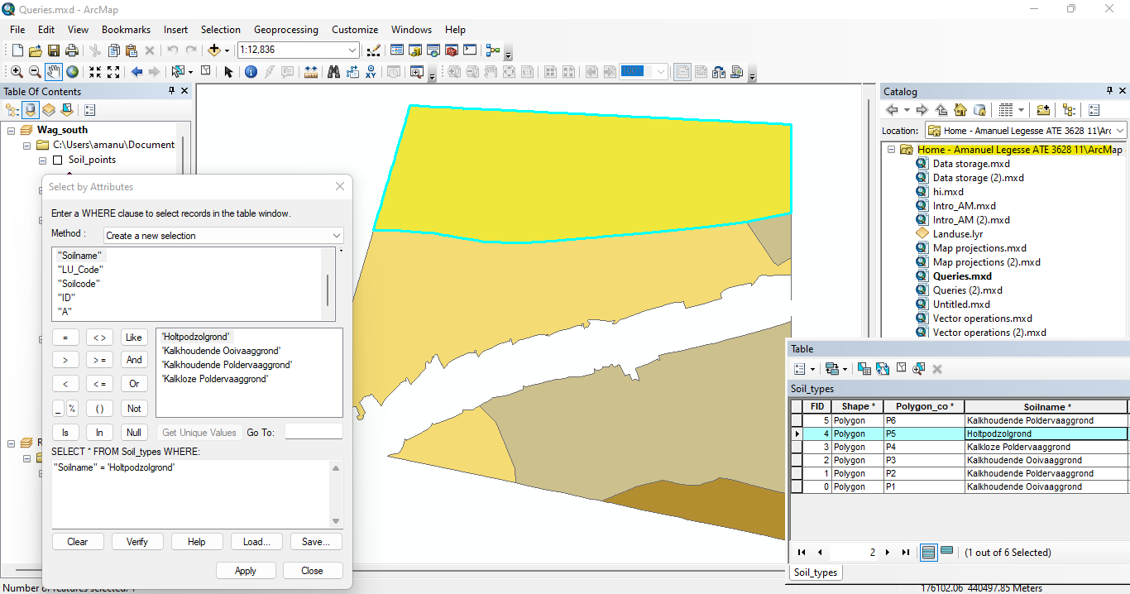

A: The selected feature which is the mathematics building is highlighted as yellow.

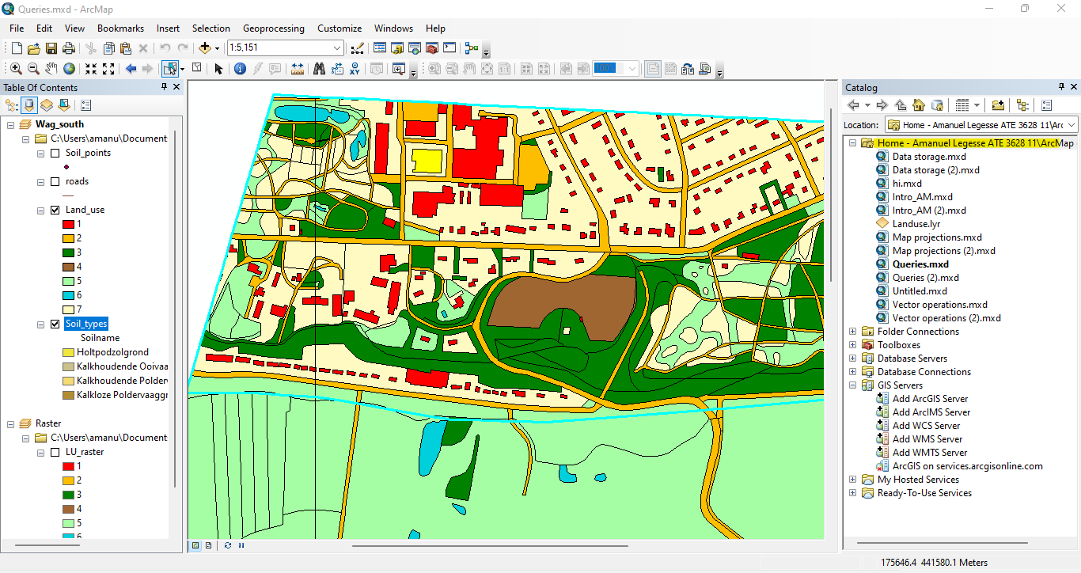

* The mathematics building also the soil feature in which the building is located is selected

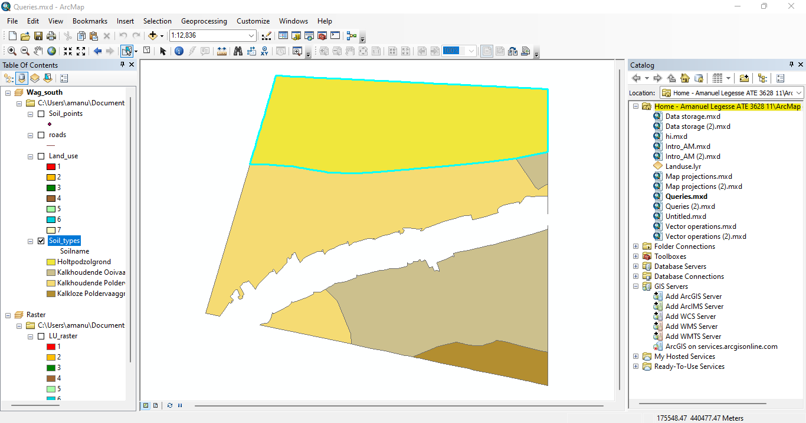

**B**:

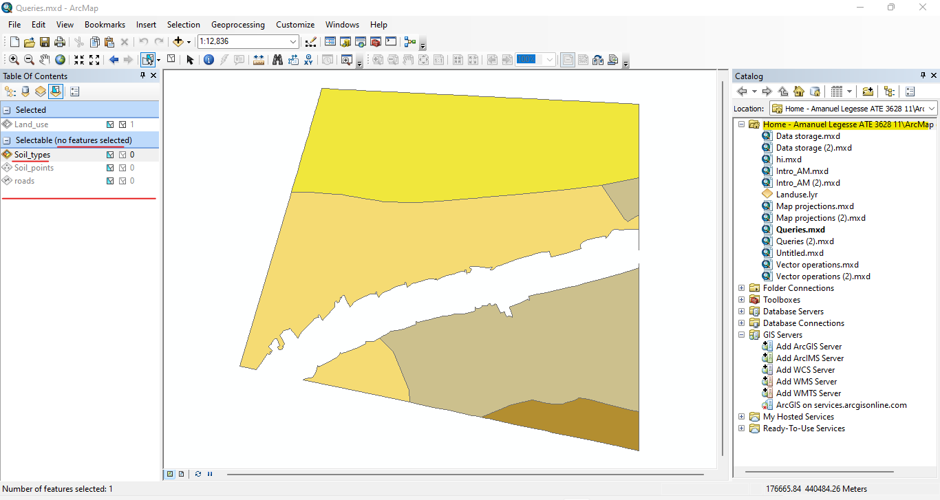

**C**: Now that the soil_types has been made not selectable the mathematics building is selected t and not the soil feature on which this building is located.

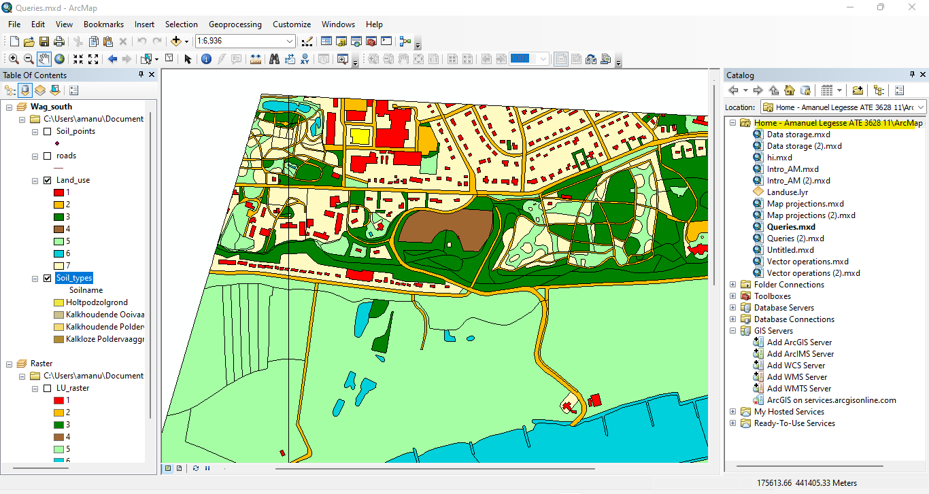

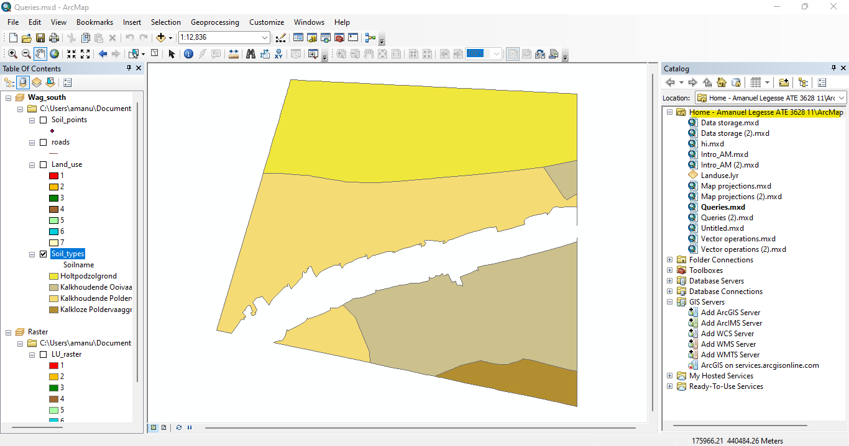

1. The soil codes of the selected features are Rd90A, Rn52A and gY30.

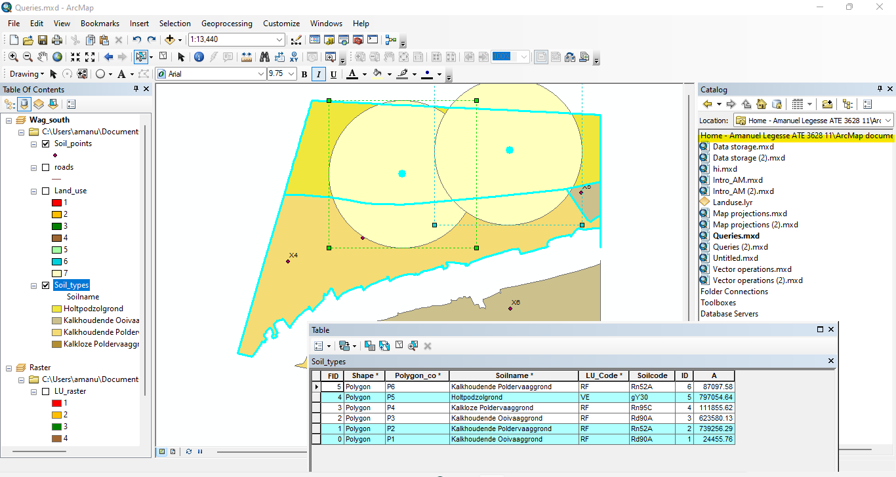

1. A: 2 features are selected, ‘kalkloze poldervaaggrond’ and ‘kalkhoudende ooivaaggrond’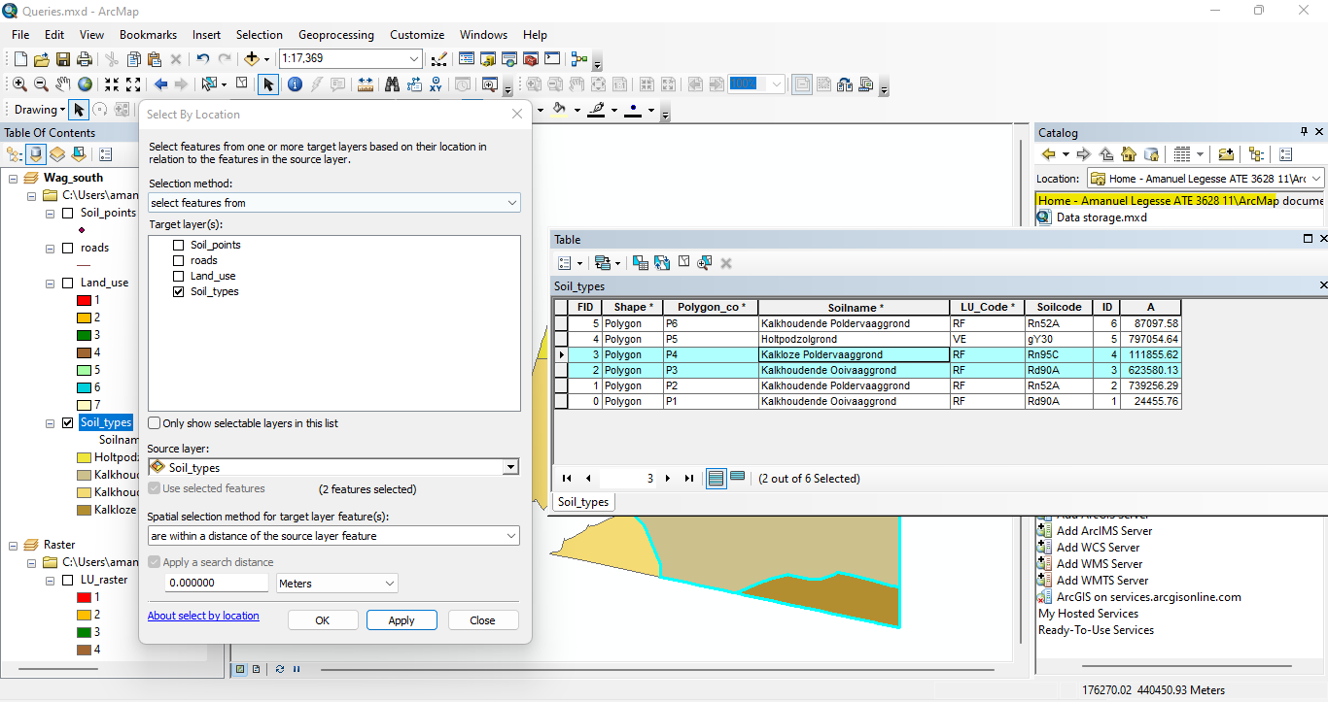

**B**: By using ‘touch the boundary of’ spatial relationship, there can be made the same selection.

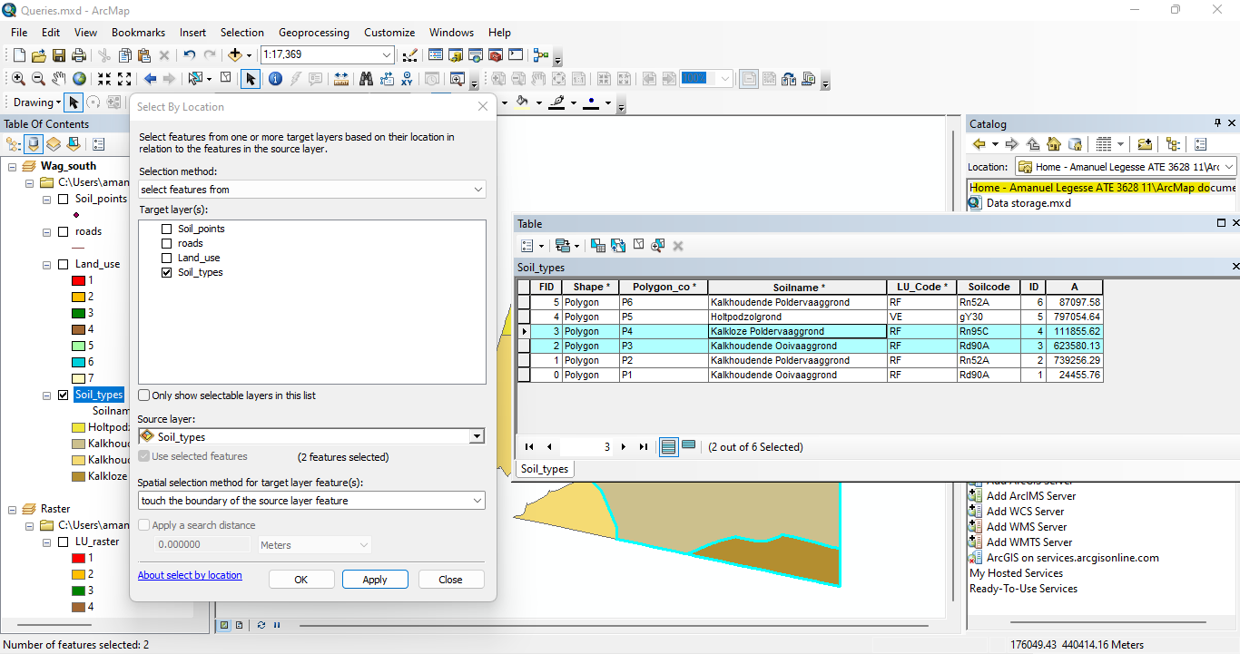

**C**: This selection results in 68 selected features in the land_use dataset. 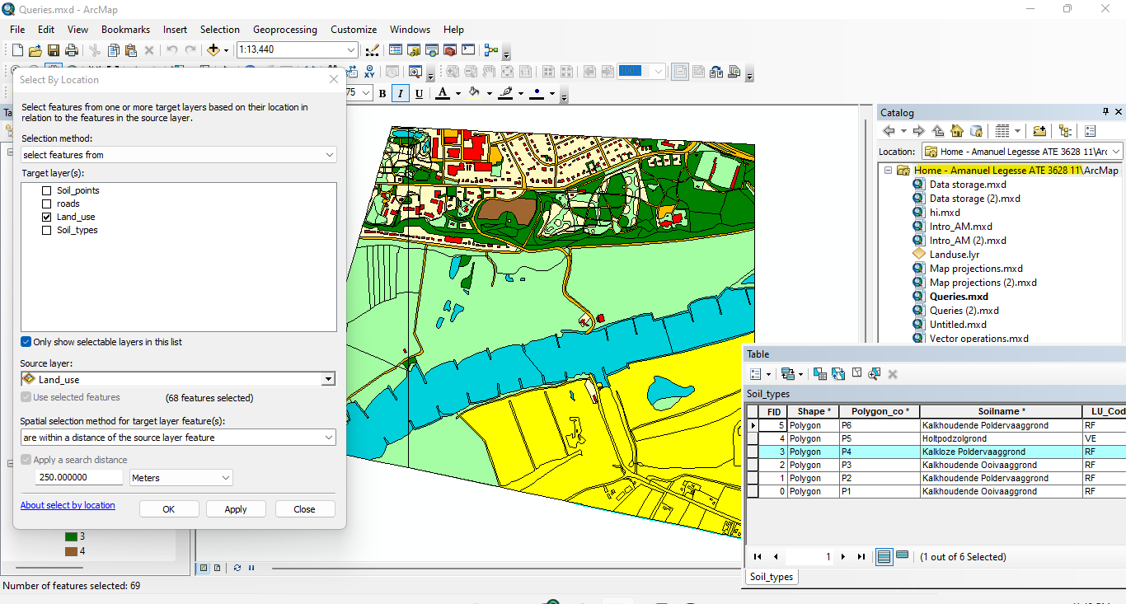

1. Point X5, X6, X7 are within the soil features classified as ‘Kalkhoudende Ooivaaggrond’.

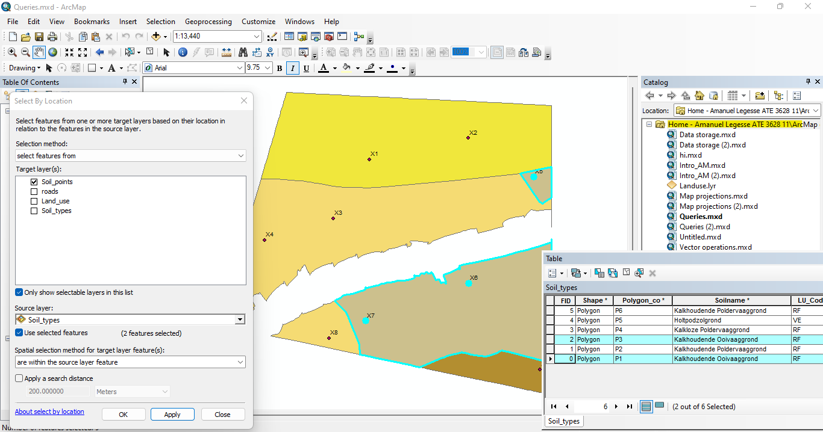

1. A: The nearest soil profile point to the Veerweg is point X1.

B: The distance is 147.3 meters.

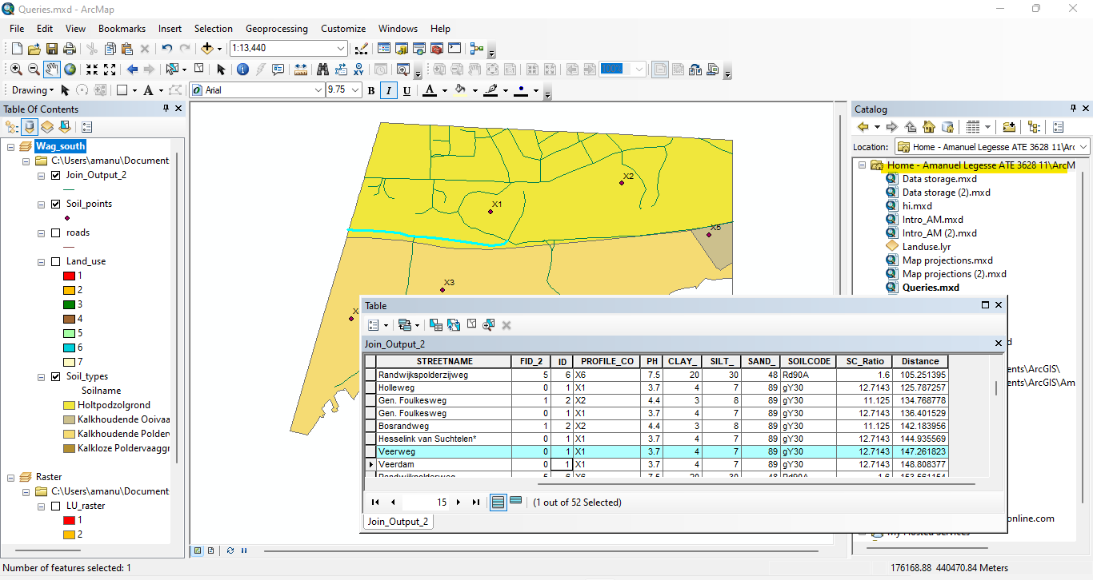

**Saving a selection into a new vector dataset**

1. **A:**

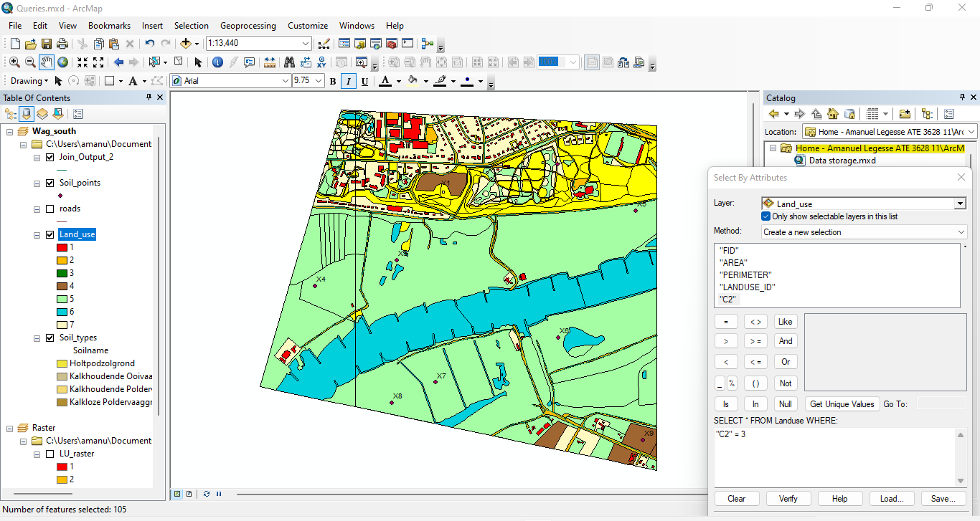

**B:**

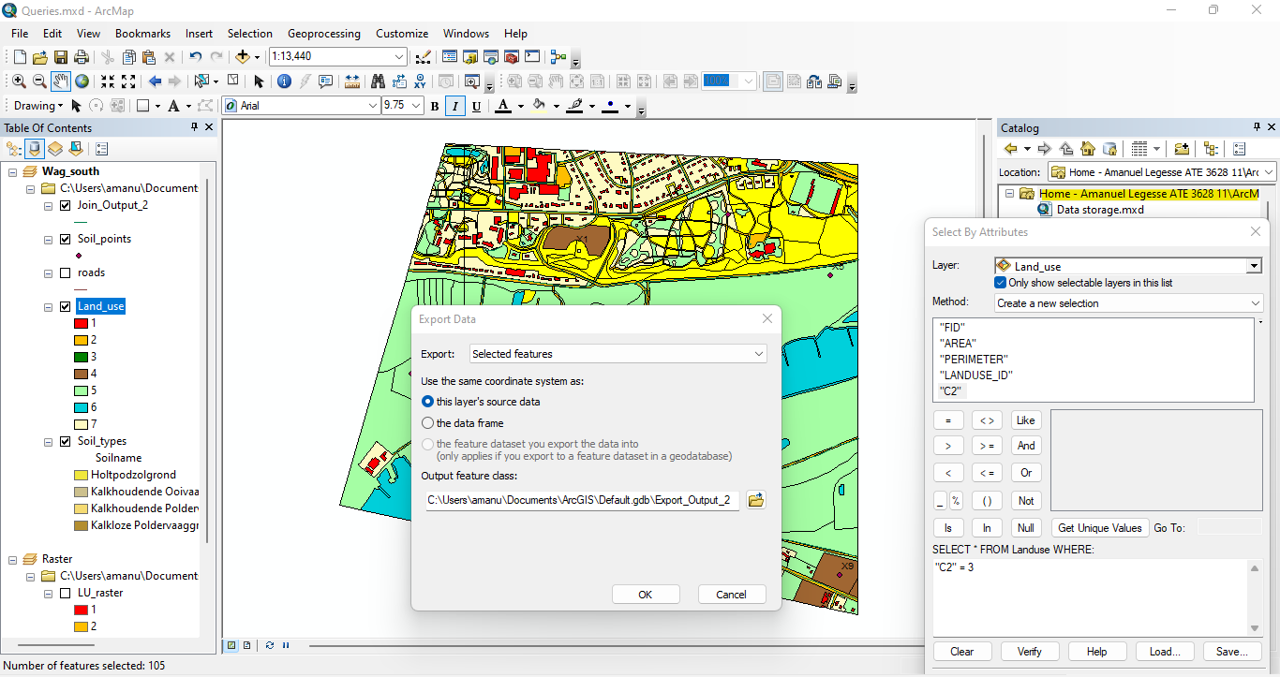

**Selecting and exporting raster cells using the ‘CON’ tool**

**A**: 15266 cells are selected.

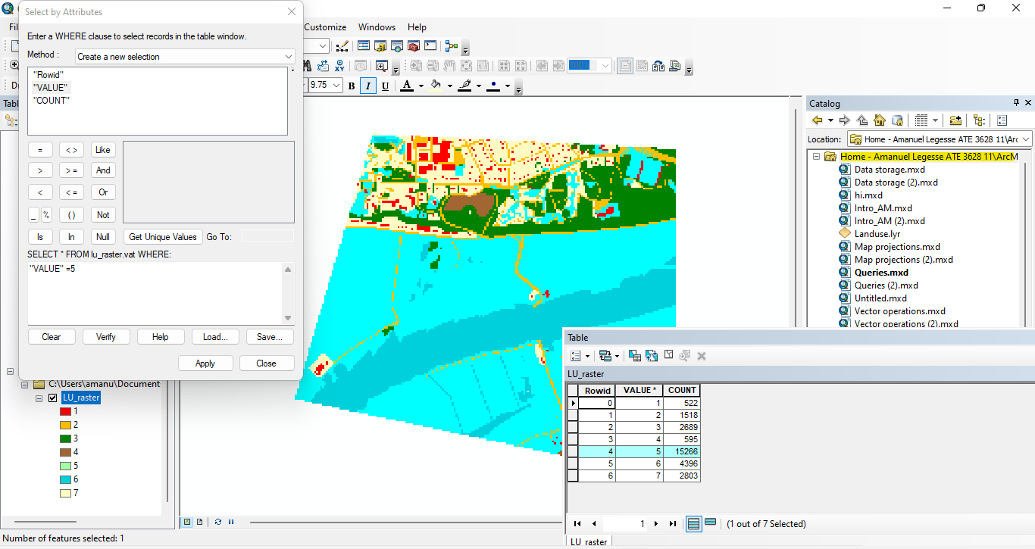

**B**: Classes with value 5 and 6 are selected.

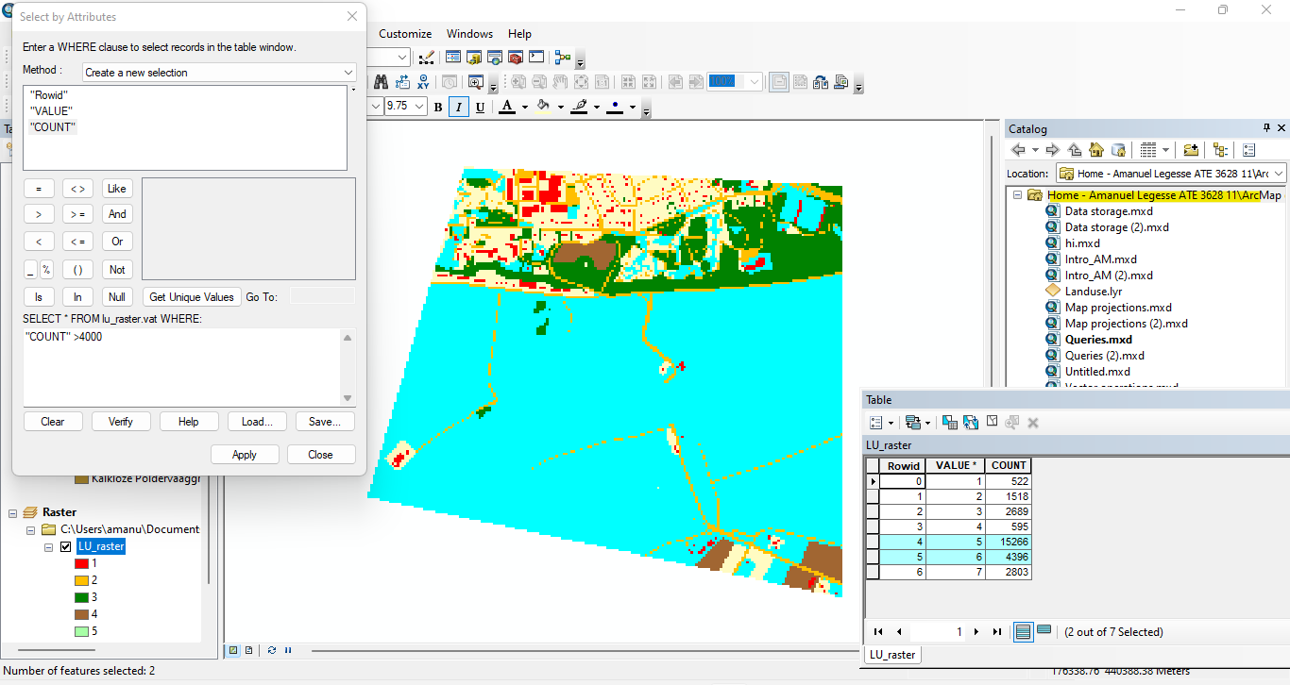

**C**: 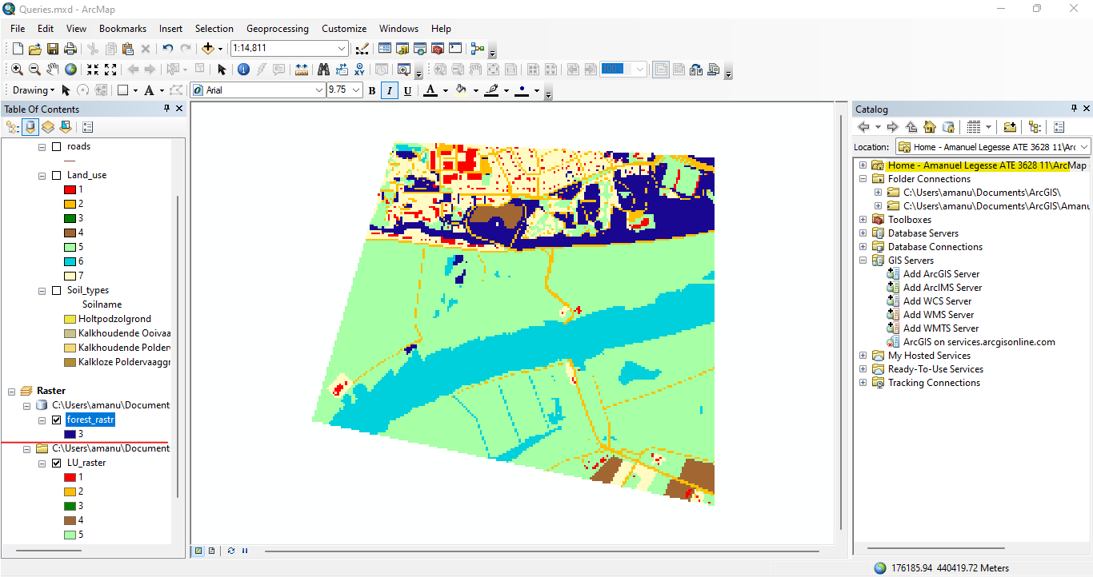

**D**:

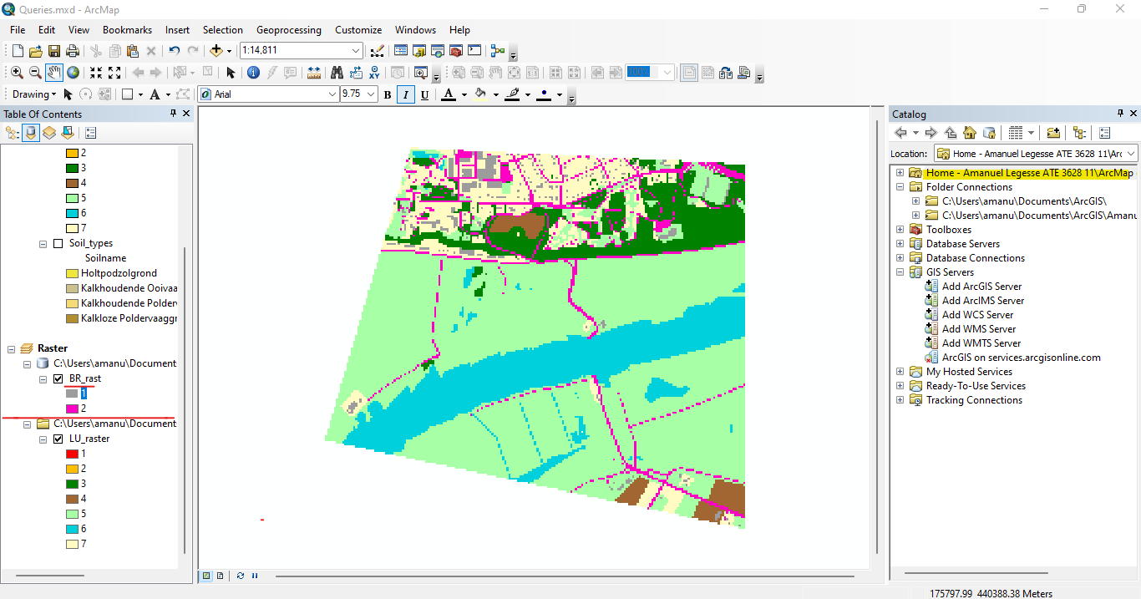

**ARC-GIS**

**PROJECT:**

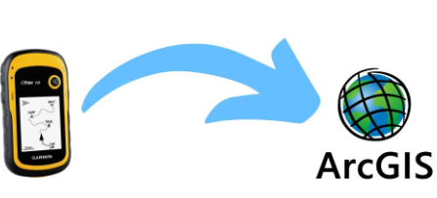

**AMANUEL LEGESSE**

**SOFTWARE ENG. EXT**

**ID – ATE/3628/11POINT PROJECTION ON ARCMAP**

This assignment is briefly about collecting 35 points from a nearby location then projecting them on arcmap.

The location I have chosen for this project starts from 6kilo yekatit 12 square up to shiro-meda roundabout. The list of points choosen are as follows:

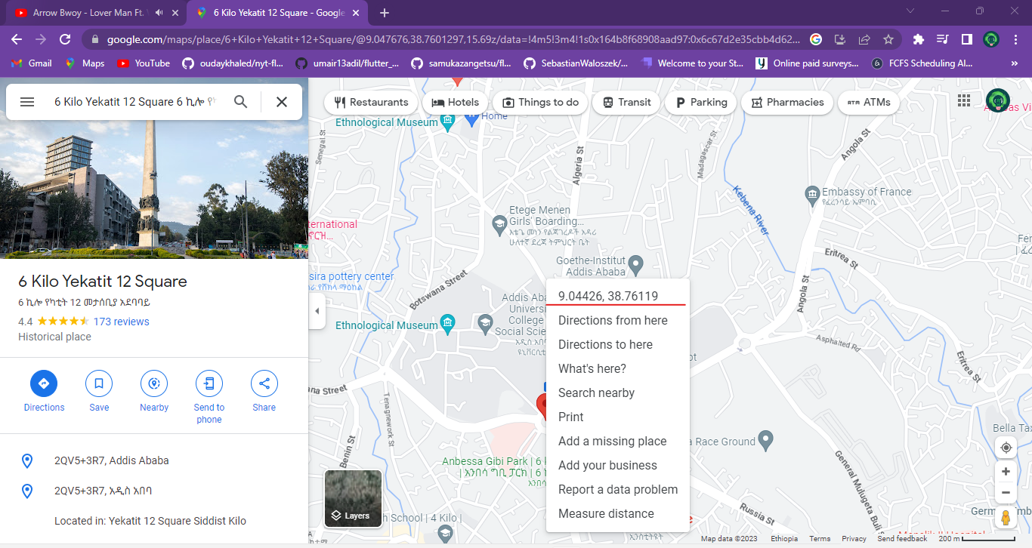

After going through the points on google map I gathered the latitude and longitude then converted them into X Y coardinate system.

I gathered the data in excel form and saved the data sheet in .xls workbook form so arcmap can easily recognize the table.

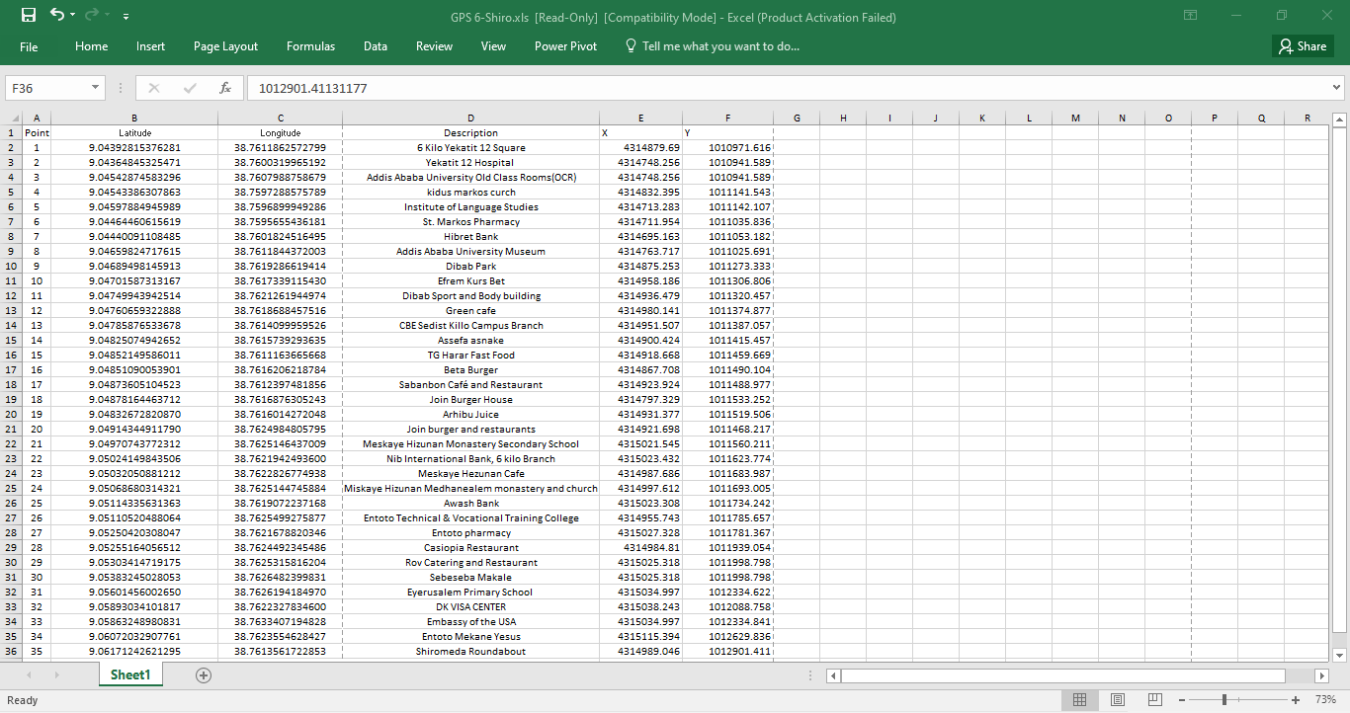

* The excel file can be found in this project folder.

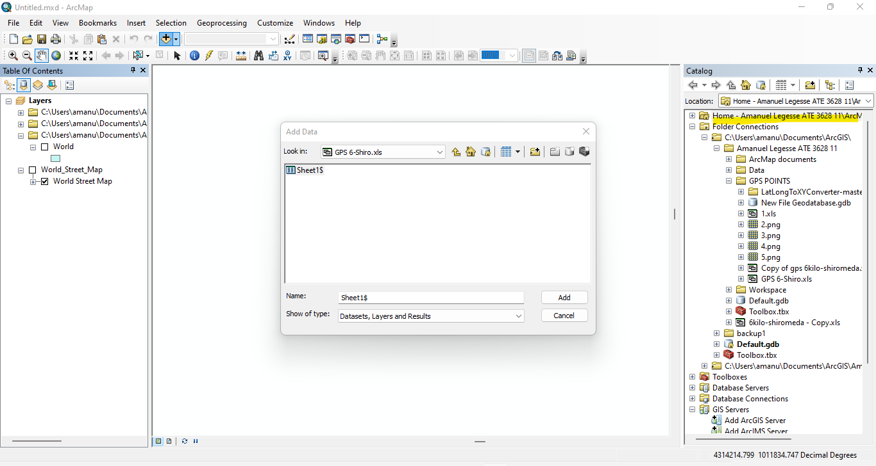 By adding my excel data arcmap was able to detect the data sheets.

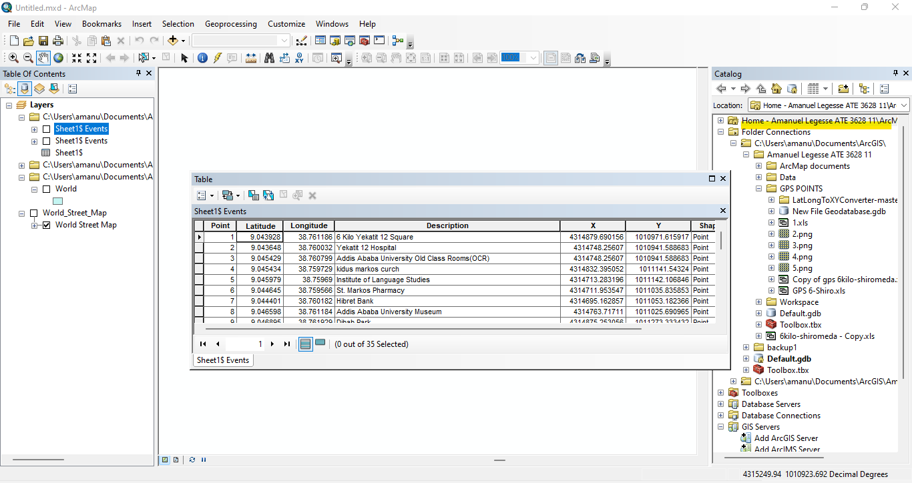 To make sure all the data are present I previewed the sheets in table form.

To preview my data sheet I selected the display XY data and gave the XY coaordinates of the points then chose GCS_WGS_1984 as the coordinate system.

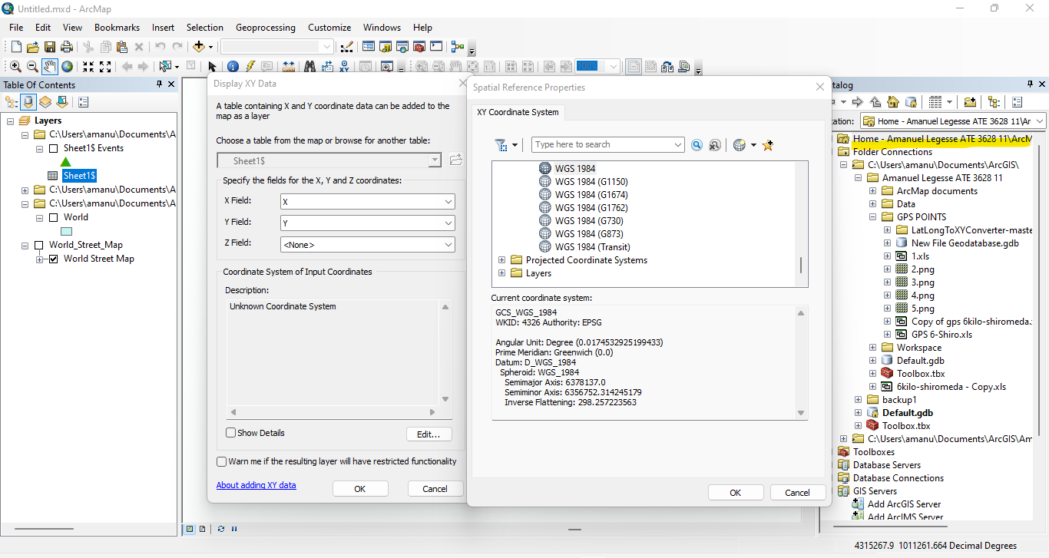

* The points are then visible as shown:

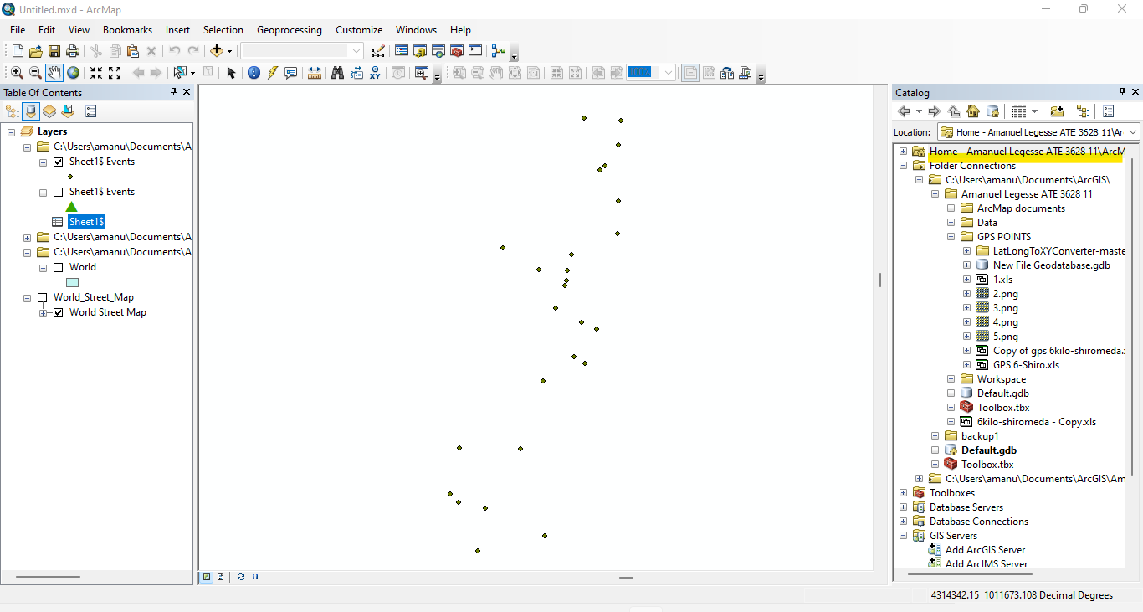

The next step would be adding the world map to display the gathered points on it yet adding basemap by accessing arcgis online services I was able to fetch map data from their website.

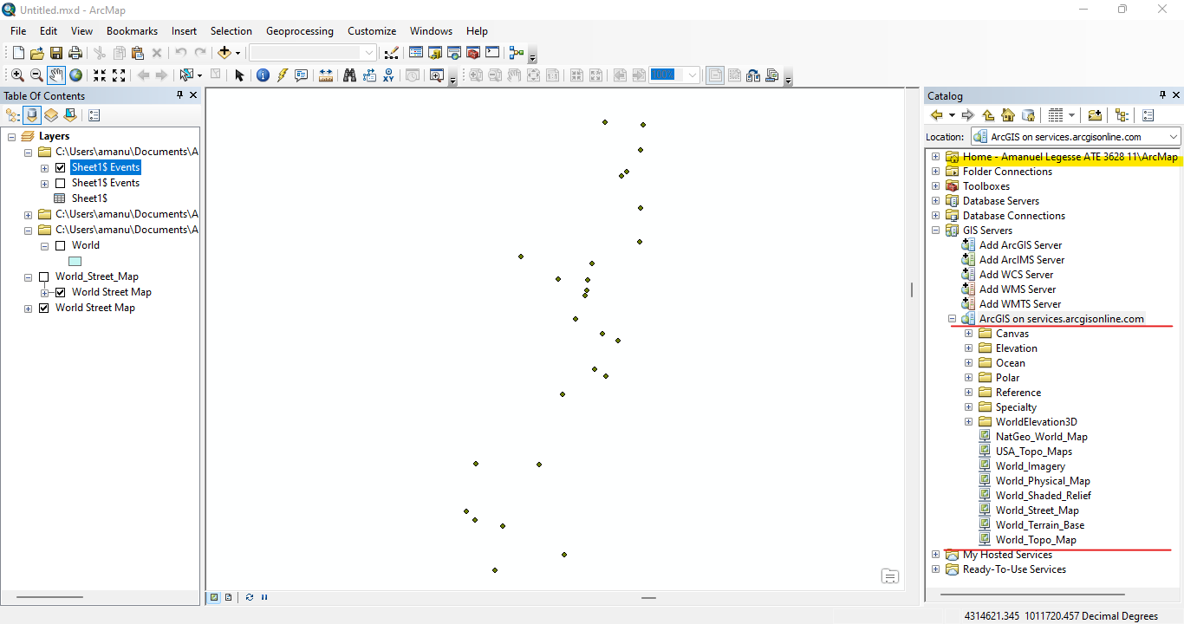

Activating the world street map results in the following map projection.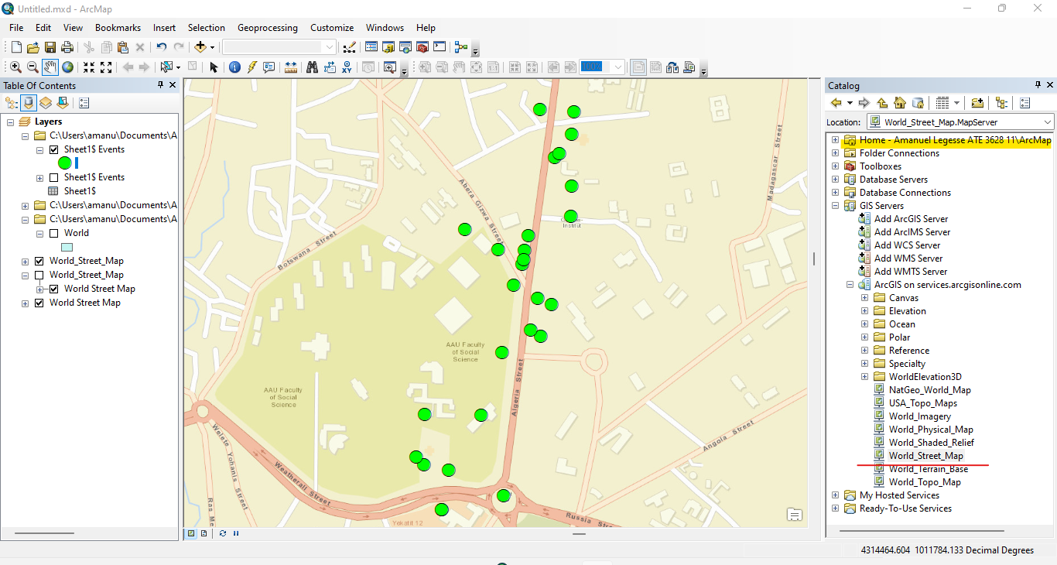

To make things clear I labeled my points with description that was already provided in the table.

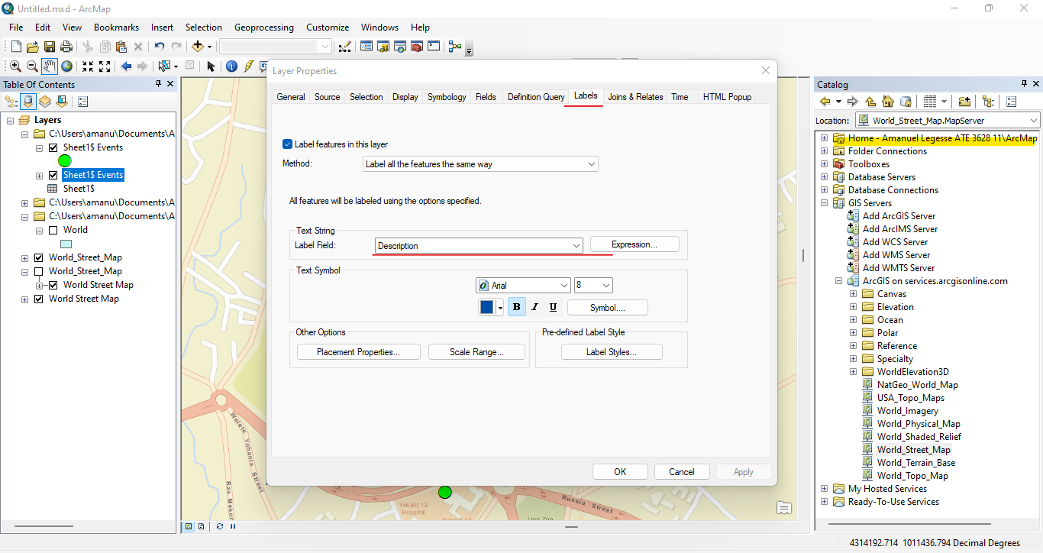

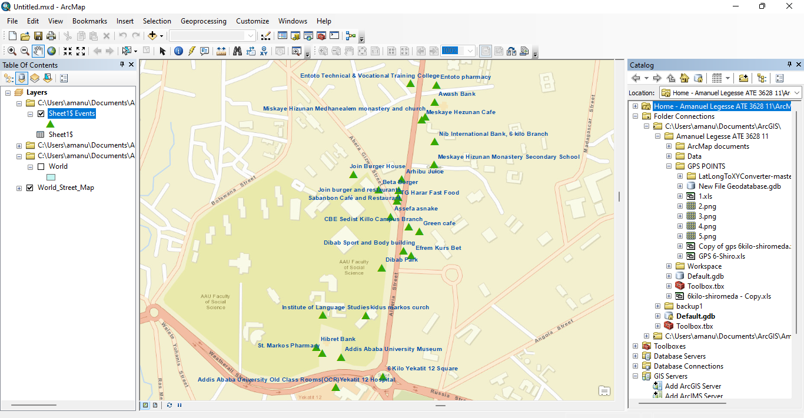

* As a conclusion, using the above steps I was able to display 35 points from my neighborhood to arcmap using XY coordinate system and by the use of arcgis services a street map was used to make sure my points are in the right coordinate system.